An Open Source Reservoir and Sediment Simulation Framework for Identifying and Evaluating Siting, Design, and Operation Alternatives

(version 1.0.0)



Documentation and User's Manual

*Please cite this document as*: Wild, T.B., Birnbaum, A.N., Reed, P.M., and Loucks, D.P. (2019). An Open Source Reservoir and Sediment Simulation Framework for Identifying and Evaluating Siting, Design, and Operation Alternatives.

*Download Software at*: https://github.com/FeralFlows/PySedSim

Table of Contents

1. Model Overview 4

2. Getting Started 5

2.1. System Specifications 5

2.2. Quick-Start Guide 5

3. Theoretical Development 10

3.1. Motivation 10

3.2. Sediment Production and Transport 10

3.3. Sediment Trapping 15

3.4. Sediment Management 16

3.4.1. Overview 16

3.4.2. Simulating Flushing 21

3.4.3. Simulating Bypassing 28

3.4.4. Simulating Sluicing 30

2.4.5. Simulating Density Current Venting 33

3.4.6. Other sediment removal methods 39

3.5. Dam and Reservoir Design Features 40

4. Overview of Model File Structure 45

5. Main Model File Description 46

5.1. Specifying Files Names and Locations 46

6. Input File Description 48

6.1. Overview of Input Workbook 48

6.2. Description of Each Worksheet 50

6.2.1. System Schematic and Meta File 50

6.2.2. Simulation Parameters and Specifications 51

6.2.3. Network connectivity 55

6.2.4. Sediment Loads 58

6.2.5. Incremental Flows 59

6.2.6. Reach Specifications 60

6.2.7. E-V-A-S 62

6.2.8. Storage Volume Elevation Target 64

6.2.9. Storage Volume Target 65

6.2.10. Evaporation Data 66

6.2.11. Environmental Flow Data 66

6.2.12. Reservoir Specifications 66

6.2.13. Outlet Capacity Data 74

6.2.14. Sediment Management Specifications Worksheets 75

6.2.15. Flushing 77

6.2.16. Sluicing 80

6.2.17. Density Current Venting 82

6.2.18. General Sediment Removal 84

6.2.19. Bypassing 85

6.2.20. IncFlowsCalibration1 85

6.2.21. Calibration1 86

6.2.22. FlowsCalibration2 86

6.2.23. Calibration2 86

7. Runtime File Description 88

8. Output File(s) Description 89

8.1. Overview of Model Output Workbook 89

8.2. Time Series Output File 89

8.3. Statistics Output File 97

9. Assumptions, Limitations and Caveats 100

10. References 101

Appendix A: Access to Model Software 104

Appendix B: Equations for Flow, Sediment and Hydropower Simulation 105

# Model Overview

This documentation describes the open-source reservoir and sediment simulation framework PySedSim. PySedSim is an open-source, daily time step river basin simulation model for water and sediment flows, and hydropower production, in networks of reservoirs and river channels. PySedSim enables water resources systems analysts and planners to explore alternative system configurations of reservoir sites, designs (i.e., dam outlet structures), and operating policies (SDO), and their implications for water flows, sediment transport, reservoir sediment trapping, and hydropower production in any river basin. The model enables simulation of a wide range of reservoir sediment management techniques, including flushing, sluicing, density current venting, bypassing, and dredging. The model performs a daily time-step mass-balance simulation of flow and sediment that is intended to predict in relative terms the spatial and temporal accumulation and depletion of sediment in river reaches and in reservoirs under different reservoir operating and sediment management policies. Thus, the model is expected to be used for estimating sediment transport in river basis including those that have experienced (or will experience) extensive reservoir development. PySedSim is generic model, in that it is comprised of flexible code that will let you model any network of river channels and reservoirs of interest to you. You provide PySedSim the basic information about the system you want to model in the form of a handful of .xlsx/.csv input files. PySedSim then creates and simulates the mass balance of water and sediment in that user-specified specified network, according to various preferences. It also exports and stores the results of your simulation in .csv file(s).

The source code is written in Python. PySedSim includes four core model features: 1) representing alternative reservoir sediment management approaches, 2) representing detailed dam design features (e.g., gates), 3) supporting emerging multi-objective optimization frameworks for discovering reservoir operating policies and their resulting tradeoffs, and 4) facilitating stochastic Monte Carlo simulation for characterizing uncertainty in hydrologic and sediment processes. The model strongly broadens the SDO design analytic capabilities of the sediment simulation SedSim model (Wild and Loucks 2015a; Wild et al., 2019)), while providing backward compatibility with its EXCEL-based interfacing for training of less advanced users. The model was developed at Cornell University, in partnership with the Natural Heritage Institute (NHI), as well as at the University of Maryland (College Park). The model is freely available at www.github.com/FeralFlows/PySedSim.

# Getting Started

The following section is a quick start guide for running a simulation with PySedSim. More detailed information is provided in later sections of this documentation, especially regarding the preparation of input data to the model. Users may wish to use the PySedSim example case provided on the model’s Github repository to test the steps below in the quick-start guide. A separate section is available for users interested in conducting optimization.

## 2.1. System Specifications

For best performance, the model should be run using Python 2, version 2.7 or later. PySedSim has not yet been tested on Python 3. The model does not require a fast processor to operate, but a large model (many system elements and/or long time series) can require extensive memory usage. In general, 8 GB of RAM should be suitable for most applications of this model.

## 2.2. Quick-Start Guide

*Downloading and Installing Python, PySedSim, and an IDE*

1. **Download and install Python 2. (Note: v. 2.7 or later is suggested for Python 2; PySedSim will not work with Python 3).**

You can get a free distribution of Python and most of its most popular packages (libraries) for scientific computing through Anaconda: https://www.continuum.io/downloads.

1. **Optional: Install a python Integrated Development Environment (IDE) from which you can execute PySedSim.**

This is not required, as you could execute PySedSim from a console. However, IDEs provide a user-friendly environment in which to view and understand PySedSim’s software design, as well as to modify PySedSim to suit your own needs. PyCharm is one example of a python IDE, and the professional version is free for students. Some details about PyCharm are available at the following blog post: <https://waterprogramming.wordpress.com/2015/07/29/pycharm-as-a-python-ide-for-generating-uml-diagrams/>.

If you want to UNINSTALL pysedsim, I recommend from the anaconda prompt, or wherever you have pip installed, trying “pip uninstall pysedsim”. PySedsim can still be uninstalled this way even though you didn’t obtain pysedsim from pip.

1. **Clone PySedSim from Github.**

PySedSim’s official repository can be found at <https://github.com/FeralFlows/PySedSim>, as shown in the figure below.

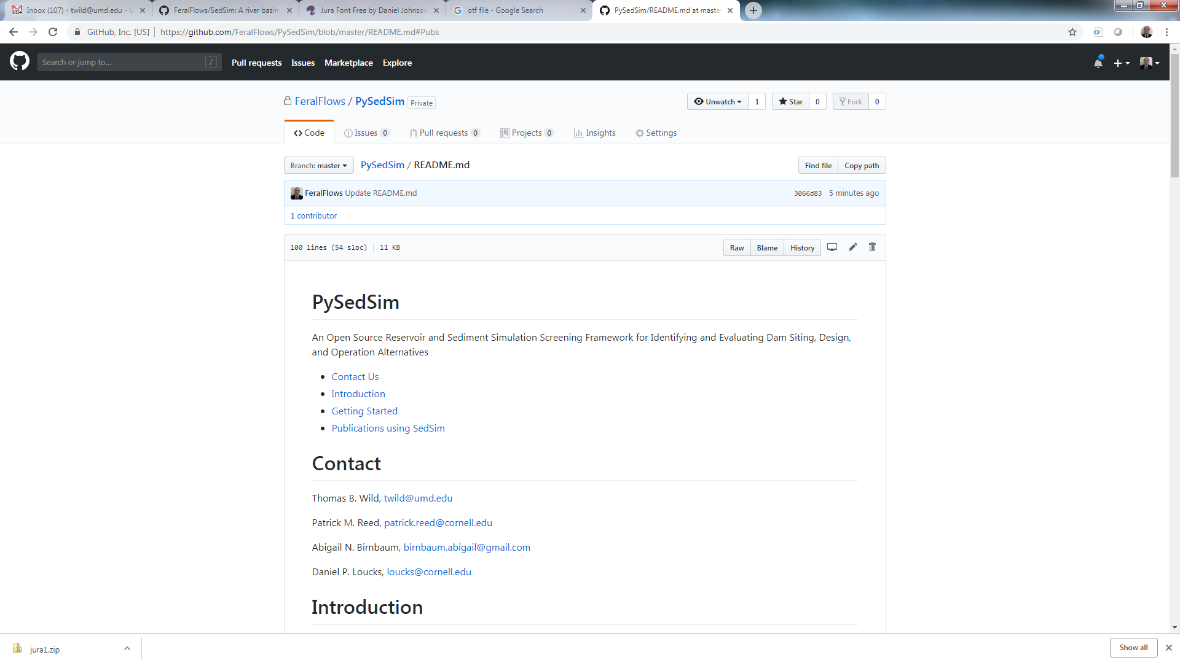

Figure 2‑1. PySedSim Github site.

Users can either directly download PySedSim files from the model’s Github repository (https://github.com/FeralFlows/PySedSim), or can clone PySedSim from a command prompt.

We recommend cloning files rather than downloading them directly from the repository. This will enable you to easily pull down recent PySedSim repository updates (e.g., new model features or bug fixes) from our team directly to the local repository on your computer.

You may wish to create a new directory on your computer into which you will place the cloned files. For clarity, herein I will refer to this folder as “pysedsim _main”. Once you conduct the clone, all of the files that appear on the model’s Github repository online will be downloaded into your newly created directory.

We recommend conducting this process from the command line. If you are unfamiliar working from the command line, we suggest you downloading Git for free here: <https://git-scm.com/downloads>. This Git download will come with “git bash”, from which you can attempt the “git clone” operation described below.

From your command prompt, change directories to the desired location of the pysedsim repository:

**>>cd /your_path_here/pysedsim_ main**

Next, be sure that the Git large file storage system is installed and activated. This will enable you to download the large data files associated with example model applications.

**>> git lfs install**

Next, clone the pysedsim Git repository:

**>>git clone https://github.com/FeralFlows/PySedSim.git**

1. **Setup PySedSim**

Next, you will need to build the PySedSim package. From within your pysedsim_sims_main directory, enter the following in the console:

>>python setup.py install

This command will build an official python “package”, and will be sure you have the correct packages installed that pysedsim needs to run. If you receive any errors that certain packages are not installed, we recommend installing these packages through the Anaconda command prompt by typing the command below (inserting the correct package where “package_name” appears”).

>>pip install package_name

1. **Run a simulation**

*a) Running pysedsim’s example simulations*

We recommend first running the example formulations provided out-of-the-box in the cloned repository. To do this, change directories to a formulation’s directory (e.g., formulation 1):

>>cd pysedsim_sims_main/example/formulation_1

Then, run pysedsim from the command prompt with the following command:

>>python formuation_1.py

Check the output directories, and log file, to confirm that the simulation has run correctly.

Alternatively, you may prefer to run pysedsim from within a python IDE. If running from a console within an IDE, establish a python interpreter. (Currently you must use a Python 2 interpreter). Open the files in PyCharm (File🡪Open, select the PySedSim_sims_main directory), and be sure that in File🡪Settings🡪Project:PySedSim_sims_main, the project interpreter is using Anaconda for Python. Scroll through the installed package list and be sure that both openpyxl and pandas (two open-source libraries for data management that PySedSim uses) are using the latest available versions.

From a console within a python IDE, you then only need to type:

>>import formulation_1

The console will print a message indicating when the simulation is complete, and/or if any errors have occurred.

*b) Prepare and run your own simulation*

Prepare the required two input files for the simulation you will run.

You must have two inputs files to run a simulation: an input specifications (.csv) file, and a main input data (.xlsx) file. Each is described separately below. We recommend looking at the pysedsim example directory for examples of how to prepare these files.

**Prepare input specifications file. (Example name: PySedSim_Input_Specifications.csv).**

Note: You can name this file anything you want, but changing the name requires you provide the name to PySedSim() during the function call as a string. An example call from a Python console with a different Input Specifications File name: PySedSim(file_name=’your_file_name.csv’). You must store this file in the same directory in which you place all the PySedSim (.py) files.

Store the information described below in PySedSim_Input_Specifications.csv. (Note: the order and location of information in the file is critical, so please use the provided file as an example to modify. If you open the .csv file in Excel, all values should be entered in Column B, starting on Row 2.).

1. **Simulation Title.** REQUIRED. Example: Sambor Original.Provide aunique title for your simulation(s). Note that if you run a simulation once with this title, then run a simulation again with this title, the output data from the first simulation will be written over if you specify the same output file path both times. To simulate multiple scenarios, separate the scenario names with a comma and a space (i.e., “, “). PySedSim will loop over the scenarios, simulating each one and storing the outputs.
2. **Input file folder path**. REQUIRED. Provide a path for the folder in which the input file for this simulation is stored. Example: “E:\PySedSim\Model Files\PySedSim Files\PySedSim_Git_Repository\Output_Storage\Scenarios_Input_Data”. Be sure to adjust forward and backslash usage to reflect your operating system.
3. **Input file name**. REQUIRED. Specify the name of the input file, which must be a .xlsx file contained within the folder at the file path you specified above. Example: “PySedSim_Input_File – Sambor Original.xlsx”. If you leave this blank input blank, PySedSim will assume your file is named “PySedSim_Input_File - _______.xlsx”, where the blank is filled in with the Simulation Title text you provided (item #1 above).
4. **Monte carlo input file.** OPTIONAL. This must be a .xlsx file of any name, stored in the Input file folder path specified above. Leave this blank if running a deterministic simulation. Example: “Parameters_for_MC.xlsx”.
5. **Simulation output file folder path**. REQUIRED. Provide a path for the folder in which you want the outputs to be saved after a simulation is completed. Example: “E:\PySedSim\Model Files\PySedSim Files\PySedSim_Git_Repository\Output_Storage”

Note that you do not need to actually create the folder in which the output files will be stored. Just indicate a folder name. This folder (and sub-folders) will be automatically created and populated if they don’t already exist. However, the folders corresponding to the input file path must actually exist, as this is how PySedSim locates the input data to run a simulation.

**Prepare Main PySedSim Input (Data) File. (Example name: PySedSim_Input_File.xlsx).**

This file must be prepared in .xlsx format. Input files formatted in .xls format are not currently supported.

This file contains all data relevant to the particular system (i.e., reservoir and river channel segments) you will simulate. Populate this file with all data relevant to the simulation. (This file must be prepared according to specifications described below.).

Different types of data are stored in different “worksheets”, or “tabs”, of the input file. The tab names roughly describe what data are to be stored. Do not change the worksheet names, though you can reorder the worksheets if you desire.

Every single worksheet contains information specific to your simulation, so every worksheet can be modified. To try the exercises I have provided, I provide a short summary of key changes to specific worksheets that may be required in your input file:

1. **Evaluate results.**

Your output files should have been automatically generated and saved in the directory you specified. A file called “Time Series Output File Descriptions.txt” should be produced that provide descriptions of each variable that was exported. A log file will be produced in your output directory with information (e.g., error messages, successful completion messages, etc.) about the simulation you ran.

# Theoretical Development

## 3.1. Motivation

Reservoirs generally trap all of the inflowing river's bedload and some fraction of the inflowing suspended load. The extent of trapping depends on many factors, including the residence time; the reservoir's trap efficiency; the amount, texture and size of inflowing sediment; and the reservoir's operating policy (Morris and Fan, 1998). Flowing water naturally transports sediment as a means of dissipating energy, so when a reservoir traps sediment and discharges the clear (or 'hungry') water downstream, that water has an increased capacity to scour and transport sediment (Kondolf 1997). This can result in a variety of effects, including bed incision, armoring of the bed, bank failure due to undercutting, lowering of the groundwater table, and isolation of the river from its floodplain.

The sections below present details regarding the process of simulating sediment production, transport, trapping, and reservoir management, as well as flow routing in river channels and reservoir management of water. Appendix B offers additional details regarding the *PySedSim* approach to water and sediment transport and storage in reaches and reservoirs.

## 3.2. Sediment Production and Transport

River basin simulation models like PySedSim often include representations of natural physical processes, which describe how water and sediment move through the natural landscape (e.g., rainfall and runoff); as well as management processes, which describe the various ways in which these natural processes may be modified by infrastructure (e.g., management of water and trapping of sediment in reservoirs). Striking a balance between computational demands and enduse purpose, PySedSim is limited in its abstraction of detailed natural physical processes. For example, in the water resources domain, natural physical processes include rainfall, runoff, groundwater infiltration, and channel flow. Among these processes, PySedSim accounts only for routing of flows through networks of river channels, relying on external models for the other processes. With respect to sediment, models are often classified as either loading models, which account for production of sediment suspended in watershed runoff, or as receiving models, which route sediment through channels and reservoirs (Kalin et al. 2003). PySedSim is a receiving model, designed to receive input from a loading model (e.g., SWAT (Neitsch et al. 2009)). An important difference among receiving models is the degree to which sediment management processes are included. PySedSim includes numerous such sediment management processes, such as the trapping of sediment in reservoirs, the distribution of that sediment within reservoirs’ storage geometry, and the various ways in which sediment can be removed or passed through or around reservoirs.

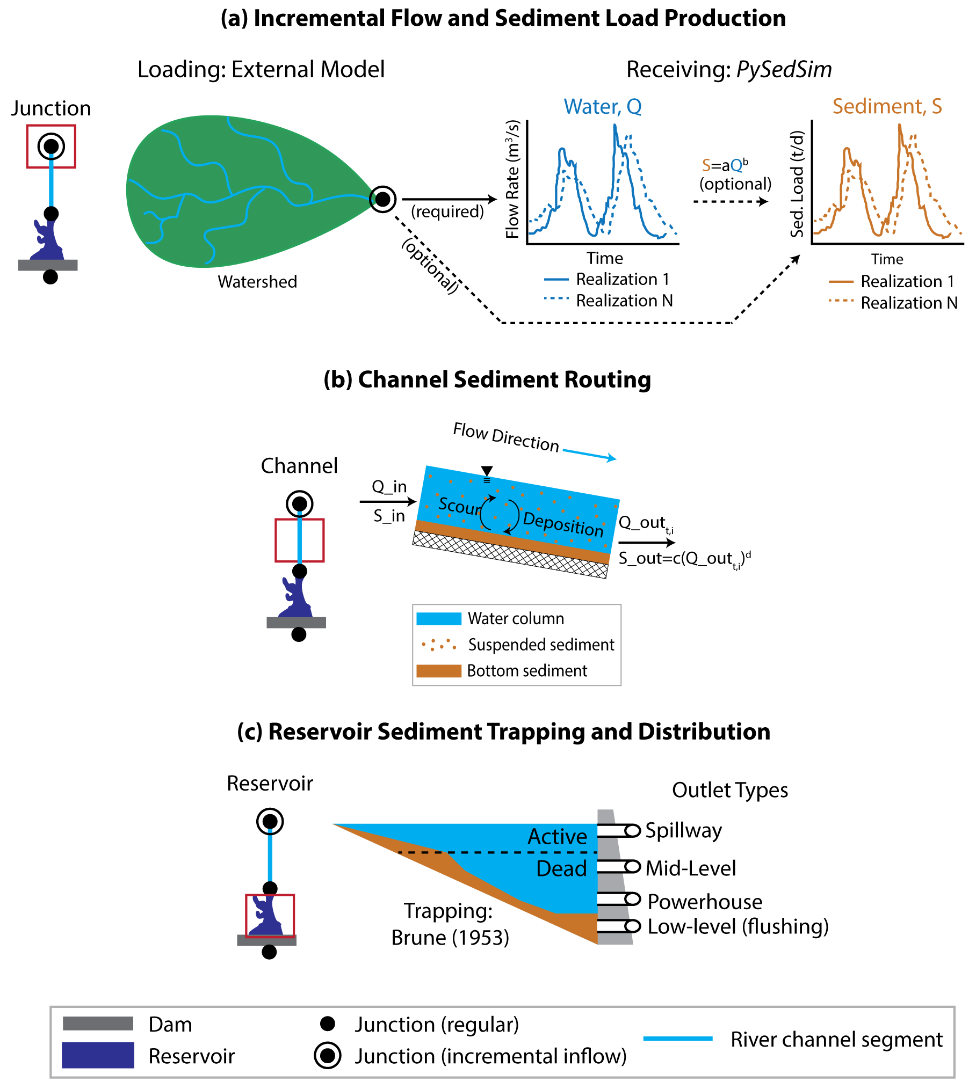

Figure ‑. Core model simulation processes take place at junctions (a), channels (b), and reservoirs (c). (a) deterministic or stochastic time series of incremental flow and sediment enters the modeled system at incremental junctions. Sediment can be externally specified or generated using a relationship that predicts sediment load based upon flow rate. (b) Channel processes include flow and sediment routing. Suspended sediment can either be scoured from the bed or deposited in a given time step. (c) Reservoir is trapped using Brune (1953), then distributed within the active and dead storage zones per user specifications. Multiple outlet (i.e., gate) types are available to release water and sediment.

PySedSim employs relatively simplistic (e.g., empirical) approaches to representing complex sediment processes, largely to ensure they are simple enough to be applied in data-limited settings. In keeping with its intended use in a screening setting, PySedSim simulates a single median sediment grain size rather than a grain size distribution. As shown in Figure 1 of Wild et al. (in review), water and sediment can only enter the modeled system at junctions. Flows specified at junctions represent incremental, rather than cumulative, daily water and sediment runoff from the local watershed. The local watershed represents the contributing watershed area between successive incremental flow junctions. PySedSim does not simulate rainfall, runoff and sediment production processes. Instead, these model inputs must be externally gathered (e.g., from gage station data) or generated (e.g., simulated with a separate model). For example, Wild and Loucks (2014, 2015a, 2015b) coupled a calibrated Soil and Water Assessment Tool (Neitsch et al. 2009) with PySedSim for use in the Mekong River basin. In data-limited river basins where sediment data may be sparse, PySedSim also offers the ability to specify parameters for a rating curve function that describe daily sediment load production as a function of daily hydrologic flow, which can be calibrated using (1) suspended sediment concentration and flow time series data, or (2) estimates of annual sediment load (e.g., Kondolf et al. 2014).

Water and sediment entering a junction in a given day immediately enter the next downstream channel segment or reservoir, and are thereafter routed through that downstream element along with any sediment and water entering from upstream. Figure 1 in Wild et al. (in review) depicts this routing process for an example river channel segment i. Channels are assumed to be unregulated by hydraulic or other structures. With respect to water flow routing, PySedSim seeks to maintain options consistent with those available in the SWAT model, which is well-suited to provide water and sediment time series inputs to PySedSim. PySedSim thus offers several routing options for determining outflow from river channel segments. This outflow rate is then used to route sediment through the channel segment. Specifically, as shown in Figure 1 (of Wild et al., in review), each channel segment is assumed to have a ‘carrying capacity’ (Bagnold 1977) to produce suspended sediment in its outflow as a power function of its already determined water outflow rate. If the concentration of sediment suspended in the water column exceeds the channel’s carrying capacity, some sediment settles to the channel bed (i.e., deposition dominates). Otherwise, sediment is scoured from the channel bed (i.e., resuspension dominates).

The Soil and Water Assessment Tool (*SWAT*), which was calibrated for the Mekong River Basin by the Mekong River Commission, may be used to generate local watershed flows (or incremental flows). Within *PySedSim*, reaches, reservoirs and diversions are connected by junction nodes. Runoff from the watershed, which is generated by *SWAT*, enters the *PySedSim* model at select junction nodes, after which the water instantaneously enters the reach or reservoir that sits immediately downstream of the junction. The *PySedSim* model conducts reservoir operations and reach routing procedures, and tracks the accumulation and depletion of sediment in reservoirs and reaches, independently of the other models (e.g., SWAT and RESCON). The *RESCON* model, which is referenced in Figure 3.1 but discussed in more detail later in the *Sediment Management* section of this chapter, is a tool that aids in assessing the feasibility of applying particular reservoir sediment management techniques at particular reservoir sites (Palmieri et al., 2003; Kawashima et al., 2003). While this figure references the specific models that have been used to conduct simulations in the Mekong basin (i.e., SWAT and RESCON), other models performing similar functions can just as easily be used instead.

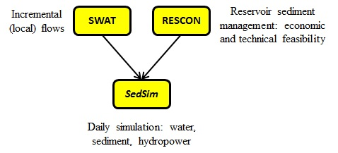

Figure 3‑2. An example of the suggested PySedSim modeling structure, including other modeling tools suggested to be used in conjunction with PySedSim.

A number of studies have indicated a strong correlation between water flow and suspended sediment concentration (SSC) in both large and small, and gauged and ungauged rivers (Milliman and Meade, 1983; Walling and Webb, 1983; Milliman and Syvitski, 1992; Meybeck et al., 2003; Morehead et al., 2003). Factors such as relief and lithology may also play important roles in sediment production (Vorosmarty et al., 2003). In keeping with this commonly observed watershed characteristic, the *PySedSim* model assumes that sediment can only enter the network of reaches and reservoirs at the same exact locations at which water flows enter. The rating curve, based on the power regression of *SSC*, *Cs*(kg/m3), on discharge, *Q* (m3/s), is given by

*Cs = kQx (2.1)*

The relationship in Eq. 2.1 is used for two purposes: (1) to generate daily incremental sediment loads at locations in the modeled system at which incremental flows are generated (by an external hydrologic model or other means); and (2) to generate sediment loads to be discharged from river reaches (channels), in keeping with the concept that each reach has a 'carrying capacity' to produce sediment as a function of reach discharge. The parameters 'k' and 'x' in Eq. 2.1 will be referred to as 'c' and 'd', respectively, when discussing the application of this general equation to incremental sediment load generation (see Eq. 2.2). Conversely, the parameters 'k' and 'x' in Eq. 2.1 will be referred to as 'a' and 'b', respectively, when discussing the application of this general equation to sediment discharge from reaches (see Eq. 2.3).

As was discussed previously, most estimates of sediment loads in the lower Mekong basin predict that about 80 Mt/yr will be generated. Kondolf et al. (2011) partitioned this 80 Mt/yr of sediment among nine geomorphic regions, which were delineated based on climatic, geologic, topographic, and tectonic features. Sediment yields (t/km2-yr) were determined by Kondolf et al. (2011) for each region. For example, the 3S basin lies within two geomorphic provinces: the Kon Tum Massif and the Tertiary Volcanic Plateau, which have estimated yields of 280 t/km2-yr and 290 t/km2-yr, respectively (Kondolf et al., 2011). While this annual sediment yield information is useful, the *PySedSim* model is operated with a daily time step. Thus, daily sediment load inputs to junction inflow locations in the *PySedSim* model are required. To accomplish this, sediment is generated on a daily basis with a version of Eq. (2.2) that has been uniquely calibrated for each incremental input location. The model user must specify a *di* value. The user may wish to set the parameter ‘*d*’ so that proportionally more sediment is transported during higher discharge events, as is often observed in practice (Walling, 2009). The model determines a *ci* value for each incremental input location such that the mean annual sum of daily sediment loads generated in the unregulated system equals the product of the watershed area that contributes to the incremental flows and the annual sediment yield per unit area (described above) for the input location. In symbolic form, the generated yields will satisfy the following equality:

 for all incremental inflow locations *i* (2.2)



where T is the simulation duration (in days), *N* is the average number of simulation years (=T/365), *ci* is the parameter being calibrated for location *i*, *di* is a specified parameter for location *i*, is the daily incremental flow at location *i*, *Δt* is the time step (number of seconds in simulation time step in one day), is the watershed area (km2) that incrementally contributes to location *i*, and is the average annual sediment yield per square km (Mt/yr-km2) of the incremental watershed.

Each Eq. (2.2) is solved in Excel, assuming the user chooses to perform parameter calibration within the model. The model also offers two additional options: (1) specifying one set of two parameter values to be used for all incremental inflow locations, or (2) specifying a separate set of two parameter values for every incremental inflow location. Selecting one of these additional options requires that user determine appropriate values externally.

The model currently assumes that there are no limitations to the sediment supply from the watershed, in that sediment is continually generated as a function of flow without exhausting sediment supply. However, sediment availability in river reaches can be optionally limited. All sediment that exists within the modeled system, including sediment deposits that existed within the system prior to the start of simulation and the incremental loads that enter the system during simulation, are subject to several transport processes. These transport processes are different for reaches and reservoirs.

For reaches, during a one-day time period, any sediment entering a reach element can either settle (with the possibility of being eroded at a later time), or can be discharged from the reach as the model attempts to satisfy the sediment discharge from the reach generated based on an equation that is identical in form to Eq. (2.1). To clarify, previously discussion of Eqs. (1) and (2) focused on incremental sediment loading. However, the *PySedSim* model permits sediment to be generated from within the system as well. Thus, if no sediment incrementally entered the system from watershed runoff, quantities of sediment would be scoured from reaches to compensate for this input of sediment-deprived water. (Sediment can only be generated within the system in reaches, not in reservoirs). The amount of sediment discharged from a given reach is also in the form of Eq. (2.1), where once again the *a* value is calibrated given the *b*, but slightly differently than they were calibrated for the incremental flows. Again, the user may wish to set the parameter ‘*b*’ so that proportionally more sediment is transported during higher discharge events, as is often observed in practice (Walling, 2009). The reach sediment rating curve coefficients are calibrated for each reach such that the mean annual sum of daily sediment loads discharged from the reach in the unregulated system is equal to the sum of the mean annual sediment loads generated incrementally at all upstream incremental input locations. Note that while a regulated *PySedSim* model consists of both reaches and reservoirs, the unregulated system consists only of reaches. Thus, the *a* value is determined for the locations in the network where reservoirs are sited, treating the unregulated reservoir site as a reach. In symbolic form, each *a* value is determined by the model to satisfy the following equality:

 for all reaches *j* (2.3)



where T is the simulation duration (in days), *N* is the average number of simulation years (=T/365), *aj* and *bj* are the parameters being calibrated for reach *j*, *U* is the group of all upstream incremental flow locations *i* that contribute to the outflow at the outlet of reach *j*, is the daily outflow from reach *i*, *Δt* is the time step (one day), is the watershed area (km2) that incrementally contributes to location *i*, and is the average annual sediment yield (Mt/yr-km2) for the incremental watershed area.

Each Eq. (2.3) is solved in Excel, assuming the user chooses to perform parameter calibration within the model. The model also offers two additional options: (1) specifying one set of two parameter values to be used for all reach sediment rating curves, or (2) specifying a separate set of two parameter values for every reach sediment rating curve. Selecting one of these additional options requires that user determine appropriate values externally.

These same parameters *aj* and *bj* for each reach *j* in the unregulated system are then stored in the model and are used to determine flow-based sediment discharge from each reach in the regulated system. Thus, Eq. (2.3) assumes that the 3S basin is in relative balance in its unregulated state, exporting approximately what is eroded on an average annual basis. However, because the unregulated system coefficients *aj* and *bj* are maintained for the reaches in the regulated system, alterations of reach flow rates by reservoirs and reduction of sediment availability due to reservoir sediment deposition can both result in significantly altered sediment discharge characteristics as given by Eq. (2.3).

## 3.3. Sediment Trapping

The sediment concentration entering a reservoir is diminished due to the trapping or settling of sediment in the reduced flow behind the dam. Some fraction of the sediment entering a reservoir is trapped. The fraction of inflowing sediment mass trapped in a reservoir during each time period, or trapping efficiency, is determined as a function of sediment size and residence time of water in the reservoir (Brune 1953). This results in declining trapping efficiency with declining storage capacity, which is an important but often neglected reservoir sedimentation process (Minear and Kondolf 2009). While there are other empirical approaches for estimating trapping efficiencies, the Brune (1953) method has been shown to provide reasonable long-term reservoir sediment trapping efficiency estimates for ponded reservoirs throughout the world (Morris and Fan, 1998). The Brune (1953) method is depicted in Figure 3.2. The Brune (1953) method uses data from reservoirs in the United States to predict trapping efficiency as a function of the reservoir’s residence time (or Capacity:Inflow ratio). Residence time for each simulation day is determined in *PySedSim* using the average total water storage in the reservoir divided by the outflow or release of water from the reservoir. PySedSim will compute trapping efficiency based on either a running monthly or annual average of residence time, as specified by the user in the input data file.

Importantly, when simulating networks of reservoirs, PySedSim naturally accounts for the impact of upstream reservoirs on the cumulative sediment inflows to downstream reservoirs, which is often neglected in large scale reservoir planning studies (Minear et al. 2010). Within the reservoir’s storage capacity, the volume occupied by settled sediment mass depends on its user-specified bulk density. Figure 3‑1c also shows that the model distributes deposited sediment within the reservoir’s active and dead storage zones per user assumptions (using the approach described in Lara and Pemberton 1972), thus reducing over time the reservoir’s water storage capacity at elevations at which deposition occurs. This, for example, captures the impact of sedimentation on hydropower operations, which typically rely on active storage volume at the reservoir’s upper elevations.

The volume of sediment deposition in *PySedSim* is computed as the ratio of trapped sediment mass to the average sediment density. The model assumes that sediment volume remains stable in the reservoir, thus ignoring any compaction processes.

Of the remaining sediment in suspension that did not settle, which is assumed to be of equal concentration throughout the reservoir volume, some is discharged due to the reservoir water release during the time period, after which a final concentration is computed that accounts for evaporation losses. The *PySedSim* model carefully accounts for the impact of sedimentation on reservoir storage volume. As sediment mass accumulates behind the reservoir during a time step, the maximum volumes of water that can be maintained in the dead and active storage zones are reduced in the next time step. This may reduce the total residence time and hence the sediment trapping efficiencies. It can also alter the release of water needed to achieve a specified storage volume or head.

Sediment that has previously settled in a reservoir can only be removed by simulating a sediment management practice, such as flushing.

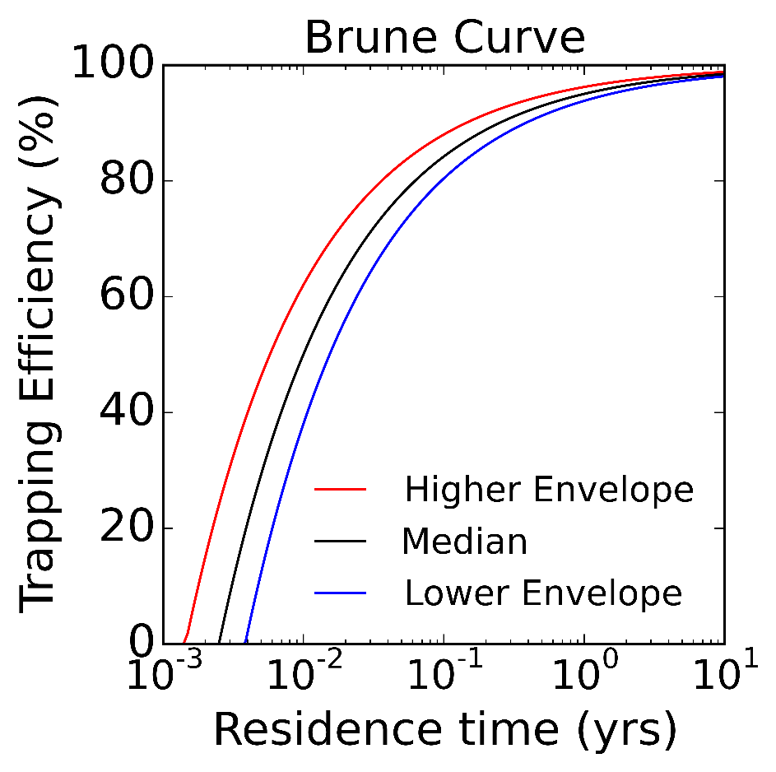

Figure 3‑3. Representation of the Brune (1953) curve for estimating sediment trap efficiency of reservoirs.

## 3.4. Sediment Management

### 3.4.1. Overview

The *PySedSim* model simulates several forms of sediment management in reservoirs, including flushing, bypassing, sluicing, and density current venting. It also can allow for specific pre-specified amounts of sediment removed by hydrosuction, dredging, and sediment excluder devices, but does not simulate those processes. PySedSim employs empirical approaches to simulating the effectiveness of flushing (Atkinson 1996), sluicing (Churchill 1946), and density current venting (Xue et al. 2002) at removing or passing sediment through a reservoir. Before considering simulating particular reservoir sediment management techniques with PySedSim, an external model such as RESCON should first be used to assess the economic and technical feasibility of those techniques given the reservoir’s site-specific characteristics (Palmieri et al., 2003; Kawashima et al., 2003).

The success of any sediment removal method depends on many factors, including the reservoir channel shape, reservoir water storage volume, reservoir hydraulic conditions, and sediment mobility (White, 2000; Morris and Fan, 1998; Habib-ur-Rehman et al., 2009). Once a decision is made that a particular sediment removal method is feasible for a particular reservoir it can be implemented in the *PySedSim* model but this model is not capable of determining what sediment management techniques are technically and economically feasible for a particular reservoir. Rather, the *PySedSim* model will simulate a sediment technique the user indicates should be simulated, without making any judgment about whether such a management practice appears to be reasonable for each reservoir. Such feasibility decisions should be made using a combination of expert judgment and a pre-feasibility sediment screening tool such as the *RESCON* model (short for REServoir CONservation) (Palmieri et al., 2003).

The specific approach taken by *PySedSim* to simulate each of these methods is discussed in below. However, before discussing *PySedSim*’s approach to simulating specific sediment management techniques, and the data requirements for the user to do so, it will first be of value to briefly discuss how the methods PySedSim simulates fit in among the range of techniques that are available for sediment management in reservoirs. A variety of options are available for managing sediment in reservoirs, and they generally fall into three categories: minimizing sediment inflow (e.g., catchment management), preventing sediment that does enter the reservoir from depositing (sediment routing), and removing sediment after it has deposited (sediment removal) (Annandale, 2012d). Other options include designing the reservoir such that it is large enough to handle significant accumulation of sediment during the desired operating period, and designing the reservoir so that sediment accumulation occurs in specific areas that permit future removal (Morris and Fan, 1998). (Note that these techniques are not generally exclusive, in the sense that multiple techniques can be often be applied at a particular reservoir, such as routing during times of high sediment inflows and removal during other times of year). *PySedSim* allows simulation of sediment routing and sediment removal, because these methods offer the opportunity to preserve a river basin's erosion and sediment transport characteristics, which are important for ecosystem health and productivity, rather than simply focusing on preventing sediment deposition in reservoirs as a means of reducing impacts of sedimentation on hydropower operations. For example, catchment management refers to practices that reduce sediment flowing into the reservoir of interest, which could include re-vegetation, tillage practices (e.g., contour farming), and structural approaches (e.g., check dams located upstream to prevent sediment deposition in a downstream dam). In the Mekong Basin, for which *PySedSim* was created, it is important not to reduce high sediment loads, but instead to preserve sediment transport processes as well as preventing sedimentation.

The difference between sediment routing and sediment removal is quite distinct: The goal of routing is to prevent deposition to the extent possible by hydraulically routing the sediment beyond the reservoir, whereas sediment removal focuses on removing previously deposited sediment. In this sense, sediment routing is advantageous in that regularly performed routing can produce reservoir sediment outflows that are consistent in timing and concentration with the natural sediment inflow regime. To prevent deposition, sediment routing seeks to manage the sediment-laden portion of reservoir inflows differently than the clear portion, and is generally done in one of two ways: sediment bypassing and sediment pass-through. Sediment bypassing routes the sediment-laden water around the reservoir to prevent deposition, whereas sediment pass-through routes the water through the reservoir by maintaining a high sediment transport capacity.

Both sediment bypassing and sediment pass-through are implemented during high flow events, which in most parts of the world is when the majority of the annual sediment load is transported. Common examples of bypassing include bypass tunnels (e.g., the Miwa Dam bypass system in Japan), river modification (e.g., Nagle Reservoir in South Africa), and off-channel reservoir storage (e.g., Fajardo Dam in Puerto Rico) (Annandale, 2012b). The extent to which hydropower production is affected by these practices depends on the conditions at the site. Certainly, if significant quantities of water are bypassed around the reservoir during high flow periods to transport sediment around the reservoir, less water is stored in the reservoir and benefits from storage are reduced. However, if the reservoir is properly designed from the beginning, then reduced inflows are anticipated and planned for, as are the associated losses in power output and water yield. While some forms of sediment bypassing can require expensive infrastructure such as bypass tunnels, sediment pass-through almost always requires inclusion of sediment management infrastructure in the dam itself (such as mid- and low-level outlets), which is much less costly when included in the initial design.

Common examples of sediment pass-through include sluicing (e.g., First Falls Dam in South Africa) and density current venting (many applications are in China, including Xiaolangdi Dam), both of which pass sediment directly through the dam via different combinations of outlets. Sluicing is not as commonly implemented as sediment management techniques such as flushing, so establishing the suitability of a particular site and dam for sluicing is not as straightforward. The goal of sluicing is to maintain a sediment balance, such that the annual sediment inflow equals the annual sediment outflow. Thus, sluicing is more successful when performed annually. This is accomplished by partially drawing the reservoir down during times of high sediment inflow to increase the energy slope (and sediment transport capacity). This drawdown may be done seasonally for long durations, or for individual flood events. The impact of sluicing on hydropower production depends on several factors, including: whether or not power production is even possible during sluicing, which depends factors such as concentration of sediment, quartzite content in sediment (hardness), and duration of sluicing; the extent of drawdown (reduction in head) required to achieve the desired increase in transport capacity; and the duration of sluicing.

While sluicing is likely the most applicable sediment pass-through technique for the Mekong basin that involves some drawdown of the reservoir, other drawdown pass-through techniques are used elsewhere. For example, a reservoir may maintain very low storage for most of the flood season to permit sediment passage, as is practiced at Sanmenxia Dam in China (Wang et al., 2005). This approach may seem similar to drawdown flushing, but is different because the sediment is being discharged before it can settle, and is thus released in a manner that is more consistent with the natural sediment regime. This, just like sluicing, can be scheduled to occur on a seasonal basis (e.g., every year during the flood season), or can be implemented during individual flood events, which may be more applicable in smaller reservoirs that have the capability to monitor in real time the sediment and water flows in the basin upstream of the reservoir. On the other hand, the goal of density current venting is to take advantage of high-density plumes of sediment (called density currents) that may form at times as sediment flows into a reservoir. Depending on the flow, concentration, and temperature characteristics at a particular site during a particular event, a density current may form. If and when the current forms, it can be released through the dam's low-level outlets upon reaching the base of the dam, generally without significant impacts on hydropower operations given the relatively low quantity of water that is released during this process.

Another option for managing sediment in a reservoir is sediment removal. There are two categories of such methods. The first is to physically remove sediment from the reservoir and place it elsewhere (e.g., into the downstream channel). Examples include dredging; use of an inline sediment collection device; draining the reservoir and performing dry excavation; and hydrosuction, which siphons sediment from the bottom of the reservoir to the downstream channel. Some of these methods (e.g., dredging) are typically very expensive, in some cases approaching the cost of building a new dam. Others (e.g., hydrosuction) are only applicable to short reservoirs (Palmieri et al., 2003). While *PySedSim* does not explicitly simulate these techniques, it does allow for the removal of a specified quantity of sediment mass from a reservoir over a specified period of time without any changes to reservoir operations, which is an adequate representation of several of the management techniques described above (e.g., dredging, but not dry excavation).

The second category of sediment removal is to implement sediment flushing, of which there are several types. The purpose of sediment flushing is to remobilize and remove sediment that has been previously deposited in the reservoir (Atkinson, 1996). This can reduce losses in reservoir water storage capacity; and can increase sediment loads being discharged downstream. Flushing is conducted by opening low-level (and often mid-level) gates. This causes an increased flow of water through the reservoir, resuspending deposited sediment and discharging both through the gates. There are two kinds of flushing: drawdown flushing (free flow flushing) and pressure flushing (partial drawdown flushing) (Atkinson, 1996; White, 2001; Palmieri et al., 2003). The *PySedSim* model only simulates drawdown flushing, but the differences between these two approaches are clarified in the section below that is dedicated to flushing in *PySedSim*.

If sluicing and flushing are to be performed annually, the significant difference between the two approaches is in the timing of sediment release. Sediment flows may be more naturally preserved with sluicing, whereas a sudden release of sediment over a shorter period of time may result with flushing. However, sluicing is more likely to remove only the finer fractions of sediment, whereas flushing can remove sediment sizes up to sand and gravel (depending on the magnitude of the flushing flow that is employed).

The purpose of sediment flushing is to remobilize and remove sediment that has been previously deposited in the reservoir (Atkinson, 1996). This can reduce losses in reservoir water storage capacity; and can increase sediment loads being discharged downstream. Sediment in river flows impacts the river's geomorphological makeup and ecosystem habitats. Flushing is conducted by opening low-level flushing gates. This causes an increased flow of water through the reservoir, resuspending deposited sediment and discharging both through the gates. There are two types of flushing: drawdown flushing and pressure flushing (Atkinson, 1996; White, 2001; Palmieri et al., 2003). The *PySedSim* model only simulates drawdown flushing. Each will be discussed separately next.

Drawdown flushing requires reducing water levels in the reservoir enough to permit free flow conditions through the low-level outlets. For this to happen the low-level outlets should be located near the original river bed elevation, and should have the capacity to discharge streamflow during the flushing period without significant ponding behind the dam (Palmieri et al., 2003). Drawdown typically begins at the beginning of the high flow season after a period of low inflows and hence low storage volumes. The high flows through the reservoir are more effective in resuspending sediment than low flow values. Low reservoir water levels must be maintained during the flushing period. Thus, drawdown flushing is typically performed at the beginning of the high flow season. The appropriate recurrence interval for flushing depends on the conditions at the reservoir site. Regularly performed flushing, if conducted at the right time, can be more environmentally beneficial than less regularly performed flushing. This is because the amount of sediment released during each flushing event may contain sediment concentrations (and durations of those concentrations) that more closely resemble the river's natural high-flow sediment conditions, in comparison to flushing events designed to discharge sediment that has collected over much longer periods of time. However, more frequent flushing results in more reductions in hydropower production and hence power reliability is lower.

Pressure flushing is not included in the *PySedSim* model. It is different from drawdown flushing in that much higher water levels are maintained in the reservoir during pressure flushing. While avoiding drawdown of the reservoir to very low storage levels may permit increased hydropower production in comparison to drawdown flushing, pressure flushing is only effective at remobilizing and discharging sediment located in the vicinity of the low-level outlet, as well as relocating sediment from upstream portions of the reservoir to downstream portions of the reservoir. In general, drawdown flushing is capable of removing larger quantities of sediment, and from more locations in the reservoir, than pressure flushing.

### 3.4.2. Simulating Flushing

The following information must be supplied by the user for every reservoir at which sluicing will be simulated. Some user inputs are described below as *Optional*, meaning these inputs are extra features that are not required to run a simulation. More details on these inputs are provided in the discussion of “Flushing” worksheet, where most of these inputs are required to be entered.

1. Target flushing start date. *Worksheet*: “Flushing”.
2. Flushing duration. *Worksheet*: “Flushing”.
3. Minimum inflow rate required to initiate drawdown for flushing after the date specified above (*Optional)*. *Worksheet*: “Flushing”.
4. Target water surface elevation during flushing. *Worksheet*: “Outlet Capacity Data”. This is the water surface elevation target during drawdown and flushing. *PySedSim* will establish this value by importing the first elevation in the low-level outlet capacity-discharge table, which should represent the elevation of the low-level outlet). This is generally close to the original river bed elevation.
5. Maximum water surface elevation (WSE) that will still result in successful flushing. *Worksheet*: “Flushing”.
6. Minimum discharge through the low-level outlets that will still result in successful flushing. *Worksheet*: “Flushing”.
7. Maximum flushing drawdown rate (*Optional)*. *Worksheet*: “Flushing”.
8. The representative reservoir bottom width close to the dam. (This information is used to determine how much sediment is removed during flushing. More details are available later in this section). *Worksheet*: “Flushing”.
9. The representative (average) side slope of the reservoir banks. (This information is used to determine how much sediment is removed during flushing. More details are available later in this section). *Worksheet*: “Flushing”.
10. The representative bottom width of the flushing channel.(*The model will calculate this as a function of other inputs described above if the user does not have this information*). *Worksheet*: “Flushing”. This information is used to determine how much sediment is removed during flushing.
11. The representative (average) side slope of the flushing channel banks. (*The model will calculate this as a function of other inputs described above if the user does not have this information*) *Worksheet*: “Flushing”. This information is used to determine how much sediment is removed during flushing.
12. Coefficient value, *k*, for sediment load generation during Flushing, used in equation *kQm* (*Optional). Worksheet*: “Flushing”. (Instead of computing the sediment loads discharged during flushing via the methods described below in this section, the user can instead specify parameters to be used in the equation *kQm* to determine sediment discharge from the reservoir each day during flushing as a function of reservoir outflow).
13. Exponent value, *m*, for sediment load generation during Flushing, used in equation *kQm* (*Optional*). *Worksheet*: “Flushing”. (Instead of computing the sediment loads discharged during flushing via the methods described below in this section, the user can instead specify parameters to be used in the equation *kQm* to determine sediment discharge from the reservoir each day during flushing as a function of reservoir outflow).
14. A discharge capacity vs. elevation table for the low-level outlet that will be used for flushing. *Worksheet*: “Outlet Capacity Data”.

The *PySedSim* model flushing procedure consists of three components: Drawdown, Flushing, and Refill. The user must supply inputs related to these three processes, all of which are described below and depicted in Figure 3.3, which demonstrates an example of *PySedSim* simulation results for reservoir water storage during flushing.

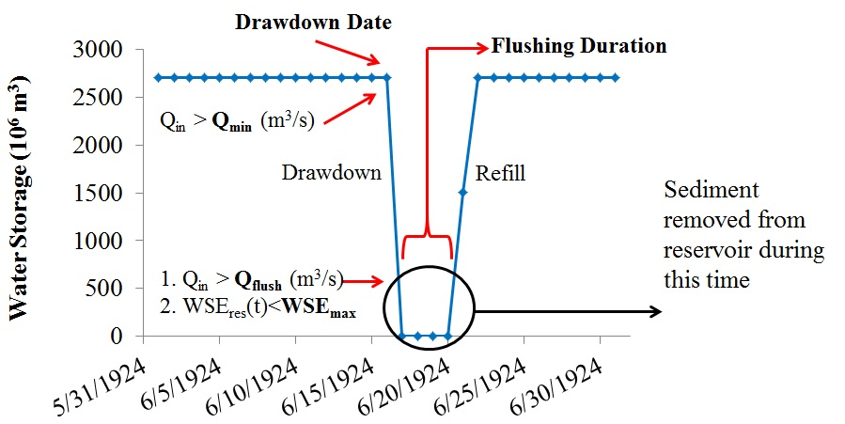

Figure 3‑4. Depiction of the flushing process in PySedSim. This figure plots simulation results for an example reservoir being flushed. In the figure, Qin(t) represents the reservoir inflow in time period t, Qflush represents the minimum flow required to achieve successful flushing, Qmin represents the minimum inflow required before reservoir drawdown is initiated, WSEres(t) represents the water surface elevation in the reservoir in period t, and WSEmax represents the maximum reservoir water surface elevation for flushing to be successful (typically this is equal to or within a few meters the elevation of the low-level outlet(s)).

On or after the date on which the user specifies drawdown is to be initiated, the *PySedSim* model initiates the drawdown process once the reservoir inflow exceeds the minimum inflow target set by the model user. (In other words, the user can establish a minimum reservoir inflow required to initiate drawdown that is different from the minimum inflow/outflow required to achieve successful flushing. The reservoir's low-level gates are opened to attempt to draw down the reservoir to the lowest possible storage so flushing can occur. (The model assumes these gates are already installed). The low-level gates are only opened when flushing is to be attempted, and they are closed as soon as flushing is complete. Other outlets can be used to drain the reservoir during the drawdown period, including the hydropower outlets, as long as the reservoir's water surface elevation during the time period of interest is large enough that the outlet has discharge capacity. Beginning with the first day of reservoir drawdown, the reservoir's pre-established operating policy is temporarily overridden to conduct flushing. In other words, the model does not require the user to modify the pre-existing operating policy (e.g., elevation targets, storage targets, or other policy data) during the time period over which flushing is to occur. Rather, during the time frame when flushing is to occur, flushing is assumed to be the primary goal of operation, and the model operates the reservoir to attempt to satisfy flushing criteria, which are discussed below. The duration of drawdown is not specified by the user, but instead depends on the water storage at the start of drawdown, the maximum drawdown rate, and the capacity of the reservoir's outlets to release water as the reservoir is drained.

During the drawdown process, the Trapping Efficiency (TE) of the reservoir is assumed to be zero. Similar to normal reservoir operations, the only sediment that can be released from the reservoir during drawdown is sediment contained in suspension in the reservoir water volume. That is, no sediment is removed from the sediment mass that has previously settled to the bottom of the reservoir. Water is released from the reservoir only through outlets that have capacity given the reservoir's water surface elevation.

The goal is to keep the reservoir’s storage volume as low as possible, so as not to exceed the maximum water surface elevation required to achieve successful flushing (as defined by the user).

Flushing is assumed to begin on the first date on which the following criteria are satisfied at the reservoir:

1. The water surface elevations (mamsl) at the beginning and end of the time period do not exceed the maximum flushing water surface elevation specified by the user.
2. The flushing discharge (discharge through the low-level outlets) exceeds the minimum flushing discharge requirement (m3/s).

Once these criteria have been satisfied for the number of days over which the user specifies flushing should occur, flushing is complete and refill begins in the next time period. If either constraints are not satisfied on a particular day, then a day is added to the number of specified flushing days. If flushing requirements fail to be satisfied, no sediment is removed from the deposited sediment mass, although already suspended sediment can be discharged from the reservoir via the low-level outlets, or can remain in suspension in the water stored in the reservoir. The model will continue to attempt to satisfy the flushing requirements until the specified number of flushing days has occurred. Due to the significant uncertainty in estimating the discharge requirements to achieve successful flushing, the model assumes that if the flow constraints are satisfied to within 20% of the provided values, flushing is successful.

During the flushing period, the TE of the reservoir is assumed to be zero. The volume of sediment that is removed from the reservoir as a result of flushing is removed from the settled sediment mass and is equally distributed in the discharge downstream over the user-specified flushing horizon. No more sediment mass than is available can be removed from the reservoir as a result of flushing. Sediment is assumed to be removed from segments of the elevation-volume-area curve in the same manner in which sediment was assumed to deposit in the reservoir. For example, if sediment is deposited linearly throughout the elevation range, then flushing will result in removal of sediment from all elevations in the same manner. The quantity of sediment removed during each flushing event is determined via a process that is described at the end of this section on flushing. Flushed sediment accumulates downstream of the flushing channel and is subject to being picked up and further transported downstream depending on the unsatisfied sediment carrying capacities of the reach flows.

During the flushing period, only those outlets that maintain a positive release capacity at the reservoir's water surface elevation each day can be used to release water and sediment. Generally, only the low-level outlets will have discharge capacity at such low elevations, thus preventing any hydropower production during flushing. The water surface elevation cannot drop below the minimum elevation at which the low-level outlet has capacity to release water. Thus, if any water remains in storage below the low-level outlet, which is not likely to be much water given that the low-level outlets are best positioned near the original river bed elevation, the low-level outlets would not have capacity to release this water. Any storage or elevation target set to a level below the low-level outlet will result in a surface elevation close to that of the low-level outlet.

Note that the goal of maintaining low storage during flushing does not mean that zero water volume is maintained in the flushing channel; rather, this means that water volume inflow is similar to water volume outflow during the time period. The goal of flushing is to permit free flow through the reservoir. Thus, at the beginning and end of every time period during which flushing occurs, in a real reservoir some water will always exist in storage in the flushing channel, because there is a constant flow of water into and out of the channel throughout the day. However, one result of conducting a daily mass balance in the reservoir without routing is that all water flowing into the reservoir each day is assumed to be immediately available for release, with storage recorded only at the beginning and end of each day. During the flushing period, this effectively results in all of the inflow being stored immediately behind the dam, and the low-level outlet thus has the capacity (and the goal) of releasing the stored water right away. This means that during flushing, while a storage close to zero m3 is recorded at the beginning and end of each day, in a real reservoir there is storage of water maintained within the flushing channel throughout the flushing period.

The refill period begins on the day after drawdown is completed (i.e., the day after the drawdown maximum elevation and minimum discharge goals have been satisfied for the specified number of days). The reservoir's pre-established operating policy is re-established during the refill period. For example, if the reservoir has a pre-established water storage or water surface elevation target for the day after flushing is completed, the reservoir will not release any water until this target is met. Hydropower production is possible during refill, but only once the water surface elevation is high enough to permit a turbine outlet discharge capacity greater than zero.

Next, note that density current venting, flushing and sluicing are assumed to be exclusive activities, in that they cannot be conducted at the same time. Multiple sediment management techniques can be simulated in the same reservoir at different times. However, flushing, sluicing and density current venting cannot be simulated concurrently. Any management technique being simulated will be allowed to finish before a new technique is begun. For example, if sluicing is being simulated at a particular reservoir and flushing is meanwhile scheduled to occur, the start of flushing will be delayed until sluicing is completed. If the user schedules two or more sediment management techniques to start on the same date, priority is given first to flushing, then to sluicing, and finally to density current venting.

The *PySedSim* approach to determining the quantity of sediment removed during a flushing event is as follows.

1. During each time step, determine the deposited sediment volume, *Vd(t)*

2. During each time step, determine the depth of the deposited sediment layer, *d(t)*.

To accomplish Step 2, *PySedSim* first determines the average Area, *A*, over which the sediment is deposited during the time step. This value is taken to be constant for the duration of simulation. This is estimated using the average surface area of the reservoir, or

(2.4)

where *A* is the average water surface area in the reservoir, *VTK* is the reservoir’s total storage capacity, *Ela* is the elevation at the top of the active storage zone, and *Elb* is the elevation at the bottom of the reservoir (likely the original river bed elevation). These two values will be taken from the user-specified elevation-volume table.

The area, A, is then used to determine the depth of the deposited sediment layer, *d(t)*, as follows:

(2.5)

(Note: This approach is a simplification. In reality, in each time step the sediment is deposited over the reservoir water surface area, which changes in each time step).

3. Determine the fraction of the sediment layer deposited in time period *t* that sits within the incised channel to be formed by flushing, which represents the quantity of sediment that can be removed via flushing.

Every flushing event results in removal of some fraction of the volume of sediment that has settled since the last flushing event. If the reservoir reaches its sustainable long-term storage capacity, *Kf*, which is determined in *PySedSim*, the model assumes that all of the sediment that has settled since the last event can be removed. The Long Term Capacity Ratio (LTCR) (see Atkinson (1996) for more details) represents the ratio of the long term storage capacity that can be sustainably maintained (in perpetuity) with frequent and successful flushing, *Kf*, to the initial storage capacity, *Ko*, as given by the following:

(2.6)

Figure 3.4 represents a simplified version of a reservoir’s cross-sectional geometry that enables a quick calculation of the LTCR of any reservoir that will be frequently flushed. In this figure, the area within the inner trapezoid (denoted by the letter “B”) represents the cross-sectional area that can be maintained in perpetuity by frequent and effective flushing. (Note that this sustainable area is assumed to extend the length of the reservoir, thus forming a sustainable storage volume.) The area of the outer trapezoid (denoted by the letter “A”) represents the total representative cross-sectional area of the reservoir. While the flushing bottom elevation (elevation of low-level outlet) is higher than the reservoir bed elevation at the dam (original river bed elevation) in this figure, the user can locate the low-level outlet at the bottom elevation of the dam, in which case the bottom of the flushing channel coincides with the bottom of the dam.

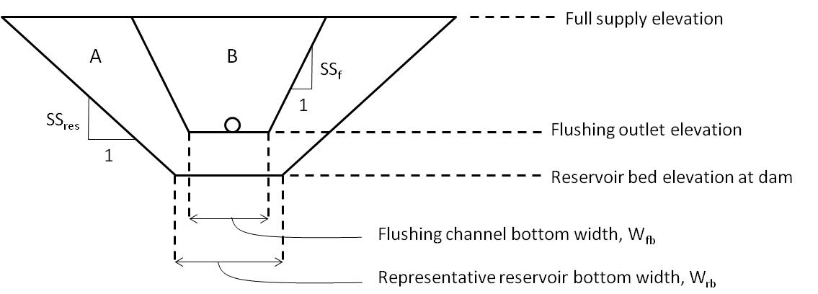

Figure 3‑5. Simplified cross-sectional geometry of a reservoir (outer trapezoid) and the sustainable channel (inner trapezoid) that can be formed by frequent and effective flushing.

The ratio of the two areas “B” and “A” in Figure 3.4 defines the LTCR, or

(2.7)

Note that *PySedSim* accounts for many possibilities regarding the geometries of areas “A” and “B”. For example, *PySedSim* accounts for the circumstance in which the flushing channel side slope is low enough that the flushing channel will eventually meet the side of the simplified reservoir geometry before the flushing channel reaches the top of the reservoir.

*PySedSim* tracks the evolution of the flushing channel as sediment layers deposit within the reservoir in each time step. When the flushing channel has finally reached its sustainable storage capacity (given by the product of the area “B” in Figure 3.4 and the reservoir length), flushing is capable of removing all of the sediment that has deposited since the previous flushing event. Also, if the flushing channel has the potential to be larger than the reservoir’s geometry from the start (i.e., “B” is greater than “A” in Figure 3.4), then complete removal of settled sediment is possible throughout simulation. Generally, it takes some time for enough sediment accumulation to occur before a reservoir reaches the LTCR. Thus, if a reservoir that is regularly flushed has not yet reached its LTCR, the fraction of settled sediment that is removed during a particular flushing event is assumed to be equal to the ratio of the current flushing channel top width in the simplified reservoir geometry, *Wf(t)*, to the width of accumulated sediment deposits in the simplified reservoir geometry, *Ws(t)*. The assumption is that sediment deposits in an equally-distributed manner within this simplified reservoir geometry. Thus, a fraction of any deposited sediment layer will fall within the confines of the channel formed by flushing and will thus be removed when flushing occurs, whereas the rest of the sediment will be located outside of the flushing channel boundary and will thus never be removed. In equation form, the fraction of the mass, *fm(t)* in a sediment layer deposited in a reservoir in time period *t* that can be removed in the next flushing event is given by the following relationship

(2.8)

Given that the layer of sediment deposited outside the confines of the flushing channel is growing as the simulation proceeds and more sediment accumulates, and given that the flushing channel geometry and reservoir geometry have different bottom widths and side slopes, the fraction in Eq. (2.8) can change in every time step. The fraction may increase or decrease depending on the relative shapes of the cross-sectional geometries.

The widths in Eq. (2.8) above is depicted in Figure 3.5 below.

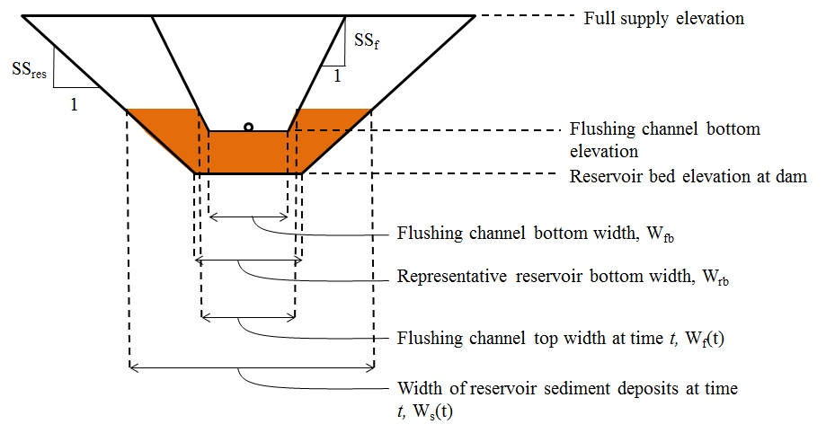

Figure 3‑6. Simplified cross-sectional geometry of a reservoir (outer trapezoid) and the sustainable channel (inner trapezoid) that can be formed by frequent and effective flushing. The brown area represents an example of sediment that has previously deposited in the reservoir up to time period t. Only the fraction of any newly deposited sediment layer in time period t+1 that deposits within the boundaries of the theoretical flushing channel will be removed in the next flushing event.

### 3.4.3. Simulating Bypassing

Bypassing divides the flow into two parts. The bottom portion flows into the reservoir and the top portion gets bypassed to a point downstream of the reservoir outlet. Bypassing can be implemented any time but is usually implemented when the flow is high, and hence carrying more sediment than a lower flow would. All sediment and flow directed into the bypass are discharged into the downstream channel without any routing considered.

To implement bypassing in the *PySedSim* model the user must specify the minimum inflow rate (m3/s) when bypassing would start, and the maximum bypass discharge capacity. Bypassing is assumed to start when the total reservoir inflow (before bypassing is considered) equals or exceeds that minimum specified inflow rate, and stops when the inflow rate drops below the specified minimum inflow rate. Only inflow in excess of the minimum inflow rate is bypassed, with the remainder entering the reservoir. However, when the reservoir inflow in excess of the minimum bypass flow rate also exceeds the maximum bypass discharge capacity, the flow in excess of the discharge capacity also enters the reservoir.

The default model assumption is that sediment is partitioned between the bypass and reservoir in proportion to the fractions of total inflow that are distributed into the bypass and reservoir. If desired, the user can specify what fraction of the sediment that would otherwise have entered the reservoir (based on the proportion of total inflow that enters the reservoir) should instead be distributed into the bypass. This option was implemented to reflect that concentration increases with depth of flow, and thus the bypass may remove more of the inflowing sediment than just the proportion of flow diverted into the bypass.

To further explain this reservoir inflow fraction assumption, suppose for a particular reservoir that the minimum bypass flow is 50 m3/s, the bypass capacity is 80 m3/s, and the total inflow is 120 m3/s. Since the inflow exceeds the minimum flow requirement, a bypass will occur. All flow in excess of the minimum threshold will be bypassed, or 120 m3/s – 50 m3/s = 70 m3/s. The remaining 50 m3/s will enter the reservoir. At least 70/120 = 0.583 (58%) of total sediment inflow (kg) will be bypassed. However, by specifying a bypass fraction in the user interface, the user can establish what fraction of the remaining 42% of the sediment load will be diverted into the bypass instead of entering the reservoir. If the user enters no fraction (0%), this corresponds to the default assumption, which is that all of the remaining 42% of sediment flows into the reservoir. If the user chose, for example, 50% instead, in this example the bypass would receive 58% + 0.5*42% = 79% of the total sediment load, while the reservoir would receive the remaining 21%.

The following information must be supplied by the user for every reservoir at which bypassing will be simulated. More details on these inputs are provided in the discussion of the sediment management specifications worksheet (“Bypassing”), where these inputs are required to be entered.

1. Flow rate above which bypass is activated during wet season (m3/s). *Worksheet*: “Bypassing”. Minimum reservoir inflow rate at which the sediment bypass is opened during the monsoon season and sediment and flow begins to be discharged around the reservoir.
2. Bypass discharge capacity (m3/s). *Worksheet*: “Bypassing”.
3. Fraction of sediment load in reservoir inflow (*PySedSim will establish a default value if the user does not specify a value*). *Worksheet*: “Bypassing”. Allows the user to describe how sediment is partitioned between the bypass, which diverts sediment around the reservoir, and the remaining sediment that enters the reservoir.
4. Minimum required bypass flow (m3/s). *Worksheet*: “Bypassing”. This is the minimum water flow that is required to be diverted into the bypass channel(s) each day (if inflow is sufficient).
5. Minimum required bypass flow (fraction). *Worksheet*: “Bypassing”. Similar to the minimum bypass required flow, except this value represents the fraction of the total daily site water inflow required to be diverted into the bypass channel at all times.

### 3.4.4. Simulating Sluicing

When the simulation date reaches a user-specified beginning date of sluicing, the reservoir will be drawn down to the associated user-specified water surface elevation (mamsl) target, permitted that all optional inflow rate and concentration conditions (described below) are met. Note that density current venting, flushing and sluicing are assumed to be exclusive activities, in that they cannot be conducted at the same time. Any management technique being simulated will be allowed to finish before a new technique is begun. For example, if sluicing is being simulated at a particular reservoir and flushing is meanwhile scheduled to occur, the start of flushing will be delayed until sluicing is completed. If the user schedules two or more sediment management techniques to start on the same date, priority is given first to flushing, then to sluicing, and finally to density current venting.

While the reservoir is drawn down to the target level, the drawdown rate (m/day) will be restricted to the user-specified maximum rate. On the beginning date of sluicing, and for the duration of sluicing, sediment trapping is defined by the Churchill curve (see below for more discussion). When the simulation date reaches the day after the user-specified sluicing end date, normal sediment trapping will resume (Brune's curve trapping), unless another form of trapping is activated immediately after the completion of sluicing. During sluicing, even if the reservoir cannot be drawn down to the target elevation on a given day, sluicing is still assumed to successfully occur. Thus, if drawdown takes a significant amount of time compared to the total sluicing duration, a significant percentage of the sluicing period could consist of drawdown.

If the user specifies that no hydropower will be produced during sluicing, then only the mid- and low-level gates can be used to drain the reservoir (not the hydropower outlets). If the user specifies that hydropower production is possible during sluicing, then water will be released through the hydropower outlets throughout the sluicing process, assuming the hydropower outlets have capacity to release flow.

Once the reservoir is drained down to the target sluicing elevation, the mid-level outlets and low-level outlets are used to achieve sluicing. The low-level outlets are only used during sluicing if (1) Only low-level outlets exist (no mid-level outlets are installed); and/or (2) the inflow is too high for the mid-level outlets to release to maintain the target elevation. If the low-level outlets are used to release water during sluicing, *PySedSim* assumes that no sediment is released as a result of scour in the vicinity of the low-level outlet.

The Churchill (1948) Curve, which appears in Figure 3.6, is used to determine trap efficiency during the sluicing period (on or in between the beginning and ending dates of sluicing). A new trap efficiency value is computed every day depending on the residence time of water in the reservoir. The Churchill Curve is used instead of the Brune Curve because it produces improved sediment passage approximation for reservoirs that have been drawn down, and are therefore hydrologically smaller than during normal operations.

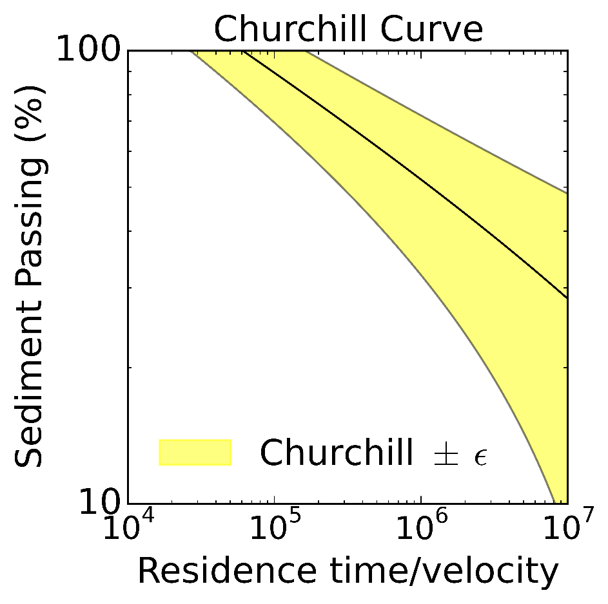

Figure 3‑7. Representation of the Churchill (1948) Curve for estimating sediment release efficiency (100-trap efficiency). The yellow uncertainty band demonstrates the ability to sample capture uncertainty in sediment passage rate in PySedSim by varying model parameters.

The Sedimentation Index (SI) is used to predict the percentage of sediment predicted to pass through the reservoir (or 1 - TE), and is given by the following:

= = = = (2.9)

where *R(t)* is the residence time (s) of water in the reservoir during the time period *t* (one day); *S(t)* is the water storage (m3) in the reservoir at the beginning of the time period; *Qo(t)* is the reservoir release rate (m3/s) during the time period; *A(t)* is the cross-sectional area (m2) through which the reservoir inflow is discharged during the time period; *L* is the reservoir length (m) at full supply level.

The SI(t) is then used to determine the percentage of sediment passing, *P(t)*, through the sluiced reservoir by applying the following approximation to Churchill's original regression curve:

*P(t)* = 800*(*SI(t)/3.28*)-0.2-12

*TE* = (100 - *P(t))/100* (2.10)

The following information must be supplied by the user for every reservoir at which sluicing will be simulated. Some user inputs are described below as *Optional*, meaning these inputs are extra features that are not required to run a simulation. More details on these inputs are provided in the discussion of the sediment management specifications worksheet (“Sluicing”), where most of these inputs are required to be entered.

1. Beginning date of sluicing. *Worksheet*: “Sluicing”.

2. Sluicing starting criterion: minimum reservoir inflow rate (m3/s) (*Optional*). *Worksheet*: “Sluicing”.

3. Sluicing duration. *Worksheet*: “Sluicing”.

4. Target drawdown water surface elevation (mamsl) or storage (m3). *Worksheet*: “Sluicing”.

5. Maximum sluicing drawdown rate (m/d) (*Optional*). *Worksheet*: “Sluicing”.

6. Maximum sluicing refill rate (m/d) (*Optional*). *Worksheet*: “Sluicing”.

7. Reservoir Length (m) at Full Supply Level (FSL). Worksheet: “Reservoir Specifications”.

8. Does hydropower production occur during sluicing? (Yes or No.) *Worksheet*: “Sluicing”.

9. Mid-level outlet elevation vs. discharge capacity table. Worksheet: “Outlet Capacity Data”. This table will be used to limit the capacity to release water from the mid-level outlets during sluicing based on reservoir water surface elevation. Note that this input is not optional, as the model makes the assumption that mid-level outlets are required to conduct sluicing.

### 2.4.5. Simulating Density Current Venting

The following are some important assumptions *PySedSim* makes in simulating density current venting. First, there is no user-specified start date for venting. Instead, it can occur on any day, at any time of year. It begins whenever the combination of inflow rate and sediment concentration result in a theoretical venting efficiency that exceeds the use-specified minimum venting efficiency (defined below). Likewise, there is no user-specified end date for venting. Instead, venting ends whenever the combination of inflow rate and sediment concentration result in a theoretical venting efficiency that is less than the user-specified minimum venting efficiency. (Venting efficiency, which is defined by the user as a function of inflow conditions, describes the percentage of sediment concentration flowing into a reservoir that can be released by the low-level outlets at the dam during density current venting).

Next, if density current venting is initiated in a time period (if the venting efficiency in time period *t* exceed the user-specified minimum venting efficiency), the reservoir maintains its originally specified rule curve, but four user-specified constraints are imposed on the reservoir during this time that may alter the reservoir’s targets from their pre-specified course. These constraints are described here. The latter three require user input, as described at the end of this section.

1. The target outflow rate (m3/s) for the low-level outlets *Qvent(t)*, is set equal to the reservoir inflow, *Qin(t)* (i.e., *Qvent(t)* = *Qin(t)*). To limit the capacity of the low-level outlets to release the inflow during density current venting, the user should establish an elevation vs. discharge capacity table for the low-level outlet used for venting.
2. The user can impose a minimum daily power production requirement during venting. Since the inflow rate will be released through the low-level outlets during venting, it is important to specify some minimum power production requirement if one exists, because the reservoir may otherwise not produce any power during venting, depending on the current water surface elevation (or storage) target on the original guide curve. Note that any water released from the hydropower outlets during venting will result in some drawdown, given that the inflow is likely being released during this time.
3. Additional water may be released from the reservoir through both the hydropower and mid-level outlets, assuming capacity exists, if the user specifies a maximum downstream sediment concentration (mg/l) during venting. The hydropower outlets will not be used to release additional water if their release is diverted away from the reservoir’s downstream channel.
4. Density current venting (and all associated density current releases) will be stopped if the reservoir’s water surface elevation drops below a user specified minimum water surface elevation.

Additionally, venting efficiency (%) is assumed to be a function of inflow rate (m3/s) and concentration (mg/l). This means that in one simulation time step (each day) a density current may have a particular set of concentration and potential venting efficiency, whereas on the very next day these two parameters may change due to a change in the inflow conditions. This would be fine if a density current entered and exited the reservoir within each day. However, a density current (1) needs time to proceed from the inflow point to the low-level outlets, and (2) will dissipate if the sediment supply driving the current stops (or drops below some threshold). *PySedSim* ignores these issues for the sake of simplicity.

Next, note that density current venting, flushing and sluicing are assumed to be exclusive activities, in that they cannot be conducted at the same time. Multiple sediment management techniques can be simulated in the same reservoir at different times. However, flushing, sluicing and density current venting cannot be simulated concurrently. Any management technique being simulated will be allowed to finish before a new technique is begun. For example, if sluicing is being simulated at a particular reservoir and flushing is meanwhile scheduled to occur, the start of flushing will be delayed until sluicing is completed. If the user schedules two or more sediment management techniques to start on the same date, priority is given first to flushing, then to sluicing, and finally to density current venting.

A few additional simplifying assumptions are important to mention. For example, density current venting and sluicing cannot be conducted at the same time. When sluicing is underway, density current venting cannot be activated. Also, no muddy lakes exist at the bottom of the reservoir, from which sediment can be released. Next, the bathymetry of the reservoir's submerged channel does not change over time. Infilling of channel running along the thalweg could lead to decreased effectiveness of current conveyance over time. Next, *PySedSim* ignores the multi-dimensional spatial variability in concentration and velocity of currents. Finally, *PySedSim* ignores the within-day temporal variability of the inflow and concentration that create the currents.

The following information must be supplied by the user for every reservoir in which density current venting will be simulated. Some user inputs are described below as *Optional*, meaning these inputs are extra features that are not required to run a simulation. More details on these inputs are provided in the discussion of the sediment management specifications worksheet (“Density Current Venting”), where most of these inputs are required to be entered.

1. Minimum venting efficiency (%).*Worksheet*: “Density Current Venting”. This represents the lowest acceptable percentage of sediment removal that must occur for density current venting to be an attractive option (e.g., 35%). See below for additional comments regarding determination of venting efficiency in *PySedSim*, against which this minimum venting efficiency is compared to determine whether or not to conduct venting in each time step.

2. Minimum reservoir water surface elevation (mamsl) during density current venting (*Optional*). *Worksheet*: “Density Current Venting”.

3. Reservoir length (km). *Worksheet*: “Density Current Venting”. Used to determine a default minimum venting efficiency value for the user if the user does not specify one.

4. Mid-level outlet elevation vs. discharge capacity table (*Optional*). *Worksheet*: “Outlet Capacity Data”. This input is used to limit the capacity to release water from the mid-level outlets during density current venting. Mid-level outlets can be used to release clear water downstream to reduce the concentration of density current releases.

5. Low-level outlet elevation vs. discharge capacity table. *Worksheet*: “Outlet Capacity Data”. This table will be used to limit the capacity to release water from the low-level outlets during venting.

6. Maximum concentration (mg/l) of sediment released from reservoir during density current venting (*Optional*). *Worksheet*: “Density Current Venting”.

7. Whether to continue venting if maximum specified release concentration is exceeded, or to stop venting. *Worksheet*: “Density Current Venting”.

8. Minimum power requirement during density current venting (MW) (*Optional*). *Worksheet*: “Density Current Venting”.

9. Reservoir bottom width (m). This input is used to determine venting efficiency during each density current venting event. *Worksheet*: “Density Current Venting”.

10. Reservoir bed slope (m/m). This input is used to determine venting efficiency during each density current venting event. *Worksheet*: “Density Current Venting”.

Some additional comments are necessary regarding the determination of venting efficiency in *PySedSim*. As described below, the *PySedSim* internally employs a methodology proposed by Morris and Fan (1998) that determines the efficiency with which a current can be vented given a reservoir inflow rate (m3/s) and inflow concentration (mg/l) on each simulation day. In each time step, if the inflow rate and concentration combine to produce a venting efficiency lower than the user-specified minimum venting efficiency, then density current venting will not occur on that simulation day, and the sediment will settle. Aside from assumptions about flow rate and concentration of inflow, input data/assumptions required to develop this venting efficiency table include temperature (for density calculations), grain size distribution, river slope, and velocity vs. grain size curve. These internal assumptions cannot be modified by the user. *PySedSim* determines the venting efficiency iteratively as follows

**1. Determine the velocity of the turbidity current in the *i*th iteration.**

(2.11)

where *v* is the velocity of the density current (m/s); *f* is a coefficient that represents the total interfacial frictional effects between the density current and the both the river bed and overlying clear water layer; *g* is the gravitational constant (9.81 m/s2); *ρws(t)* is the density of water at 20**°** C with a suspended solids concentration equal to the concentration of the reservoir’s inflow during time period *t*, *Cin(t)*; *ρw* is the density of pure water at 20 **°**C (zero suspended solids concentration); *B* is the representative bottom width of the reservoir; S is the representative bed slope of the reservoir; and *Qin(t)* is the reservoir inflow rate.

Note that the density of water, *ρws*, with suspended sediment concentration *C* (ppm), was assumed to be given by the following relationship:

ρws = 0.9982 + 0.0006C (2.12)

Eq. (2.12) was determined using data from Washburn (1928), as appears in Table 3.1 below.

Table 3.1. Density of water and sediment mixtures as a function of temperature (°C) and suspended solids concentration (g/L). Original Source: Washburn 1928. Table taken from Morris and Fan (1997).



**2. Using the velocity, *vi*, calculated in Step 1 of iteration *i*, determine the maximum grain size that can be transported by *vi* using Figure 3.7 below.** This figure represents the relationship between turbidity current velocity and the grain size that can be maintained in suspension (Fan 1996).



Figure 3‑8. Relationship between density current velocity (m/s) and the sediment grain size (mm) that can be maintained in suspension. Figure borrowed from Fan (1986).

The fitted curve appearing in Figure 3.7representing velocity, *v*, as a function of 90th percentile particle size, *d90*, can be approximated by the following relationship:

d90 = -0.0074(v2) + 0.0369(v) + 0.0007 (2.13)

**3. Remove all grain sizes from suspension that are too large (> d90) to be transported by the velocity of the current, *v,* in iteration *i*.**

To complete this step, the following particle size distribution is assumed (Figure 3.8).

Figure 3‑9. Particle size distribution used to compute percent of sediment in suspension that does not settle in the reservoir (is fine enough to be transported by the velocity of the density current).

The following relationship can be used to approximate the data points in Figure 3.8.

% Finer = 15.226ln(d90) + 95.839 (2.14)

**4. Apply the % finer value determined in iteration step 3 to the concentration of the inflow, and repeat steps 1 - 4 until convergence of the % finer value.** The % finer value represents the venting efficiency (%). It is the portion of the inflowing suspended sediment load that can remain in suspension, which is the percentage that can be vented and will not settle. As this %finer value affects water density and thus the velocity of the current, which affects the particle size that can be transported, this iterative process is required.

Once convergence of the % finer value is achieved, the venting efficiency is given by the final % finer value.

If the user chooses to allow density current venting at a particular reservoir, and if the venting efficiency in this table corresponding to the current inflow and concentration exceeds the user-specified minimum venting efficiency (see below), then a percentage of the inflowing concentration equal to the corresponding venting efficiency will be released from the low-level gates of the reservoir. The remaining percentage (100-venting efficiency) will settle in the reservoir.

Consider the following example of how the venting efficiency computed in *PySedSim* is used:

Average daily flow into reservoir from upstream reach, *Qin*: 100 m3/s

Average daily concentration into reservoir from upstream reach, *Cin*: 20,000 mg/l

Venting efficiency = *f*(*Qin*, *Cin*) = 30%

Venting flow, *Qout* = *Qin* = 100 m3/s

Mass released from venting in one day, assuming user defines 30% efficiency as acceptable: 0.3*100 (m3/s)*20,000 (mg/L)*1000 (L/m3)*86400 (s/day)*10-9 (kg/mg) = 51,840 kg.

In the example above, the sediment concentration released in the vented flow, *Qvent*, is equal to the product of the sediment concentration in the flow entering the reservoir (from the upstream channel) and the venting efficiency. The venting efficiency is equal to the percentage of sediment remaining in suspension by the time the current reaches the dam

### 3.4.6. Other sediment removal methods

To account for the removal of sediment from a reservoir in *PySedSim*, the following information must be supplied in the “General Sediment Removal” Worksheet by the user for every reservoir in which a sediment removal practice will be simulated:

1. Calendar date on which to begin sediment removal. *Worksheet*: “General Sediment Removal”.
2. Removal duration (days). *Worksheet*: “General Sediment Removal”.
3. Amount of sediment to be removed (tons). *Worksheet*: “General Sediment Removal”.
4. The user-defined name of the system element into which the removed sediment will be distributed. *Worksheet*: “General Sediment Removal”.
5. The fraction of sediment that is removed from the active storage zone (the remainder of sediment is assumed to be removed from the dead storage zone). *Worksheet*: “General Sediment Removal”.

For these techniques, the *PySedSim* model approach is very simple. On the date on which the user specifies sediment removal is to be initiated, the model attempts to remove the user-specified amount of sediment volume from the reservoir, while first making sure that no more sediment than is initially available can be removed from the reservoir. The volume removed may be distributed over a user-specified number of days, and is transferred to the settled sediment reserve at a location in the modeled system that the user must specify. If no destination location for the sediment is specified, the sediment is assumed to permanently leave the modeled system. The user can optionally specify the fraction of sediment volume removed that contributes to recovery of active storage, while the remainder of storage is assumed to be recovered in the dead storage zone. Hydropower production and reservoir storages/releases are not altered during the removal process.

## 3.5. Dam and Reservoir Design Features

Reservoirs are assumed to be regulated by a dam, the daily outflows from which are determined by an operating policy, subject to constraints related to the dam’s outlet works and primary operational objectives. The theoretical details of PySedSim’s EMODPS approach to identifying tradeoffs composed of alternative reservoir operating policies appears in Wild et al. (2018). No reservoir flow and reservoir sediment routing features currently exist.

To estimate hydropower production and release capacity of reservoir outlets, the model requires that Elevation-Volume-Area information be provided for each reservoir, so the model can determine the elevation (mamsl) corresponding to the storage volume (m3) at the beginning and end of every simulated day. The original Elevation-Volume-Area relationship provided by the user is modified over time as either (1) sedimentation reduces the water volume and surface area at each water surface elevation, or (2) sediment management practices increases the water volume available at each water surface elevation.

For each reservoir, the *PySedSim* model requires the user to select a reservoir type from four different options, shown in Figure 3.9. A reservoir can either have, or not have, the capability to produce hydropower. Within the two hydropower categories, a reservoir can either only have the capability to release water downstream, or can have the added capability to divert water to another location in addition to downstream. At diversion reservoirs, all diverted water and sediment is immediately transferred to the specified location without routing (i.e., there is no routing time lag in the transfer of diverted water and sediment from one location to another).

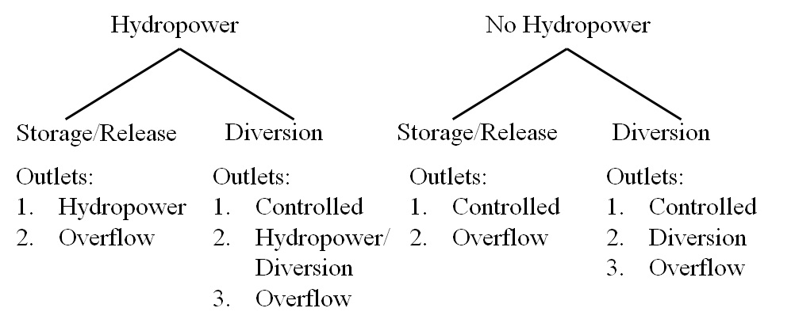

Figure 3‑10. Diagram of the four different reservoir types a user can simulate using the PySedSim model.

These reservoir type distinctions are important for the user to establish so the model can determine appropriate release outlets for each reservoir type, as well as the priority of releases from those outlets. The outlet types established for each reservoir type are listed in Figure 3.9., but each is described in more detail below. First, it will be important to discuss some important general points about specifying outlets in *PySedSim*.

First, it is suggested that for each reservoir to be simulated, the user specify the same type of outlets listed in Figure 3.9 for the reservoir type being simulated, though this is not a requirement. For example, if a reservoir with no hydropower or diversion capabilities is to be simulated, a controlled and overflow outlet should be specified by the user. However, if the user only includes the overflow outlet (i.e., omits the controlled outlet), only the overflow outlet will be capable of releasing flow. If the user specified a hydropower outlet for this reservoir type, it would not be used, because this reservoir type is not capable of producing power.

When the user selects a reservoir type (in the "Reservoir Specifications" worksheet), the model must be supplied with information for each of its outlets. It is very important that the user have a maximum of only one outlet of each type that is appropriate for the reservoir selection (again, see Figure 3.9). For example, even if the reservoir in reality has 5 spillway gates, the individual capacities of these gates should be combined into one larger gate when reservoir data are provided by the user. Additionally, the maximum capacity of each outlet to release flow is dependent only on the water surface elevation in the reservoir. The user must establish the maximum discharge capacity of each outlet for elevations at which the capacity is different. Finally, all outlets are assumed to be controllable. For example, even if the water surface elevation in a reservoir is at the level of the spillway outlet, the spillway is not assumed to release any water unless the storage or elevation target for the reservoir dictates a release is needed. So, while possible it is not likely water will be stored above the spillway elevation since the target elevation or volume would not normally be set greater than this limit.

Note that the discussion below references specific sediment management techniques, detailed descriptions of which are presented later in this chapter.

Reservoir outlets include:

1. **Controlled Outlet.** This outlet type, which does not result in any hydropower generation, is used to ensure that water is released into the downstream channel. For example, diversion reservoirs can divert a significant volume of water away from the downstream channel, but this outlet is located at a low point in the reservoir to increase the likelihood that some water can be released downstream.
2. **Hydropower Outlet.** This outlet type directly supplies the turbines with flow to generate hydropower. Water released through this outlet type is discharged into the downstream channel after passing through the turbines. Importantly, the model does not limit discharge through the hydropower outlet when the provided capacity (MW) of the powerhouse is exceeded. That is, the user-supplied capacity vs. elevation curve for the hydropower outlet applies to the ability to supply water to the turbines, rather than a power production capacity-based discharge limit. The model does, however, prevent power production in excess of the user-provided maximum power production capacity of the plant. Any water being released through this outlet that does not generate hydropower is also classified as spilled flow in the model output.
3. **Diverted Outlet.** This outlet type, which does not result in any hydropower generation, diverts water away from reservoir's downstream channel. The location to which water is diverted can be within the basin being modeled, or outside of the modeled system.
4. **Hydropower/Diversion Outlet.** This outlet type directly supplies the turbines with flow to generate hydropower. This outlet type is only different from the hydropower outlet type described above in that the water is diverted away from the downstream channel after producing power.
5. **Spillway** (**overflow) Outlet.** This outlet type, which does not result in any hydropower generation, is a spillway. Thus, this outlet is assumed to be located at the top of the active storage zone, which is the zone of the reservoir that is operated for hydropower production. These outlets are used to drain any storage space above the active storage zone (i.e., the flood storage zone). Assuming the reservoir’s storage or elevation targets are below the spillway outlet, any water stored above the spillway outlet is spilled into the downstream channel, assuming the outlet has the capacity to release the water.
6. **Low level Outlet.** This outlet type, which does not result in any hydropower generation, is used to release water and sediment into the downstream channel for sediment management purposes. This outlet type can be used to release water during flushing, density current venting and sluicing. For flushing and sluicing, the outlet should be properly sized to enable drawdown (either complete or partial) of the reservoir, as well as properly sized to release reservoir inflows during the flushing and/or sluicing period. For effective flushing, the invert elevation of this outlet should be close to the original river bed elevation at the reservoir site. (Important: The first elevation entry in the elevation-capacity table for this outlet will be assumed to be the original river bed elevation for flushing calculations). This outlet is the only operable outlet during flushing once the water levels drop below the operating levels of other outlets, due to the low water surface elevation maintained during flushing. For density current venting, the low-level outlet should be sized to discharge the reservoir inflow at normal operating water surface elevation during inflow events that produce concentrations significant enough to warrant density current venting.
7. **Mid Level Outlet.** This outlet type, which does not result in any hydropower generation, can be used to release water during sluicing (a form of sediment management that includes drawing the reservoir level down to the mid-level outlets and releasing the reservoir inflow, usually during high inflow season). The mid-level outlets are opened when all criteria are satisfied to initiate drawdown for sluicing, and are generally kept open throughout sluicing. The goal of sluicing is to release the reservoir inflow, so in the event that hydropower outlets exist and have the capacity to release the inflow during sluicing, the mid-level outlets would not be used.

All outlets are assumed to be functional regardless of the amount of sediment contained in the reservoir. That is, even if sedimentation significantly reduces a reservoir’s water storage capacity, all of the outlets are assumed to remain functional for water release throughout simulation.

In addition to selecting a reservoir type, the user must define an operating policy for every reservoir (i.e., how much water to release every day in m3/s). The model allows operating policies based on (1) storage volume targets or (2) storage elevation targets. Both options require that the user pre-establish a time series of targets. (Future versions of the model may allow release decisions in response to the reservoir's storage or elevation state, rather than pre-established targets).

Regardless of which target option is selected, the model implements a similar approach in operating each reservoir, which is to determine how much water must be released, if any, to meet the target, given the initial reservoir storage, potential evaporation, constraints on the release capacity of the reservoir's user-defined outlets (discussed above), and minimum environmental flow constraints. Once the model has determined how much water must be released during the simulation period to meet the specified target, discharge is distributed among the outlets using a set of priorities that depend on the reservoir type. For reservoirs that can only release water downstream (regardless of whether or not the reservoir produces hydropower), the primary outlet (controlled or hydropower) discharges as much of the target flow release as possible, and the overflow outlet only receives the remainder of flow that could not be distributed to other outlets due to release capacity constraints at those outlets. If drawdown flushing is being conducted, any flow that could not be released by other outlets is released by the low-level outlet. For diversion reservoirs, which can divert water away from the downstream channel, the approach is only slightly different. In this case, water is first allocated to the controlled outlet (the primary outlet responsible for releasing water downstream) to meet any user-established minimum environmental flow constraints, after which the hydropower/diversion outlet, overflow outlet and low-level outlet are allocated flow (assuming they have capacity), in that order.

1. **Storage Targets.** If this option is selected, a water storage target (m3) must be established for the end of each simulation day. This input must be provided in the form of a time series. If sediment accumulates in a reservoir and a "Storage Target" policy is selected, the model will only store the water required to meet the storage target, without regard to the impact of sediment on the elevation of the water. For example, if one specifies an operating policy that assigns an identical target value for the reservoir for the duration of simulation, the model will attempt to meet this target, but the water surface elevation to which the constant storage target corresponds will continue to rise as simulation proceeds. (The second reservoir operations option, presented below, offers an approach that accounts for this sediment accumulation issue).

**Elevation Targets.** If this option is selected, a water surface elevation target (m3) must be established for the end of each simulation day. This input must be provided in the form of a time series. If sediment accumulation in the reservoir is negligible in comparison to the storage capacity, then this policy option will result in the same policy one would establish just using storage targets, because an elevation corresponding to every water storage value can be determined from the Elevation-Volume data. However, if sediment accumulation in the reservoir is significant, this option will allow specified elevations to be maintained in the reservoir over time, which may require that less water be maintained in storage as the simulation proceeds due to sediment accumulation in the reservoir's storage space.

# Overview of Model File Structure

Figure E1 summarizes the three steps involved in running and reviewing a PySedSim simulation: preparing input files (Figure 4‑1 - upper), running a simulation (Figure 4‑1 - middle), and viewing outputs (Figure 4‑1 - lower). As shown in Figure 4‑1 (upper), to run a simulation (or simulation-optimization) experiment the user is required specify at least two input files: (1) a top-level “configuration.csv” input file, referred to henceforth as the configuration file; and (2) a main “Input_Data_File.xlsx” input file, referred to henceforth as the main input data file. In the event the user is running a Monte Carlo simulation, Figure 4‑1 (upper) shows that the user may also specify two file types: 1) “.csv” files containing time series of stochastic realizations of daily hydrologic and sediment inflows at each incremental inflow junction (see description in Appendix A), with a unique file for every junction, and water and sediment appearing in different files; and 2) a “Monte_Carlo_Input_Specifications.xlsx”, referred to henceforth as the Monte Carlo input file. The configuration file is used to specify the file paths of all input and output files, as well as to run multiple experiments in batch mode. The main input data file serves as the model’s user interface, giving the user control over model operation as well as data input, editing, and output, and in doing so facilitates PySedSim’s use as a decision support system (DSS) (Loucks 1995). This file organizes related inputs into worksheets (i.e., tabs).

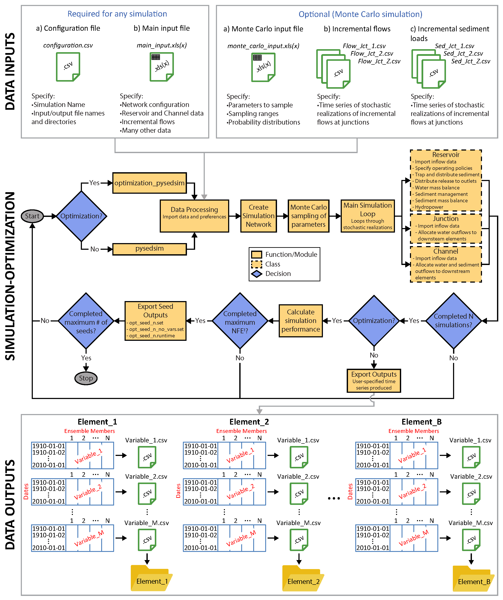

Figure ‑. Steps to executing a PySedSim simulation, including (a) Required and optional input files and the data they must contain; (b) Functional flow diagram describing the order in which various PySedSim modules and class methods (i.e., functions) are invoked during a typical PySedSim simulation run or simulation-optimization run; and (c) PySedSim’s outputs, including three-dimensional pandas dataframes and directories with .csv files.

Figure 4‑1 (middle) is a functional flow diagram showing the order in which various PySedSim modules and class methods (i.e., functions) are invoked during a typical PySedSim simulation run or simulation-optimization run. Modules and/or their relevant functions are shown as box icons. Classes are structured similarly to modules, so they are also represented as boxes with dashed outlines Decisions are represented with diamond icons. Beginning with the “Optimization” diamond in Figure 4‑1, the pysedsim module is used to execute a simulation run, whereas the optimization_PySedSim.py module is used to execute a simulation-optimization run. The latter module facilitates interaction with the serial and parallel implementations of the optimization model Borg through a python wrapper, feeding decision variable and constraints into the simulation module.

Next, Figure 4‑1 shows that in the data_processing.py module, PySedSim uses the openpyxl and pandas packages to import various user-defined simulation specifications from the configuration and main input data files. The system_element_creation module then creates a network connectivity matrix describing the relationships among elements (reservoirs, channels, etc.) and the order in which the elements will be assembled and simulated. This module also creates multiple user-defined class-instances (i.e., objects) for each user-defined element, assigning to each object the attributes imported during the data import step. Next, if the user is conducting a stochastic simulation, the model imports stochastic simulation preferences and samples uncertain model parameters per user specifications. The PySedSim_main_simulation.py module then calibrates sediment model parameters; and loops through Monte Carlo simulation realizations, daily time steps within each realization, and ordered simulation elements, until the experiment finishes. Given the model’s object-oriented structure, not all of the code will be accessed in a given simulation run. If PySedSim is being run in a simulation-optimization setting, once all stochastic realizations have been completed (if applicable), the performance.py module is used to report simulated multi-objective performance back to the optimization model so it can use this information to refine future decision variable values to simulate. A “.runtime” file may be continually updated with information about the current set of optimal solutions the approach has discovered. Once all function evaluations (i.e., simulations executed by the optimization model) have been executed for a particular random seed, a “.set” file will be produced containing equally optimal decision variable values and their performance across user-defined objectives.

As Shown in Figure 4‑1, PySedSim uses the data_processing.py module to produce two types of model output in a pure simulation setting: 1) a Python dictionary of pandas dataframes, where the dictionary keys are system element names (e.g., “Sambor EA Reservoir”); and 2) an output file directory containing individual sub-directories for each system element, wherein each subdirectory contains a .csv file of time series outputs for a particular PySedSim state variable (e.g., daily hydropower production) for one or many simulation realizations. PySedSim uses three-dimensional pandas dataframes, wherein axis 0 corresponds to the state variable name, axis 1 (i.e., rows) correspond to simulation dates, and axis 2 corresponds to simulation ensemble members. A Monte Carlo simulation will have multiple ensemble members, whereas a deterministic simulation will have only one. The output .csv files are directly exported using pandas functionality, so they are organized in much the same way as pandas dataframes. Only those variables and locations the user specifies in the main input file will be stored in pandas dataframes and exported to .csv files.

.

# Main Model File Description

## 5.1. Specifying Files Names and Locations

As shown in Figure xx, insert the following information into the

**Simulation Title.** REQUIRED. Example: Sambor Original.Provide aunique title for your simulation(s). Note that if you run a simulation once with this title, then run a simulation again with this title, the output data from the first simulation will be written over if you specify the same output file path both times. To simulate multiple scenarios, separate the scenario names with a comma and a space (i.e., “, “). PySedSim will loop over the scenarios, simulating each one and storing the outputs.

**Input file folder path**. REQUIRED. Provide a path for the folder in which the input file for this simulation is stored. Example: “E:\PySedSim\Model Files\PySedSim Files\PySedSim_Git_Repository\Output_Storage\Scenarios_Input_Data”. Be sure to adjust forward and backslash usage to reflect your operating system.

**Input file name**. REQUIRED. Specify the name of the input file, which must be a .xlsx file contained within the folder at the file path you specified above. Example: “PySedSim_Input_File – Sambor Original.xlsx”. If you leave this blank input blank, PySedSim will assume your file is named “PySedSim_Input_File - _______.xlsx”, where the blank is filled in with the Simulation Title text you provided (item #1 above).

**Monte carlo input file.** OPTIONAL. This must be a .xlsx file of any name, stored in the Input file folder path specified above. Leave this blank if running a deterministic simulation. Example: “Parameters_for_MC.xlsx”.

**Simulation output file folder path**. REQUIRED. Provide a path for the folder in which you want the outputs to be saved after a simulation is completed. Example: “E:\PySedSim\Model Files\PySedSim Files\PySedSim_Git_Repository\Output_Storage”

1. **Input File name/location.** Specify the location and file name of the input file on the computer. For example, the following would be a valid file name and location: C:\Users\YourName\My Documents\PySedSim_Input.xlsx. The model will use this information to locate, open and import input data from the specified file. The file can be located anywhere on the computer, but the file name must have a .xlsx or .xls extension. (If this file is to be located in the same directory as the main model workbook, only a file name must be specified, without any file routing information. If no file routing or name are specified, the model will assume the input file is located in the same directory as the main model workbook, and is named "Input.xlsx").
2. **Time series output file name/location.** Specify the desired location and file name of the time series output file that will be automatically created and saved by the model, assuming the user chooses to have this file created (see the "File creation specifications" options below). For example, the following would be a valid file name and location: C:\Users\YourName\My Documents\Time_Series_Output.xlsx. The model will use this information to create and save the specified file, and export data to this file. The file can be located anywhere on the computer, but the file name must have a .xlsx or .xls extension and must not have the same name as pre-existing files in the specified location or the pre-existing files will be replaced. (If this file is to be located in the same directory as the main model workbook, only a file name must be specified, without any file routing information. If no file routing or name are specified, the model will assume the time series output file should be located in the same directory as the main model workbook, and will be named " Time_Series_Output.xlsx".).
3. **Statistical output file name/location.** Specify the desired location and file name of the statistical summary output file that will be automatically created and saved by the model, assuming the user chooses to have this file created (see the "File creation specifications" options below). For example, the following would be a valid file name and location: C:\Users\YourName\My Documents\Statistics_Output.xlsx. The model will use this information to create and save the specified file, and export data to this file. The file can be located anywhere on the computer, but the file name must have a .xlsx or .xls extension and must not have the same name as pre-existing files in the specified location or the pre-existing files will be replaced. (If this file is to be located in the same directory as the main model workbook, only a file name must be specified, without any file routing information. If no file routing or name are specified, the model will assume the statistics output file should be located in the same directory as the main model workbook, and will be named "Statistics_Output.xlsx".).
4. **File creation specifications.** Select one of the following options from the drop-down menu:
5. Create only Time Series Output File
6. Create only Statistical Output File
7. Create Time Series File and Statistical Output File

These four options allow the user to specify as many, or as few, output data files as wanted. These options are available because the output files, depending on their size, can take significant time and storage space to be created, populated with data, and saved.

# Input File Description

## 6.1. Overview of Input Workbook

To illustrate how *PySedSim* works a simple single reservoir problem will be simulated. The simplified example will be based on the proposed Sambor reservoir in the Mekong River.

The input workbook file, “INPUT_SAMBOR.xlsx,” to the *PySedSim* model consists of a variety of separate worksheets, each responsible for storing a different type of information. This file should be updated, saved and closed before the simulation is conducted. The simulation will run if the file is open at the start of simulation, but this may make the simulation proceed more slowly (or fail to execute) if your RAM is sufficiently low given the duration of simulation and number of system elements being simulated.

Some of the worksheets in this workbook are required to contain time series. For such cases, additional discussion about formatting of the input data is provided below.

In time series worksheets, each column represents a unique location in the modeled system, whereas each row represents a date. Time series should begin in the second column on the second row, as the first column should just contain dates (in DD/MM/YYYY format).

The name of the location for which each time series applies must be listed in the first row of the associated column. The name of the location must *contain* the same exact name as is listed in the "Network Connectivity" worksheet for that reservoir. For example, if a reservoir in the system is defined in the network connectivity matrix as "LowerSeSan3", then the string typed into the third row for a particular column must contain the letters "LowerSeSan3" in that exact order. There are no case restrictions in this regard; that is, "LoWeRsEsAn3" would also suffice, as would "LoWeRsEsAn3-POOL", because the correct name is still contained within the string, even though the word POOL is added. However, "LoWeR sE sAn 3-POOL" would not suffice as a time series column heading, because spaces are placed in locations in which they did not appear in the name of the reservoir in the "Network connectivity" worksheet.

For each variable for which you are providing time series input, there is no limit to the number of contiguous columns or rows for which data can be provided. The model will search for the time series data for each element by name (located at the top of each time series) for the dates contained within the simulation horizon, and will thus skip data that do not pertain to elements and dates being modeled in the current simulation. This is especially useful for cases in which simulations corresponding to different levels of development (e.g., different numbers of reservoirs) or different time horizons in the basin are of interest. This is because one large data set can be stored in the input file corresponding to the maximum extent of development, and simulations with fewer reservoirs will not then require new, smaller input files to be created. This being said, changes to time series files can still be required when a new system configuration or time horizon is simulated. For example, do not store incremental flow data in the "Incremental Flow" worksheet for junctions that exist in the modeled system but at which incremental flows do not occur in the current simulation.

The date on which each time series value occurs must appear in the first column on the same row on which the associated time series value occurs. If no data exist for a particular element, then no data are required to be entered for that element. For example, if one worksheet corresponds to reservoir evaporation, then if the system has 41 reservoirs but evaporation time series for only 40 of them are available, then the worksheet only needs 40 time series columns. If you omit the time series input for a particular system element (or if you incorrectly spell the name of the element in the column heading), the model will assume all zero values for the omitted element. However, the model will automatically generate a warning message (before simulation proceeds) that indicates you have omitted data, and for what element. (No such error messages will be generated for any incremental flow data supplied by the user in the "Incremental Flow" worksheet). The time series columns can be placed in any order in the worksheet, as long as the reservoir's name is correctly spelled in the third row of the time series column, as explained above.

No row gaps or column gaps in time series data are permitted. That is, the *PySedSim* model assumes that data are provided for every day of simulation, and that time series are stacked as contiguous columns. For example, there should not be a sequence of two numbers in the time series that skips a date, nor should there be any blank rows or columns.

Note that some of the conditions discussed above for time series worksheets also hold for worksheets that do not require time series input. For example, no gaps between columns or rows should exist in any of the input data worksheets. Additionally, data for more than one element can be provided, as the model will locate and import only data pertaining to elements that will be included in the simulation.

The following worksheets are required at a minimum to conduct a simulation:

1. Simulation Specifications
2. Network Connectivity
3. Sediment Loads
4. E-V-A-S
5. Storage Volume Target OR Storage Volume Elevation Target (depending on preferences established in "Reservoir Specifications" worksheet)
6. Incremental Flows
7. Evaporation Data
8. Environmental Flow Data
9. Reach Specifications
10. Reservoir Specifications
11. Flushing (only if Flushing will be simulated as specified in "Reservoir Specifications" worksheet)
12. Sluicing (only if Sluicing will be simulated as specified in "Reservoir Specifications" worksheet)
13. Density Current Venting (only if Density Current Venting will be simulated as specified in "Reservoir Specifications" worksheet)
14. Bypassing (only if Bypassing will be simulated as specified in "Reservoir Specifications" worksheet)
15. General Sediment Removal (only if General Sediment Removal will be simulated as specified in "Reservoir Specifications" worksheet)
16. Outlet Capacity Data

## 6.2. Description of Each Worksheet

### 6.2.1. System Schematic and Meta File

In this worksheet, users are encouraged to place a map (or schematic) of the system being modeled. Any figures or data placed in this worksheet will not be used in the execution of the sediment model. Meta data pertaining to the model inputs and assumptions can also be included in this worksheet. An example of this worksheet is shown below.

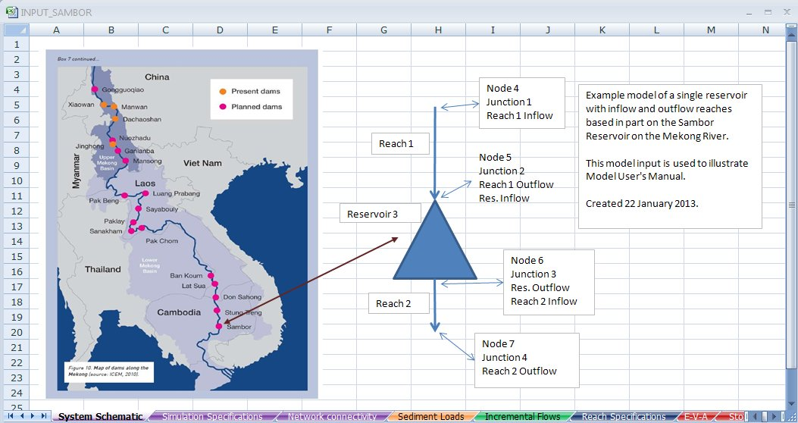

Figure 6‑1. Illustration of a Map and Meta data on the “System Schematic” worksheet page of Input file “INPUT_SAMBOR.xlsx”

This worksheet is accessed by clicking on the purple “System Schematic” worksheet tab at the bottom of the worksheet. Nothing in this worksheet is used during the simulation.

### 6.2.2. Simulation Parameters and Specifications

This worksheet is shown below. It is accessed by clicking on the "Simulation Specifications" worksheet tab at the bottom of the input data workbook.

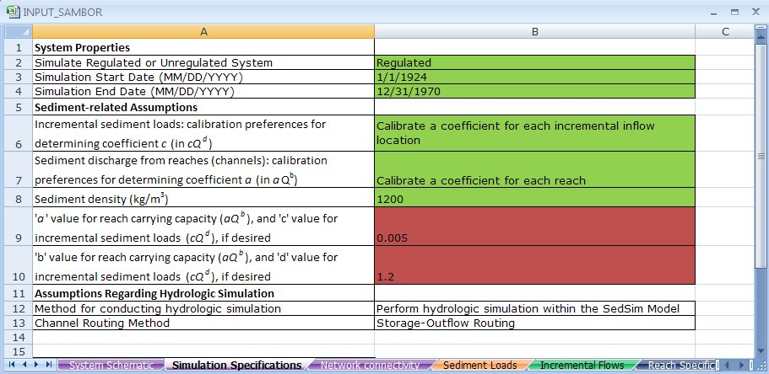

Figure 6‑2. The “Simulation Specifications” worksheet of the input file for the PySedSim model.

In this worksheet, users are required to enter a variety of assumptions for the model to use during the simulation run. Any cell highlighted in green requires input from the user, whereas any cell highlighted in red only requires user input if the model feature pertaining to the cell will be used. Do not leave blank any cells that are highlighted green. Also, do not change the location of any data descriptions within the workbook, as the model assumes that all parameters will be located in particular, pre-established cells.

#### 6.2.2.1. System Properties Category

The following information must be specified by the user in this section:

1. **Regulated or unregulated simulation.** Select either "Regulated" or "Unregulated" from the drop-down menu. The regulated system is defined as one in which reservoirs and diversions are present, with the number and connectivity of reservoirs and diversions, and the system flows that have been affected by these structures, are specified in the input data. The unregulated simulation simply assumes that no reservoirs or diversions exist, and therefore all locations at which reservoirs are expected to exist (or currently exist) become reaches. This option is not necessarily the same as simulating the "current" state of an already regulated basin.
2. **Simulation start and end dates.** Specify the simulation start date and end dates in MM/DD/YYYY format. In the model input files, several time series inputs for each system location (and several variables) may be required, so users should be careful to specify start and end dates of simulation for which a corresponding value exists for every variable of input time series data.

#### 6.2.2.2. Sediment-related Assumptions Category

1. **Incremental sediment loads: calibration preferences for determining coefficient *c* (in sediment rating curve equation *cQd*) for each incremental inflow location *i*.** Select one of the following options from the drop-down menu:
2. Calibrate a coefficient for each incremental inflow location.
3. Use coefficients calibrated in most recent simulation.
4. Specify one coefficient for all incremental flow locations.
5. Specify a separate coefficient and exponent for each incremental inflow location.

A few comments about these options are now important to make, but note that detailed discussion of the calibration process is available in Chapter 2 under the *PySedSim Model Development* section.

Note the units of sediment concentration resulting from this equation are kg/m3.

Option 1 results in a series of calibrations to determine an appropriate *c* value for every location in the system at which an incremental flow (and therefore sediment load occurs). This requires that the model calls Microsoft Excel's Solver to calibrate a parameter for each location. The model will store and save the calibrated parameters in the output files.

Option 2 allows the user to save time and CPU usage by running a simulation using incremental sediment load parameters that were determined in a previous calibration run. If you have selected Option 1 in a previous simulation run, the model will store and save the calibrated parameters in the input data file used to supply data for that simulation run. Selecting Option 2 will mean the model imports those most recently calibrated incremental sediment load parameters stored in the current input data file.

Option 3 allows the user to specify one set of two parameters (the same coefficient and exponent to be used at all incremental inflow locations for sediment load generation). This is a useful option for studies with very limited data availability. For example, there may not be enough evidence that having different parameters at different locations in the system is reasonable. The two values should be specified in the "Simulation_Specifications" worksheet in the two cells highlighted in red, as described below. The two cells are highlighted in red, rather than green, because these specifications are only required if Option 3 is selected.

Option 4 allows the user to specify a different set of two parameters (coefficient and exponent) to be used for sediment load generation at each incremental inflow location. As the model will not perform a calibration to determine these values, the values must be supplied by the user in the "Annual_Sed_Loads" worksheet. The "Annual_Sed_Loads" worksheet stores mean annual sediment loads for each incremental inflow location. Thus, additional columns are available for also storing coefficients and exponents to be used for generating incremental sediment loads.

Note that, depending on the watershed in which this model is applied, you may wish to establish the parameters ‘c’ and ‘d’ so that proportionally more sediment is transported during higher discharge events, as is often observed in practice (Walling, 2009).

1. **Sediment discharge from reaches (channels): calibration preferences for determining coefficient a (in sediment rating curve equation *aQb*).** Select one of the following options from the drop-down menu:
2. Calibrate a coefficient for each reach.
3. Use coefficients calibrated in most recent simulation.
4. Specify one coefficient for all reaches.
5. Specify a separate coefficient and exponent for each reach.
6. Sediment mass out (kg) = Sediment mass in (kg).

A few comments about these options are now important to make, but note that detailed discussion of the calibration process is available in Chapter 2 under the *PySedSim Model Development* section.

Note the units of sediment concentration resulting from this equation are kg/m3.

Option 1 results in a series of calibration to determine an appropriate *a* value for the sediment carrying capacity function for every reach (channel) in the system. This requires that the model calls Microsoft Excel's Solver to calibrate a parameter for each reach, which can take a significant amount of time depending on the number of locations and simulation duration. The model will store and save the calibrated parameters in the input data file used to supply data for the simulation run

Option 2 allows the user to save time and CPU usage by running a simulation using reach sediment carrying capacity parameters that were determined in a previous calibration run. If you have selected Option 1 in a previous simulation run, the model will store and save the calibrated parameters in the input data file used to supply data for that simulation run. Selecting Option 2 will mean the model imports those most recently calibrated reach carrying capacity parameters stored in the current input data file.

Option 3 allows the user to specify one set of two parameters (coefficient and exponent) to be used in the sediment carrying capacity function for all reaches in the system. These two values should be specified in the "Simulation_Specifications" worksheet in the two cells highlighted in red, as shown in Figure 6.2. The two cells are highlighted in red because these specifications are only required if Option 3 is selected.

Option 4 allows the user to specify a different set of two parameters (coefficient and exponent) to be used in the sediment carrying capacity function for each reach. As the model will not perform a calibration to determine these values, the values must be supplied by the user in the "Reach_Data" worksheet.

Option 5 allows the user to assume that each reach maintains a sediment transport capacity that results in a daily discharge of sediment from each reach that is equal to the sediment inflow to the reach, regardless of the water inflow and outflow rates. This is a steady state assumption, in that the sediment leaving the system every day should equal the sum of the sediment incrementally generated within the system every day. This is not a physically realistic assumption, but can be useful for evaluating the impact of assumptions regarding sediment transport capacity in studies in which very little is known about sediment production in channels.

Note that, depending on the watershed in which this model is applied, you may wish to establish the parameters ‘*a*’ and ‘*b*’ so that proportionally more sediment is transported during higher discharge events, as is often observed in practice (Walling, 2009).

1. **Sediment density.** Specify one value for sediment density (kg/m3). This value is only used to determine the volume (m3) of sediment settles in each reservoir in each day, given a mass (kg) of settled sediment.
2. **The 'a' value for all reach carrying capacities (*aQb*), and 'c' value for all incremental sediment loads (*cQd*), if desired.** A value must be specified here only if option 3 is selected in either the Incremental Sediment Load category ("Specify one coefficient for all incremental flow locations") or the reach carrying capacity category ("Specify one coefficient for all reaches").

Note the units of sediment concentration resulting from this equation are kg/m3.

1. **The 'b' value for all reach carrying capacities (*aQb*), and 'd' value for all incremental sediment loads (*cQd*), if desired.** The value in this cell is jointly imported by the incremental sediment load generation function and by the reach carrying capacity function to be used as the exponent in each case. The only reason not to specify a value in this cell is if either (1) all of the calibrated parameter values from a previous simulation are to be used, or (2) appropriate options have been selected in order for the user to specify exponent values for each location in separate worksheets (the "Annual_Sed_Loads" worksheet for the incremental sediment load function, and the "Reach_Specifications" worksheet for the reach carrying capacity function).

Note the units of sediment concentration resulting from this equation are kg/m3.

1. **Channel Routing Method.** Select one of the following options from the drop-down menu:
2. Storage-Outflow Routing
3. Null Routing (Flow in = Flow out)

Storage-outflow routing determines daily reach outflow rates (m3/s) as a function of reach storage (m3). This option is described in Appendix B. Null routing results in reach inflow rate equal to reach outflow rate (a steady state assumption).

### 6.2.3. Network connectivity

The “Network connectivity” worksheet contains the network connectivity matrix, which describes how system elements (reaches, reservoirs, junctions, and diversions) are connected together.

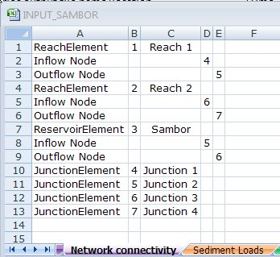

Figure 6‑3. Portion of "Network connectivity" worksheet of input file containing network configuration of the system being simulated.

The "Network connectivity" worksheet is used to assign unique names, ID numbers, and element types to every system element, and to describe to which junctions the upstream and downstream ends of each reach, reservoir and diversion are connected. Column A contains the element name and column B the element number. Column C is the element name used in the simulation, and columns D and E are the inflow and outflow nodes associated with a particular reach or reservoir element. Nodes are also called junctions.

The network connectivity matrix must be 5 columns wide. Every element that exists in the modeled system, which includes reaches, reservoirs, junctions and diversions, must be represented in at least one row of the network connectivity matrix. The process is different depending on what type of element is of concern. Each will be addressed separately below.

The following describes what users should type into each specified cell. The string enclosed in quotes should be entered into the specified cell without including the quotation marks. Follow very closely the syntax suggested below. For example, when establishing a reach element, the single string "ReachElement" must be typed in the first column, not the two strings "Reach Element". Note that reaches must have a single inflow node and a single outflow node to be modeled properly in the *PySedSim* model. Conversely, reservoirs can have multiple inflow nodes. For reaches and reservoirs, users should follow the steps described below to (1) establish the existence of the element, and (2) define its inflow and outflow nodes (inflow nodes must appear first, and outflow nodes must appear second). Names and ID numbers must be unique for every system element. No element should ever be defined with an ID of "0".

Reaches:

Row 1 [required; used to establish existence of element, its ID, and its name)]

Column 1: "ReachElement"

Column 2: "Unique Reach ID #" (e.g., 105)

Column 3: "Unique Reach Name" (e.g., 12008)

Column 4: No input required

Column 5: No input required

Row 2 [required; used to establish the inflow node for the reach and the ID of that inflow node]

Column 1: "Inflow Node"

Column 2: No input required

Column 3: No input required

Column 4: "Unique ID of the Inflow Junction; must be the same ID that is established when the node/Junction is defined"

Column 5: No input required

Row 3 [required; used to establish the outflow node for the reach and the ID of that outflow node]

Column 1: "Outflow Node"

Column 2: No input required

Column 3: No input required

Column 4: No input required

Column 5: "Unique ID of the Outflow Junction; must be the same ID that is established when the node/Junction is defined"

Reservoirs:

Row 1 [required; used to establish existence of Reservoir, its ID, and its name)]

Column 1: "ReservoirElement"

Column 2: "Unique Reservoir ID #" (e.g., 105)

Column 3: "Unique Reservoir Name" (e.g., V009-Buon Tua Srah)

Column 4: No input required

Column 5: No input required

Row 2 [required; used to establish the first inflow node for the Reservoir and the ID of that inflow node]

Column 1: "Inflow Node"

Column 2: No input required

Column 3: No input required

Column 4: "Unique ID of the first Inflow Junction; must be the same ID that is established when the node/Junction is defined"

Column 5: No input required

Row 3 [optional; used to establish the second inflow node for the Reservoir and the ID of that inflow node]

Column 1: "Inflow Node"

Column 2: No input required

Column 3: No input required

Column 4: "Unique ID of the second Inflow Junction, established when defining the Junction"

Column 5: No input required

Row 4 [required; used to establish the outflow node for the Reservoir and the ID of that inflow node]

Column 1: "Outflow Node"

Column 2: No input required

Column 3: No input required

Column 4: No input required

Column 5: "Unique ID of the Outflow Node, established when defining the Junction"

Junctions:

Row 1 [required; used to establish the existence of a Junction node]

Column 1: "JunctionElement"

Column 2: "Unique Junction ID #" (e.g., 2675)

Column 3: "Unique Junction Name" (e.g., Junction 10)

Column 4: No input required

Column 5: No input required

Diversions:

Row 1 [required; used to establish the existence of the Diversion, and the reservoir at which it originates]

Column 1: "DivertedOutletElement"

Column 2: "Unique Diversion ID #" (e.g., 1385)

Column 3: No input required

Column 4: No input required

Column 5: “Name of Reservoir at which diversion originates, same as listed when initially establishing reservoir.”

Row 2 [required; used to establish the ID of the junction node to which the diversion flows]

Column 1: “Outflow Node”

Column 2: No input required

Column 3: No input required

Column 4: No input required

Column 5: “Unique ID# of Junction to which diversion flows”

### 6.2.4. Sediment Loads

The “Sediment Loads” worksheet contains estimates of the cumulative average annual sediment loads (in kg/yr) that are discharged past every location in the system at which incremental flows enter. See Figure 6.4 below.

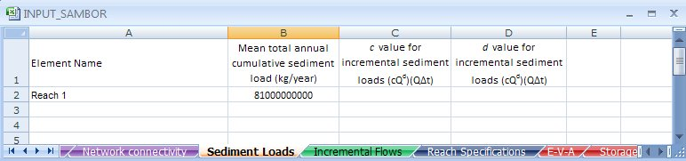

Figure 6‑4. “Sediment Loads” worksheet of the input file.

This worksheet should contain four columns. In the first column, each row should contain sediment load data relevant to each system element (reach or reservoir) into which incremental sediment loads (and incremental flows) will enter the system at an upstream inflow junction of the element. Data entry for the first element should begin on the second row. The reservoir or reach name in each row of the first column must be identical to the name as defined in the "Network connectivity" worksheet in the input file. Data for more locations than just those being modeled can be stored in this worksheet, as the model will only import information relevant to elements being simulated. Each column represents a different input data requirement. Column data entries should begin on the second column.

1. **Mean total annual cumulative sediment load (kg/year).** In column 2, users should enter the mean annual cumulative sediment yield (kg/km2-yr) that is expected to flow into each incremental inflow location in a completely unregulated system. This should be the mean annual sediment load that is discharged past each reservoir site, assuming no reservoirs exist in the system to trap sediment, and assuming that the system is in relative balance. Assuming the system is in balance requires that there are no long-term sediment sinks. All sediment generated upstream of an incremental inflow location is expected to be discharged past the incremental inflow location, on average, when the system is in balance). The model will only import this value for calibration purposes (calibrating c and d in Eq. (2.2)). Thus, this column is only required if the user selects the option to calibrate a coefficient for each incremental inflow location in the "Simulation Specifications" worksheet of the input workbook.
2. **The *c* value for incremental sediment load generation (Eq. 2.2).** In column 3, specify a coefficient value to be used by the model directly in Eq. (2.2). This column is only required if the user chooses not to conduct a calibration of incremental sediment load coefficients using the model, and instead prefers to supply the model directly with these coefficient values. The preference to supply these values instead of conducting a calibration must be established in the "Simulation Specifications" worksheet of the input workbook.
3. **The *d* value for incremental sediment load generation (Eq. 2.2).** In column 4, specify an exponent value to be used by the model directly in Eq. (2.2). This column is only required if the user chooses not to conduct a calibration of incremental sediment load coefficients using the model, and instead prefers to supply the model directly with these exponent values. The preference to supply these values instead of conducting a calibration must be established in the "Simulation Specifications" worksheet of the input workbook.

### 6.2.5. Incremental Flows

The “Incremental Flows” worksheet, shown in Figure 6.5, defines where the incremental flows take place and when.

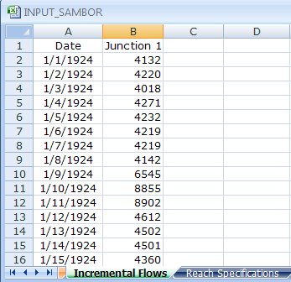

Figure 6‑5. Portion of the “Incremental Flows” worksheet of the input file. In this example these are the flows that enter the upstream reach of the reservoir, Junctrion 4, and get routed through the reach and enter the reservoir.

The sheet is only required to contain average daily incremental flow rates (m3/s) that enter each junction in the modeled system. Incremental flows should only include those flows that locally enter the modeled system, rather than flows that have already entered the system upstream. Each column should represent a time series of incremental flow rates that enter a particular junction, whereas each row represents the incremental flow rates for all junctions for a particular date. As with all other time series sheets, time series data should begin on the second column and second row, dates should begin on the first column and second row, and the reservoir name should be placed on the first row of every time series column (beginning with the second column). The junction name in each column must be identical to the junction's name as defined in the "Network connectivity" worksheet in the input file. Time series data for more than just those junctions for which elevation targets will apply can be stored in the worksheet, as can data for more dates than just those contained within the simulation horizon. The model will locate and import only the data necessary to conduct the simulation. However, be careful not to store incremental flow data in this worksheet for junctions that exist in the modeled system but at which incremental flows do not occur in the current simulation.

### 6.2.6. Reach Specifications

“Reach Specifications” worksheet stores all data relevant to sediment transport and flow routing in river reaches (channels). Each row corresponds to a different reach in the modeled system for which data exist. The reach name stored in each row must be identical to the reach name as defined in the "Network connectivity" worksheet in the input file. Each column in this worksheet corresponds to a different category of information for which the user should supply data for all reaches for which the data category is relevant. (Each of these categories is introduced in detail below). If all data columns do not apply to a particular reach, no row for the reach is needed. Do not rearrange the locations of columns, as the model searches in specific columns for specific information. Importantly, the model converts reservoirs to reaches when the user runs an unregulated simulation. Thus, each reservoir that will exist in the regulated system simulation should be listed in a separate row in this worksheet (in addition to all reaches that will exist in the regulated system). The data you specify in each column on the row corresponding to each reservoir name will only be applied to the unregulated simulation.

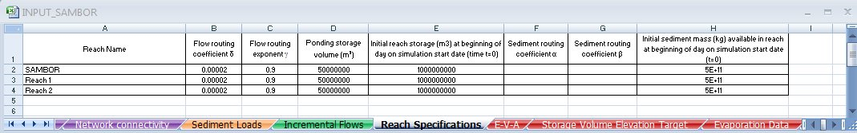

Figure 6‑6. “Reach Specifications” data worksheet.

1. **Flow Routing Flow routing coefficient δ.** This data column is required only if the Storage-Outflow routing method is selected in the "Simulation Specifications" worksheet within the input file. The specified coefficient value will be used in the pair of reach routing Eq. (1) and Eq. (2) for the corresponding reach.
2. **Flow Routing Flow routing exponent γ.** This data column is required only if the Storage-Outflow routing method is selected in the "Simulation Specifications" worksheet within the input file. The specified exponent value will be used in the pair of reach routing Eq. (1) and Eq. (2) for the corresponding reach.
3. **Ponding storage volume (m3).** This data column is required only if the Storage-Outflow routing method is selected in the "Simulation Specifications" worksheet within the input file. The specified value will be used in the pair of reach routing Eq. (1) and Eq. (2) for the corresponding reach.
4. **Initial reach storage (m3) at beginning of day on user-specified simulation start date.** This information is required because the model predicts end-of-period storage volume values for every reach. To predict the end-of-period storage volume for the simulation start date, the user must supply the beginning of period storage volume for the simulation start date. This value is identical to the end-of-period storage in the date before the specified simulation start date.
5. **Sediment routing coefficient 'a'.** This information is required only if the user chooses the "Specify a separate coefficient and exponent for each reach" calibration option in the reach sediment discharge category (within the "Simulation Specifications" worksheet in the input file). The specified coefficient value will be used in the sediment routing Eq. (2.3) for the corresponding reach.
6. **Sediment routing coefficient 'b'.** This information is required only if the user chooses the "Specify a separate coefficient and exponent for each reach" calibration option in the reach sediment discharge category (within the "Simulation Specifications" worksheet in the input workbook). The specified coefficient value will be used in the sediment routing Eq. (2.3) for the corresponding reach.
7. **Initial sediment mass (kg) available in the reach at beginning of simulation start date.** This represents the amount of sediment (kg) available in storage (bed sediment) in each reach at the beginning of the day on the simulation start date. (Sediment in suspension at the beginning of simulation in all reaches is assumed to be zero. Absence of sediment in suspension in reaches during the first simulation time period will briefly affect the quantity of sediment that is scoured from (or that settles onto) the river channel bed. For this reason, you may wish to run the simulation for a few extra days, or simply ignore the first few days of results.). An accurate value may be difficult to determine in practice, in which case the user could assume some large value of initial sediment availability, simply to prevent complete exhaustion of sediment supply in reaches. Relative Changes in sediment mass stored in the reach from the initial value assumed would then become more important than absolute changes. This initial sediment mass value is required because the model predicts end-of-period sediment mass values for every reach. To predict the end-of-period sediment mass on the simulation start date, the user must supply the beginning of period mass for the simulation start date. This value is identical to the end-of-period mass in the date before the specified simulation start date.

### 6.2.7. E-V-A-S

The “E-V-A-S” worksheetcontains the Elevation (meters above mean sea level: mamsl)-Volume (m3)-Area (ha)-Sediment (cumulative fraction) data for each reservoir in the modeled system.

Starting with the first column on the left, the user must specify exactly four columns of information for each reservoir, in the exact order in which they appear below:

1. Column 1: **Elevation data**
2. Column 2: **Water volume data**
3. Column 3: **Water surface area data**
4. Column 4: **Cumulative fraction (in the range from 0-1) of settled sediment to be stored below each corresponding elevation in Column 1 in each time step of simulation.**

No blank columns should be placed between the sets of 4 columns (e.g., if your system includes 41 reservoirs, then you should populate 41 sets of 4 columns, or 41*4=164 columns of E-V-A-S data, with no blank columns). The first three rows are reserved for column headers and reservoir identification. Thus, data should be first entered on the fourth row. In the first row of the worksheet, above the first of the four column entered for each reservoir, users should enter the name of the reservoir to which the data correspond, exactly as the name appears in the "Network connectivity" worksheet.

The elevation, volume and area data are generally measured or estimated using GIS. These data are used for four purposes. First, the data is used in conjunction with each reservoir's empty and full supply level elevations to estimate each reservoir's active and dead storage capacity. Second, the data are used to determine the water surface elevation corresponding to the reservoir's storage in each time period, and therefore the capacities of discharge outlets and the head available for hydropower production. Third, the Area (ha) data are used to determine the reservoir's average surface area during each time period corresponding to each water level elevation, which is used to determine evaporation during each time period. Fourth, the sediment information is used to continually adjust the originally specified elevation-volume data (from the “E-V-A-S” worksheet) as the simulation proceeds to account for sediment accumulation in the water storage space. That is, less space is available to store water as sediment accumulates, and more space is available to store water as sediment is removed from the reservoir via sediment management techniques.

The cumulative fraction of sediment stored below different elevations in the reservoir depends on several factors, including the reservoir operating policy, reservoir shape, and predominant grain size of settling sediment. (More information about how to specify a cumulative curve for a particular reservoir can be found in Morris and Fan, 1997 and Strand and Pemberton, 1987).

If the user does not specify any sediment storage information, the model will assume that sediment is continually deposited equally in the reservoir at all elevations. For example, if a reservoir’s total water volume (dead and active) is stored over 20 m of depth, when sediment is deposited *PySedSim* will reduce the available water storage capacity at each of the depths (i.e., reduce the cumulative water storage volume value for each elevation) in proportion to the fraction each depth represents out of the total 20 m differential.

When a sediment removal practice is simulated for a particular reservoir (e.g., flushing or general sediment removal), this sediment is assumed to be removed equally from all elevations in the reservoir. For flushing, this assumption is particularly appropriate because the flushing channel extends from the upstream end of the reservoir (at the highest elevation) to the base of the dam (the lowest elevation). Thus, when flushing occurs, some sediment is likely removed from every elevation in the reservoir’s profile. When this sediment is removed, more volume at each elevation becomes available for water storage (i.e., there is a partial recovery of the elevation-volume curve towards its original profile).

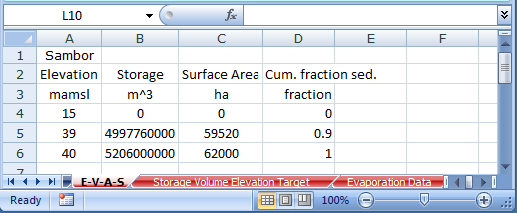

Figure 6‑7. Portion of "E-V-A-S" worksheet of input data file.

### 6.2.8. Storage Volume Elevation Target

“Storage Volume Elevation Target” worksheet is only required if the elevation target option is selected for any reservoir in the reservoir operations goal column in the "Reservoir Specifications" worksheet in the input data file. Otherwise, this worksheet will not be used by the model, and thus can be ignored (deleted, left blank, or kept in its current state). The sheet is only required to contain time series of the end-of-day water elevation (mamsl) for reservoirs for which the elevation target option is selected in the reservoir operations goal column in the "Reservoir Specifications" worksheet in the input data file. The time series of targets must contain a target value for the end of the day the simulation starts, but not for the end of the day on the date before the simulation begins. Each column should represent a time series of elevation target values for a particular reservoir, whereas each row represents the elevation target values for all reservoirs for a particular date. As with all other time series sheets, time series data should begin on the second column and second row, dates should begin on the first column and second row, and the reservoir name should be placed on the first row of every time series column (beginning with the second column). The reservoir name in each column must be identical to the reservoir's name as defined in the "Network connectivity" worksheet in the input file. Data for more than just those reservoirs for which elevation targets will apply can be stored in the worksheet, as can data for more dates than just those contained within the simulation horizon. The model will locate and import only the data necessary to conduct the simulation.

### 6.2.9. Storage Volume Target

This worksheet is only required if the storage target option is selected for any reservoir in the reservoir operations goal column in the "Reservoir Specifications" worksheet in the input data file. Otherwise, this worksheet will not be used by the model, and thus can be ignored (deleted, left blank, or kept in its current state). The sheet is required to contain time series of the end-of-day water storage targets (m3) for reservoirs for which the storage target options are selected in the reservoir operations goal column in the "Reservoir Specifications" worksheet in the input data file. The time series of targets must contain a value for the target for the end of the day the simulation starts, but not for the end of the day on the date before the simulation start date. Each column should represent a time series of storage target values for a particular reservoir, whereas each row represents the storage targets for all reservoirs for a particular date. As with all other time series sheets, time series data should begin on the second column and second row, dates should begin on the first column and second row, and the reservoir name should be placed on the first row of every time series column (beginning with the second column). The reservoir name in each column must be identical to the reservoir's name as defined in the "Network connectivity" worksheet in the input file. Data for more than just those reservoirs for which storage targets will apply can be stored in the worksheet, as can data for more dates than just those contained within the simulation horizon. The model will locate and import only the data necessary to conduct the simulation.

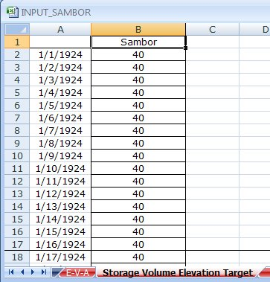

Figure 6‑8. Portion of the “Storage Volume Elevation Target worksheet of the input file.

### 6.2.10. Evaporation Data

This worksheet is only required to be created if the user wants to account for evaporation during simulation of reservoir operations. “Evaporation Data”worksheet stores average monthly evaporation data (mm) for each reservoir. Each row corresponds to a different reservoir in the modeled system for which data exist. The reservoir name stored in each row must be identical to the reservoir's name as defined in the "Network connectivity" worksheet in the input file. Each column in this worksheet corresponds to a different month for which the average monthly evaporation (mm) is required. If no evaporation data is available for a particular reservoir, a row for the reservoir is not required. Do not rearrange the locations of columns, as the model searches each column in order (1 through the 12), assuming they are in chronological order.

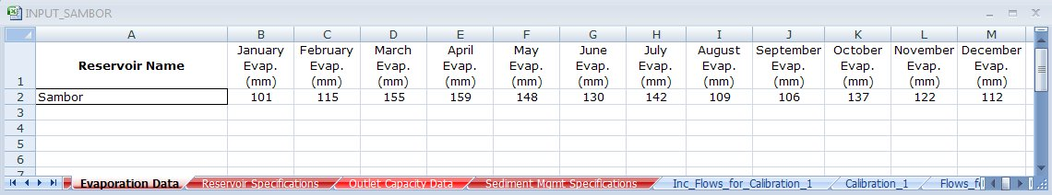

Figure 6‑9. “Evaporation data” worksheet of input file.

### 6.2.11. Environmental Flow Data

This worksheet is only required to be created if the user wants to require minimum environmental flow releases (m3/s) at any reservoirs during simulation. The “Environmental Flow Data”worksheet stores the minimum average daily flow (m3/s) that must be released into the downstream channel at each reservoir site. This requirement is assumed to take precedence over rule curve-based requirements. For example, if the reservoir's pre-established operating policy dictates that no water should be released in a particular time period, the model will override this goal to make a release downstream to attempt to satisfy the minimum environmental flow requirement. Each row corresponds to a different reservoir in the modeled system for which data exist. The reservoir name stored in each row must be identical to the reservoir's name as defined in the "Network connectivity" worksheet in the input file. Each column in this worksheet corresponds to a different month for which the flow data are to be specified. If no data are available for a particular reservoir, a row for the reservoir is not required. Do not rearrange the locations of columns, as the model searches each column in order (1 through the 12), assuming they are in chronological order.

### 6.2.12. Reservoir Specifications

“Reservoir Specifications”worksheet stores a significant quantity of data (aside from time series) required to simulate sediment and water flows in reservoirs. Each row corresponds to a different reservoir in the modeled system for which data exist. The reservoir name stored in each row must be identical to the reservoir name as defined in the "Network connectivity" worksheet in the input file. Each column in this worksheet corresponds to a different category of information for which the user should supply data for all reservoirs for which the data category is relevant. (Each of these categories is introduced in detail below). If a particular data column does not apply to a particular reservoir, no input is required in that column. Do not rearrange the locations of columns from the order in which they appear below, as the model searches in set columns for specific information.

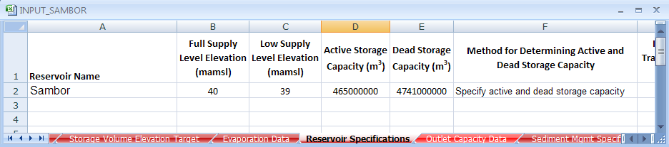

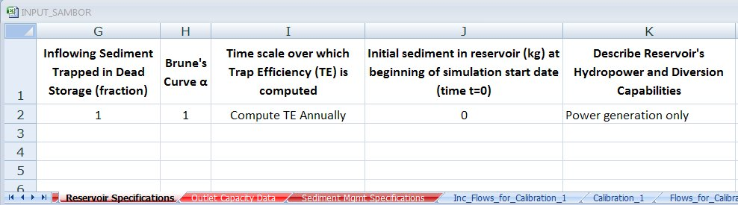

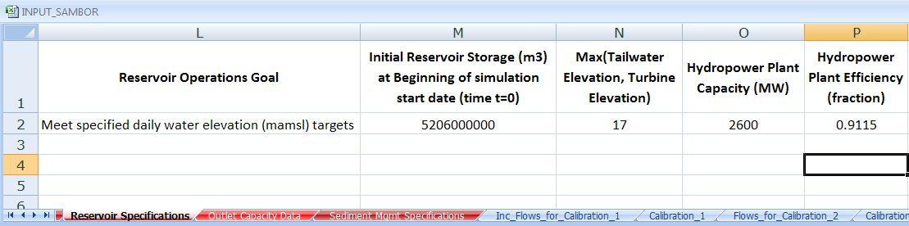

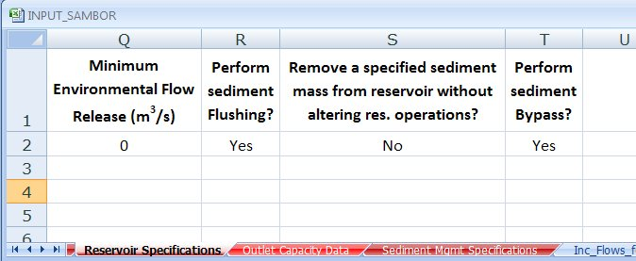

Figure 6‑10. Portions of "Reservoir Specifications" worksheet of input data file.

1. **Full supply level elevation (mamsl).** This information represents the upper elevation (mamsl) threshold of the active storage zone, and is used by the model to estimate each reservoir's dead and active storage capacity. If you know the dead and active storage capacity, skip this column and enter the capacity data in the two appropriate capacity columns (discussed below). The only reason the model attempts to determine dead and active storage capacity is to report in the model output separate estimates of the loss in storage capacity within each zone that results from sediment deposition. This elevation information is only required when the "Compute active and dead storage capacity using elevation-volume-area data and dead/active elevations" option is selected in the column (within the "Reservoir Specifications" worksheet) that represents the method for determining active and dead storage capacity (see below for a description of this column). If the user selects this option, indicating the low and full supply level elevations will be used to determine active and dead storage capacity, the model will import the specified upper and lower elevations and use them to interpolate over the Elevation-Volume-Area data (within the "E-V-A-S" worksheet) to determine the dead and active storage capacities. Note that the active storage zone is defined here as the zone of the reservoir within which water elevations are fluctuated for purposes of hydropower production, whereas the dead storage is defined as all storage that remains at an elevation below active storage zone (i.e., below the low supply level elevation).
2. **Low supply level elevation (mamsl).** This information represents the lower elevation (mamsl) threshold of the active storage zone, and is used by the model to estimate each reservoir's dead and active storage capacity. If you know the dead and active storage capacity, skip this column and enter the capacity data in the two appropriate capacity columns (discussed below). The only reason the model attempts to determine dead and active storage capacity is to report in the model output separate estimates of the loss in storage capacity within each zone that results from sediment deposition. This elevation information is only required when the "Compute active and dead storage capacity using elevation-volume-area data and dead/active elevations" option is selected in the column (within the "Reservoir Specifications" worksheet) that represents the method for determining active and dead storage capacity (see below for a description of this column). If the user selects this option, indicating the low and full supply level elevations will be used to determine active and dead storage capacity, the model will import the specified upper and lower elevations and use them to interpolate over the Elevation-Volume-Area data (within the "E-V-A-S" worksheet) to determine the dead and active storage capacities. Note that the active storage zone is defined here as the zone of the reservoir within which water elevations are fluctuated for purposes of hydropower production, whereas the dead storage is defined as all storage that remains at an elevation below active storage zone (i.e., below the low supply level elevation).
3. **Brune Curve Type (L=Low trapping; M=Median trapping; H=High trapping; number (fraction) = constant trapping).** Sediment trapping in reservoirs is given by Brune's curve (1953). Brune (1953) originally specified three curves, each fitted to different portions of his available data set. Type one of the following options into the cell for the reservoir of interest (type only the value appearing in quotation marks).
4. “L”. This represents the Brune (1953) original low trapping curve (for colloidal/dispersed and fine-grained particles).
5. “M”. This represents the Brune (1953) original median curve.
6. “H”. This represents the Brune (1953) upper (or high) trapping curve (for highly flocculated and coarse sediments).
7. “C”. This represents use of the Churchill (1948) Method, as described in Chapter 2.
8. Enter a numeric fraction from 0-1 to specify a constant trapping efficiency instead of using the Brune curve (e.g. enter “0.4” for a constant trapping efficiency of 40% throughout simulation at the reservoir).

Note: If the user specifies no value in this cell for a particular reservoir, the default is to assume zero trapping efficiency (0%).

1. **Time scale over which Trap Efficiency (TE) is computed (A=Annual; M=Monthly).** This value is only required if the user specifies “L”, “M”, or “H” in the Brune Curve Type Column of the “Reservoir Specifications” worksheet (i.e., if the user elects to use Brune curve trapping instead of specifying a constant trapping efficiency). Type one of the following options into the cell for the reservoir of interest (type only the value appearing in quotation marks).
2. “A”. *A* represents *Annual*. This indicates the model should apply the Brune (1953) curve using Annual residence time (computed using data from the previous 365 days).
3. “M”. *M* represents *Monthly*. This indicates the model should apply the Brune (1953) curve using Monthly residence time (computed using data from the previous 30 days).

To provide more detail on these two options, trapping in reservoirs in *PySedSim* is determined using Brune's curve (1953). Trap Efficiency depends on a reservoir's residence time. The first option computes the residence time based on the average reservoir storage (m3) and average outflow volume (m3) over the previous 30 days. The second option computes the residence time based on the average reservoir storage (m3) and average outflow volume (m3) over the previous 365 days.

Note: If the user specifies “L”, “M”, or “H” in the Brune Curve Type Column of the “Reservoir Specifications” worksheet but does not specify a value in the column described here, the default will be “A”, as described above. If the user elects to apply a constant trap efficiency in the in the Brune Curve Type Column of the “Reservoir Specifications” worksheet, no information from this worksheet will be used.

1. **Initial sediment in reservoir (kg) at beginning of simulation start date (time t=0).** This represents the amount of sediment (kg) available in storage (at the bottom of the reservoir rather than in suspension) in each reservoir at the beginning of the day on the simulation start date. (Sediment in suspension at the beginning of simulation in all reservoirs is assumed to be zero. Absence of sediment in suspension in reservoirs during the first simulation time period will briefly affect the quantity of sediment that settles in the reservoir, and that is discharged from the reservoir, in the first few days of simulation. For this reason, you may wish to run the simulation for a few extra days, or simply ignore the first few days of results.) This column represents sediment that is available to be released from the reservoir, and that exists in the active and/or dead storage zones. This option is designed to allow a simulation of a reservoir that has already experienced sedimentation. Hence, for a new reservoir, the value in this initial sediment availability column should be 0, as no sediment has accumulated in either zone by the start of simulation. Clearly, a new reservoir will have some sediment availability where the original river bed existed, but this model assumes none of this sediment is available to be released from the reservoir, and is therefore ignored. As with other initial (time zero) values, this is required because the model attempts to predict the end-of-period sediment mass on the simulation start date, so the user must supply the beginning of period mass for the simulation start date. This value is identical to the end-of-period mass in the date before the specified simulation start date.
2. **Describe Reservoir's Hydropower and Diversion Capabilities.** Select one of the following options from the drop-down menu:

i.) Power generation only

ii.) Diversion only

iii.) Power generation & diversion

If no drop-down menu is available, type one of the listed options into the cell exactly as it appears above. Leave the cell blank if the reservoir has neither power production nor diversion capabilities. As detailed in Chapter 2, the model simulates four different types of reservoirs. A reservoir can have (or not have) hydropower production capabilities, and can have (or not have) the capability to divert water away from the downstream channel and instead to another site within the modeled system. In this column, the user specifies which of the reservoir types described in Chapter 2 is applicable to the reservoir of interest. This column is designed for users to specify only whether the reservoir of interest has a hydropower and/or diversion capability.

1. **Reservoir operations goal.** Select one of the following options from the drop-down menu:

i.) Meet specified daily water elevation (mamsl) targets.

ii.) Meet specified daily water storage targets (m3).

If no drop-down menu is available, type one of the listed options into the cell exactly as it appears above. This column allows the user to specify the operational goal of each reservoir. If sediment accumulation in the reservoir is negligible in comparison to the storage capacity, then this option will result in essentially the same policy one would establish using storage targets, because an elevation corresponding to every water storage value can be determined from the user-supplied Elevation-Volume data. However, if sediment accumulation in the reservoir is significant, the water elevation targets option allows specified elevations to be maintained in the reservoir over time, which may require that less water be maintained in storage as the simulation proceeds due to sediment accumulation in the reservoir's storage space.

1. **Initial reservoir storage volume (m3) at beginning of simulation start date (time t=0).** This information is required because the model predicts end-of-period storage volume values for every reservoir. To predict the end-of-period storage volume for the simulation start date, the user must supply the beginning of period storage volume for the simulation start date. This value is identical to the end-of-period storage volume on the date before the specified simulation start date.

If the user specifies no value, the model default assumption is that the reservoir’s initial water storage value is equal to the dead storage capacity (i.e., the water surface elevation is at the bottom of the active storage elevation and top of the dead storage elevation).

1. **Maximum of turbines' centerline elevation and reservoir's tailwater elevation (mamsl).** In this column, specify the maximum of the constant tailwater elevation (the elevation of the water in the channel immediately downstream of the reservoir) and the turbines' centerline elevation. The larger of these two values will serve as the lower elevation used to compute hydropower head (and therefore hydropower production) during each time period, as given in Chapter 2. The value specified in this cell is assumed to remain constant throughout simulation. The hydropower head during the time period is assumed to be the average difference between the reservoir's water elevation and the constant tailwater elevation at the beginning and end of each time period. These data are only required if the user has selected that the reservoir has hydropower capabilities.
2. **Hydropower plant capacity (MW).** In this column, specify the hydropower plant capacity (MW) for each reservoir. This value should represent the sum of the rated (nameplate) capacities of all installed generators. No combination of turbine flow, net head, and efficiency will be permitted to produce an amount of hydropower exceeding this plant capacity value. This information is only required if the user has selected that the reservoir has hydropower capabilities.
3. **Hydropower plant efficiency (fraction).** In this column, specify the hydropower plant efficiency. This value is assumed to remain constant throughout simulation (not assumed to be a function of head and discharge). This information is only required if the user has selected that the reservoir has hydropower capabilities. The value in this column will be used to compute hydropower production during each time period.
4. **Reservoir Length (m).** This is the reservoir length at the normal reservoir operating level. This input is used to simulate sluicing and density current venting. For sluicing, it is used to compute the Sedimentation Index (SI), which is used in *PySedSim* to implement the Churchill Method (1948) to compute reservoir trap efficiency during sluicing. For density current venting, this input is optional, as it is used to determine a default minimum venting efficiency value for the user if the user does not specify one.
5. **Perform sediment Flushing?** Select one of the following options from the drop-down menu:

i.) Yes

ii.) No

If no drop-down menu is available, type one of the listed options into the cell exactly as it appears above. In this column, specify whether or not sediment flushing should be attempted in the reservoir of interest. (Note that more detailed background information about flushing, and the approach to flushing taken by this model, is contained in Chapter 2). If you select "Yes", you must supply additional flushing information in (1) the "Flushing" worksheet, and (2) the "Outlet Capacity Data" worksheet. See descriptions of these two worksheets for more details. Also, sediment flushing can only be performed if the user chooses to perform the hydrologic simulation using the *PySedSim* model.

1. **Remove a specified sediment mass from reservoir without altering reservoir operations?** Select one of the following options from the drop-down menu:

i.) Yes

ii.) No

In this column, specify whether or not general sediment mass removal should be simulated at this reservoir, via a technique that does not require reservoir operational changes (e.g., dredging). If no drop-down menu is available, enter either “Yes” or “No” into the cell for each reservoir. Any entry other than “Yes” (e.g., a blank cell) will result in no mass removal. (Note that more detailed background information about this technique, which results in net sediment removal from a reservoir without altering the reservoir's operations, is provided in Chapter 2). If you select "Yes", you must supply additional information in the "General Sediment Removal" worksheet.

1. **Perform Sediment Bypass?** Select one of the following options from the drop-down menu:

i.) Yes

ii.) No

In this column, specify whether or not sediment bypassing should be simulated at this reservoir. If no drop-down menu is available, enter either “Yes” or “No” into the cell for each reservoir. Any entry other than “Yes” (e.g., a blank cell) will result in no sediment bypassing. (Note that more detailed background information about sediment bypassing is provided in Chapter 2). If you select "Yes", you must supply additional information in the "Bypassing" worksheet.

1. **Perform Density Current Venting?** Select one of the following options from the drop-down menu:

i.) Yes

ii.) No

In this column, specify whether or not density current venting should be simulated at this reservoir. If no drop-down menu is available, enter either “Yes” or “No” into the cell for each reservoir. Any entry other than “Yes” (e.g., a blank cell) will result in no density current venting. (Note that more detailed background information about density current venting is provided in Chapter 2). If you select "Yes", you must supply additional information in (1) the "Density Current Venting" worksheet, and (2) the "Outlet Capacity Data" worksheet.

1. **Perform Sluicing?** Select one of the following options from the drop-down menu:

i.) Yes

ii.) No

In this column, specify whether or not sluicing should be simulated at this reservoir. If no drop-down menu is available, enter either “Yes” or “No” into the cell for each reservoir. Any entry other than “Yes” (e.g., a blank cell) will result in no sluicing. (Note that more detailed background information about density current venting is provided in Chapter 2). If you select "Yes", you must supply additional information in (1) the "Sluicing" worksheet, and (2) the "Outlet Capacity Data" worksheet.

### 6.2.13. Outlet Capacity Data

**“**Outlet Capacity Data**”** worksheet provides elevation vs. discharge capacity tables for every outlet that will be operated on each reservoir. This worksheet is only required if the user chooses to perform a hydrologic simulation using the *PySedSim* Model. For every outlet at every reservoir, the user must supply two columns of data (elevation and discharge, from left to right). The number of outlets for which data must be provided for a particular reservoir will depend on the number of outlets the reservoir has, which is strictly dictated by the reservoir type (as selected in the "Reservoir Specifications" worksheet). More detailed discussion of outlets is provided in Chapter 2. Specifically, Figure 3.9 describes the number and types of outlets required for each reservoir type. For example, if a model is being built for ten reservoirs, and every reservoir has the same basic capability (hydropower production), then only two outlet types are required per reservoir (Hydropower Outlet and Overflow Outlet). For these ten reservoirs, a total of 10*2 = 20 pairs (40 columns) of elevation vs. max. discharge data must be supplied by the user. If flushing were to be performed in each of the ten reservoirs, an additional 10 outlets would be required for a total of 80 columns. The most outlets required for a reservoir occurs in the case of a diversion dam. For example, if the ten reservoirs were instead hydropower/diversion reservoirs with flushing capabilities, a total of 10*4 = 40 outlets would be required.

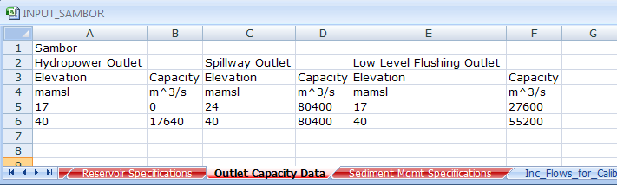

Figure 6‑11. “Outlet Capacity Data” worksheet.

Every time outlets for a particular reservoir are defined, the name of the reservoir for which the outlet capacity vs. elevation data are provided must be listed in the first row of the first of all the elevation-discharge columns defined for a particular reservoir. (The reservoir name at the top of each column must be identical to the reservoir's name as defined in the "Network connectivity" worksheet in the input file). For example, if a particular reservoir has four outlets, then a total of 8 consecutive columns should be defined for the reservoir, with the name of the reservoir appearing only once at the very top of the first of the 8 columns.

Every time a new outlet for a reservoir is defined, the user should select the outlet type from a drop-down menu in the second row in the column in which the elevation data are provided (the left-hand column in each pair of two elevation-discharge columns). If no drop-down menu is available, type one of the listed options into the cell exactly as it appears below. For example, if a particular reservoir has four outlets, then an outlet type should be selected four times, each in the second row of the elevation data column. The drop-down menu offers the following six options:

1. Controlled Outlet
2. Hydropower Outlet
3. Diversion Outlet
4. Hydropower/Diversion Outlet
5. Spillway Outlet
6. Low level Outlet

Data in each column should not begin until the fifth row. This is only to allow space for the user to list data type headings (e.g., "Flow") and data units ("cms"), if desired (this is not a requirement).

Data for more than just those reservoirs that will be modeled in the current simulation can be stored in the worksheet. The model will use only the data for those reservoirs that will be modeled. This saves time in the input file preparation process in instances in which one wishes to run simulations that explore different of reservoir development.

### 6.2.14. Sediment Management Specifications Worksheets

The input file can contain up to five different sediment management worksheets:

1. Flushing
2. Sluicing
3. Density Current Venting
4. General Sediment Removal
5. Bypassing

The “Flushing”, “Sluicing”, and “General Sediment Removal” worksheets have similar formatting requirements. Likewise, the “Density Current Venting” and “Bypassing” worksheets have similar formatting requirements. Thus, common formatting requirements are presented here before each of the worksheets is presented, to avoid repeating this information in the sections for each individual worksheet.

Note that multiple sediment management techniques can be simulated in the same reservoir at different times. However, flushing, sluicing and density current venting cannot be simulated concurrently. Any management technique being simulated will be allowed to finish before a new technique is begun. For example, if sluicing is being simulated at a particular reservoir and flushing is meanwhile scheduled to occur, the start of flushing will be delayed until sluicing is completed.

#### 6.2.14.1. Comments on “Flushing”, “Sluicing”, and “General Sediment Removal” worksheets

Each worksheet is only required if the user will implement the corresponding sediment management technique in any reservoir (e.g., if you specify "Yes" in the Flushing column of the “Reservoir Specifications” worksheet, then you need a “Flushing” worksheet to store additional information). For every in which a sediment management technique is to be applied to a reservoir, a new block of 12 (for “Flushing”), 8 (for “Sluicing”), and 5 (for “General Sediment Removal”) columns of information must be supplied by the user. For example, if a model is being built for ten reservoirs, and both Flushing and General Sediment Removal are to be conducted at some time during simulation at every one of the ten reservoirs, then a total of 10*12 + 10*5 = 170 columns of information must be supplied by the user.

Within each worksheet, the name of the reservoir for which the technique and data apply must be listed in the first row and in the first of the set of columns (e.g., in the “Sluicing” worksheet, the reservoir name should appear in (row 1, column 1) for the data set of the first reservoir in which sluicing will occur, in (row 1, column 9) for the data set for the second reservoir in which sluicing will occur, etc. The reservoir name should only be listed once in each worksheet for each reservoir in which the corresponding sediment management technique will be simulated.

The reservoir name at the top of each column must be identical to the reservoir's name as defined in the "Network connectivity" worksheet in the input file. Data for more than just those reservoirs for which you have selected to implement a sediment management technique can be stored in the worksheet, as the actual implementation of the technique is controlled by the preferences selected in the "Reservoir Specifications" worksheet. The model will use only the data for those reservoirs at which sediment management techniques will actually be implemented.

Each row in these three worksheets, starting with the third row, represents a different event date. The events should appear in chronological order. For example, if sluicing will be simulated twice at one reservoir during the simulation horizon, from 9/1/1980 to 9/15/1980, as well as from 8/3/1985-8/8/1985, data corresponding to each of these separate events should appear in separate, consecutive rows. If some of the required user input data will remain the same every time the technique is simulated (e.g., the flushing duration, flushing minimum discharge, etc.), then the user is only required to enter this information in the first row (corresponding to the first event). *PySedSim* will import information from the first row when the user does not specify information for future events. If particular specifications are different for different events (e.g., the target sluicing water surface elevation), then the user can also just specify new information in each row. For example, if ten sluicing events are scheduled in ten different rows in column 1, then the user can specify ten different sets of input data in the input data columns.

#### 6.2.14.2. Comments on “Density Current Venting” and “Bypassing” worksheets

In these two worksheets, each row corresponds to a different reservoir in the modeled system for which data exist. The reservoir name stored in the first column of each row must be identical to the reservoir name as defined in the "Network connectivity" worksheet in the input file. Each column in this worksheet corresponds to a different category of information for which the user should supply data for all reservoirs for which the data category is relevant. (Each of these categories is introduced in detail below). If a particular data column does not apply to a particular reservoir, no input is required in that column. The Data entry should begin on the second row and second column. Do not rearrange the order of columns from how they appear in each section below, as the model searches in set columns for specific information.

### 6.2.15. Flushing

The following information must be supplied by the user for every reservoir at which flushing will be simulated. Some user inputs are described below as *Optional*, meaning these inputs are extra features that are not required to run a simulation. The columns should be specified in exactly the order (left to right) in which they are listed below.

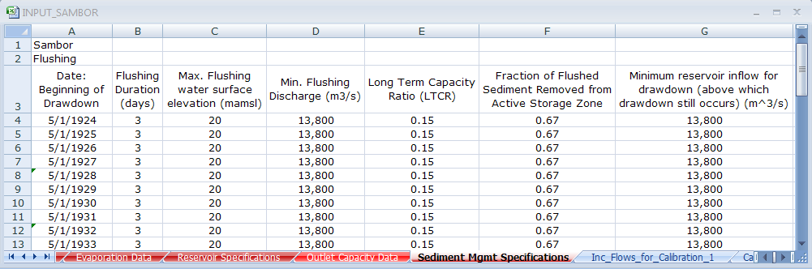

Figure 6‑12. “Flushing” worksheet of input file.

1. **Target Date: Beginning of Drawdown.** In this column, enter the calendar date(s) defining when reservoir drawdown for flushing can begin (if the inflow rate criterion defined below is satisfied) and the number of days of flushing. Every time flushing (and therefore drawdown) are to occur, a new date should be listed in a new row in the column for this reservoir.
2. **Flushing Duration.** This is the number of days during which flushing criteria (flow and elevation requirements discussed below) must be satisfied, and does not include any days that only serve to draw down (empty) the reservoir.
3. **The maximum flushing water surface elevation (WSE).** This is the maximum elevation of water in the reservoir that will still result in successful flushing. (For example, if the original river bed elevation, and/or low-level outlet invert elevation, is 56 masl, then 56 masl will be the target drawdown elevation. However, flushing can still be successful if the reservoir is not able to fully draw down to 56 masl. If, for example, successful flushing will still occur if the reservoir is drawn down to 58 masl (2 m above the target) because free flow conditions are relatively well maintained, then the user would input 58 masl into this column for the flushing date(s) of interest.
4. **Minimum inflow rate at which drawdown is initiated.** *Optional*. The minimum inflow rate that will permit the drawdown process to be initiated on or after the target date specified in the date column. The user must specify the date on which drawdown should first be considered. The model waits until this specified date to consider drawdown, but does not actually initiate drawdown until the reservoir inflow exceeds the value specified in this cell. This will prevent a drawdown that begins too early in the dry season, before flows at the beginning of the wet season begin to increase. If the user does not enter a value in this column, the model will assume that no such threshold exists for the initiation of drawdown.
5. **Flushing channel bottom width (m)***.* This is the width of the bottom of the channel that will form during flushing. Assuming the channel will form a trapezoidal cross-section over time, this width represents the (smaller) bottom width of the trapezoid. This value is used to determine the dimensions of the flushing channel, which is used to determine the quantity of sediment removed during flushing as the flushing channel grows over time. The channel width can be approximated fairly well as a function of flushing discharge, though it also likely depends on channel slope and sediment properties. In absence of field measurements or other data, Atkinson (1996) suggests estimating this property using the equation given below.

If the user does not specify any channel width, the model will use this relationship below to determine channel width as a function of the user-specified minimum flushing flow value (the reservoir inflow (m3/s) below which flushing is assumed not to be successful on a flushing day).

*Wf* = 12.8*Qf*0.5

where *Wf*is the width (m) of the channel formed during flushing and *Qf* is the flushing discharge (m3/s).

This value cannot be different for each flushing date, so the value is imported from the first row of flushing data.

1. **Flushing channel average side slope (m/m, 1 horizontal to SSf vertical).** This is the slope of the side walls of the incised channel formed during flushing. This value is used to determine the dimensions of the flushing channel, which is used to determine the quantity of sediment removed during flushing as the flushing channel grows over time. Flushing channel side slopes can vary widely, and depend upon the degree of sediment consolidation, sediment properties, the depth of the deposits through which the incised channel is cut, and the extent of water level fluctuation during flushing. In the absence of field measurements or other data, Atkinson (1996) suggests using the formulation proposed by Migniot (1981), as given below. If the user does not specify any side slope, the model will use this relationship to determine side slope as a function of the user-specified sediment density.

Side slope

where *ρd* is the average dry density (t/m3) of the sediment through which the flushing channel will be cut.

This value cannot be different for each flushing date, so the value is imported from the first row of flushing data.

1. **Maximum flushing drawdown rate (m/day)***.**Optional*. This is the maximum rate at which the water level of the reservoir can be drawn down per day during the drawdown phase of sediment flushing. Rapid drawdown of a reservoir can lead to bank failure, landslides, or similar events, in which large quantities of soil fall into the reservoir storage space. In the absence of better information, the user may wish to restrict the drawdown rate to within the range of 1-3 m/day.
2. **Minimum flushing discharge***.* In this column, enter the minimum discharge through the low-level outlets that will still result in successful flushing. No removal of sediment from the reservoir's settled sediment storage will occur if this minimum flow rate criterion is not satisfied, which will extend the number of total days the reservoir spends trying to meet the flushing duration goal.
3. **Reservoir bottom width (m).**This is the representative bottom width of the reservoir. This value is used in *PySedSim* to determine the relative volume of the reservoir, which, when compared to the volume of the channel formed during flushing, aids in determining the quantity of sediment released during a flushing event. It is suggested to use the widest section of the reservoir bottom close to the base of the dam, as a wider value will produce a more conservative flushing result (a wider reservoir results in lower quantities of sediment removed during flushing events).

This value cannot be different for each flushing date, so the value is imported from the first row of flushing data.

1. **Reservoir average side slope (m/m, 1 horizontal to SSres vertical).** This is the representative bank side slope of the reservoir. This value is used in *PySedSim* to determine the relative volume of the reservoir, which, when compared to the volume of the channel formed during flushing, aids in determining the quantity of sediment released during a flushing event.

This value cannot be different for each flushing date, so the value is imported from the first row of flushing data.

1. **Coefficient value, k, for sediment load generation during Flushing (kQm).** *Optional*. Instead of computing the sediment loads discharged during flushing via the methods described in the Flushing section of Chapter 2, the user can instead specify parameters to be used in the equation *kQm* to determine sediment discharge from the reservoir each day during flushing as a function of reservoir outflow). Sediment discharge during a flushing day (kg) is determined by *kQm*Q(dt)*, where *Q* (m3/s) is the reservoir inflow and *dt* is the daily time step in seconds. Entering information in this column will dictate the use of this method for sediment flushing discharge, whereas leaving this column blank will dictate the use of the long term capacity ratio for the flushing simulation.
2. **Exponent value, m, for sediment load generation during Flushing (kQm).** *Optional*. Instead of computing the sediment loads discharged during flushing via the methods described in the Flushing section of Chapter 2, the user can instead specify parameters to be used in the equation *kQm* to determine sediment discharge from the reservoir each day during flushing as a function of reservoir outflow). Sediment discharge during a flushing day (kg) is determined by *kQmQ*(dt)*, where *Q* (m3/s) is the reservoir inflow and *dt* is the daily time step in seconds. Entering information in this column will dictate the use of this method for sediment flushing discharge, whereas leaving this column blank will dictate the use of the long term capacity ratio for the flushing simulation.

### 6.2.16. Sluicing

The following information must be supplied by the user for every reservoir at which sluicing will be simulated. Some user inputs are described below as *Optional*, meaning these inputs are extra features that are not required to run a simulation. The columns should be specified in exactly the order (left to right) in which they are listed below.

**Some comments on default sluicing assumptions.** Before describing the user inputs specifically, some comments are important regarding default assumptions. Except for the sluicing start and stop dates each year, the user is only required to specify assumptions for the categories above in the row corresponding to the first sluicing event. As long as preferences (e.g., target drawdown elevation) are established for the first sluicing event, the model will continue to use these values if the user neglects to specify preferences for future sluicing dates. For categories including the sluicing inflow-based starting criteria, drawdown rate, and refill rate, the model assumes the constraints do not exist if values of zero are specified for the first sluicing event (or if cells are left blank). For the sluicing drawdown elevation, if no value is specified the default is Elevation 0 masl. For power production during sluicing, if no value is stored in the first row, then the model assumes a default that no power is produced during sluicing.

1. **Beginning date of sluicing.** This is the first date on which drawdown for sluicing will begin. Application of the Churchill curve to determine sediment trapping begins on this date. If sluicing is to occur annually, the user must specify this date for every year in which sluicing will occur. Sluicing is typically performed for an extended period of time when water and sediment inflows are high (e.g., the monsoon season). To prevent the majority of inflowing sediment from depositing in the reservoir, sluicing should be performed for as long as possible during the season in which sediment production is highest.

Note: specifying no sluicing start date or duration will result in sluicing that can occur on any given day (with no set start date or duration). In this case sluicing will be triggered by the minimum reservoir inflow rate as specified below.

1. **Sluicing starting criterion: minimum reservoir inflow rate (m3/s).** *Optional.*This input is optional. If the reservoir inflow is lower than this value on the sluicing beginning date, the start of sluicing will be delayed by one day, and the condition will be checked again on the next day. The purpose of this option is to allow the user to avoid initiation of drawdown for sluicing during conditions that are not typical of high sediment inflows. For example, if the monsoon season begins in October on average, the user might specify 10/1 as the sluicing date every year. However, in a given year the monsoon might actually begin in November. This optional input is thus an extra check that could hold sluicing off until the high inflows actually begin in a given year. If sluicing is delayed, the original sluicing duration will be maintained (as defined by the number of days between the user-specified beginning and ending dates).
2. **Sluicing Duration.** Sluicing will last for this many days.

Note: specifying no sluicing start date or duration will result in sluicing that can occur on any given day (with no set start date or duration). In this case sluicing will be triggered by the minimum reservoir inflow rate as specified below.

1. **Sluicing stopping criterion: minimum reservoir inflow (m3/s).** *Optional.*This input is optional. If the reservoir inflow is higher than this value on the sluicing end date, the end of sluicing will be delayed by one day, and the condition will be checked again on the next day. The purpose of this option is to allow the user to avoid ending sluicing if reservoir inflows are high for longer than expected, in which case extending the duration of sluicing could be beneficial from a sediment management perspective.
2. **Target sluicing drawdown water surface elevation (mamsl) or storage (m3).** This is the reservoir water surface elevation or storage to which the reservoir will be drawn down to begin the sluicing process. The extent to which the reservoir is drawn down affects the energy slope and ultimately the percentage of sediment that will pass through the reservoir during sluicing. In the absence of better information, the target elevation could be set to an elevation at or slightly above the mid-level gates.
3. **Maximum sluicing drawdown rate (m/d).** *Optional*. This is the maximum rate at which the water level of the reservoir can be drawn down per day during the drawdown phase of sediment sluicing. Rapid drawdown (and/or refill) of a reservoir can lead to bank failure, landslides, or similar events, in which large quantities of soil fall into the reservoir storage space. In the absence of better information, the user may wish to restrict the drawdown rate to within the range of 1-3 m/day.
4. **Maximum sluicing refill rate (m/d).** *Optional*. This is the maximum rate at which the water level of the reservoir can be refilled per day upon the completion of sluicing. In the absence of better information, the user may wish to restrict the refill rate to 4 m/day or less.
5. **Does hydropower production occur during sluicing**? Valid responses are either "Yes" or "No". If sluiced sediment is of high concentration for a long duration, and/or contains significant quartz content, hydropower-related infrastructure (e.g., turbines) can be damaged due to abrasion if power is produced during sluicing operations.

### 6.2.17. Density Current Venting

The following information must be supplied by the user for every reservoir at which density current (or turbidity current) venting will be simulated. Some user inputs are described below as *Optional*, meaning these inputs are extra features that are not required to run a simulation. The columns should be specified in exactly the order (left to right) in which they are listed below.

1. **Minimum venting efficiency (%).** This represents the lowest acceptable percentage of sediment removal that must occur for density current venting to be an attractive option (e.g., 35%). In determining this value, the user should weigh the relative importance of releasing sediment compared to the water that will be wasted during venting without power production.

If the user does not specify a minimum venting efficiency, Figure 14.13 from Morris and Fan (1998) is used to establish a default value based on the reservoir length (km), using the following equation:

Min. Efficiency = 0.5384 - 0.08*ln(Reservoir Length)

1. **Minimum reservoir water surface elevation (mamsl) during density current venting.** *Optional***.** Density current venting will not be allowed to reduce the water surface elevation below this specified elevation. The user should leave this cell blank if no minimum level exists, in which case venting will proceed until completed. Note that if the reservoir’s water surface elevation approaches this minimum elevation, there exists the possibility that flow releases through the low-level outlets for venting may be significantly reduced (< *Qin(t)*) or even entirely eliminated, because any releases in this circumstance are first allocated to satisfying minimum hydropower production requirements.
2. **Maximum concentration (mg/l) of sediment released from reservoir during density current venting**. *Optional*. This input is optional. If the sediment mass released during density current venting divided by water volume released from the hydropower and low level outlets during venting cannot achieve this target 'concentration' (total mass/total volume), extra water will be released from the hydropower outlets (up to their capacity), and if this still does not achieve the target concentration, more water will be released from the mid-level outlets to attempt to achieve the target level. *PySedSim* will not reduce the release of the density current flow from the low-level outlets in order to satisfy this target concentration, as such a practice could theoretically reduce the effectiveness of the density current release.
3. **Continue venting if max concentration exceeded?** If the user specifies a maximum concentration (mg/l) of sediment released from the reservoir during density current venting, the reservoir will attempt to meet this target by releasing additional clear water through available outlets, if necessary. The option described here allows the user two options: (1) to continue density current venting despite the inability of the reservoir to satisfactorily dilute the sediment released during the venting process (enable this option by entering “Yes”), and (2) to end density current venting due to the inability of the reservoir to satisfactorily dilute the sediment released during the venting process (enable this option by entering “No”).
4. **Reservoir bottom width (m).** This input is used in Eq. (2.11) as part of the *PySedSim* procedure to determine venting efficiency during density current venting events.
5. **Reservoir bed slope (m/m).** This input is used in Eq. (2.11) as part of the *PySedSim* procedure to determine venting efficiency during density current venting events.
6. **Minimum daily power requirement during density current venting (MW).** *Optional*. During density current venting, water will be released through available hydropower outlets to satisfy this minimum power production requirement, subject to hydropower outlet capacity-elevation constraints. While the *PySedSim* approach to density current venting is to attempt to release the reservoir’s inflow (minus evaporation) through the low-level outlets, thus maintaining the water surface elevation, any additional releases to satisfy this minimum power requirement will result in a more significant reduction in the water surface elevation of the reservoir. If the user also specifies a minimum water surface elevation during density current venting and the reservoir reaches this minimum elevation, priority is first given to satisfying the minimum hydropower production requirements, after which remaining releases are allocated to the low-level outlets for venting flow release.

### 6.2.18. General Sediment Removal

The following information must be supplied by the user for every reservoir at which the user wishes to remove a specified sediment mass during a specified period of time without explicitly simulating the process. Some user inputs are described below as *Optional*, meaning these inputs are extra features that are not required to run a simulation. The columns should be specified in exactly the order (left to right) in which they are listed below.

1. **Removal start date.** This is the calendar date on which to begin removing sediment mass.
2. **Removal duration (days).** Specify number of days over which the specified sediment mass should be removed during each event. The sediment mass to be removed will be equally distributed among this number of days.
3. **Sediment mass removal (tons).** Specify the sediment mass to be removed during each event. This mass will be equally distributed over the removal duration.
4. **Destination element name.** Specify the user-defined (in the "Network connectivity" worksheet) name of the element into which the removed sediment mass will be deposited. If the user leaves this cell blank, the model's default assumption is to discharge this sediment out of the modeled system (the modeled system permanently loses this mass).
5. **Fraction of sediment removed from active storage zone.** Specify the fraction of sediment that is removed from the active storage zone when the sediment is removed from the reservoir during each event. The remaining fraction of sediment is assumed to be removed from the dead storage zone. If no value is entered, the model maintains the following default percentages: 50% of removed sediment is removed from the active storage zone, while the remaining 50% is removed from the dead storage zone.

### 6.2.19. Bypassing

The following three columns of information must be supplied to perform a sediment bypass around a reservoir. The columns should be specified in exactly the order (left to right) in which they are listed below.

1. **Flow rate above which bypass is activated during wet season (m3/s).** Specify the minimum reservoir inflow rate at which the sediment bypass is opened during the wet season and sediment and flow begins to be discharged around the reservoir. If the inflow rate is lower than this value, the sediment and water will enter the reservoir without being bypassed (except for any minimum required bypass flow rate as specified below).
2. **Bypass discharge capacity (m3/s).**Specify the flow capacity of the sediment bypass. If the reservoir inflow rate exceeds this value, any inflow in excess of the bypass discharge capacity will enter the reservoir. However, only a fraction of the sediment concentration in this flow will enter the reservoir, whereas the remaining fraction of sediment will be distributed into the bypass. This fraction must be specified by the user, as described below.
3. **Fraction of sediment load in reservoir inflow.**The model's default assumption is that sediment is partitioned between the bypass and reservoir in proportion to the fractions of total inflow that are distributed into the bypass and reservoir. The user should thus enter nothing in this column if this is the desired assumption. Alternatively, the user can specify what fraction of the sediment that would otherwise have entered the reservoir (based on the proportion of total inflow that enters the reservoir) should instead be distributed into the bypass. This option was implemented to reflect that concentration increases with depth of flow, and thus the bypass may remove more of the inflowing sediment than just the proportion of flow diverted into the bypass.
4. **Minimum required bypass flow (m3/s).** This is the minimum flow that is required to be maintained in the bypass channel(s) at all times (when possible).
5. **Minimum required bypass flow (fraction).** Similar to the minimum bypass required flow, except this value represents the fraction of the total daily site water inflow required to be diverted into the bypass channel at all times.

### 6.2.20. IncFlowsCalibration1

The *PySedSim* model will automatically create this worksheet if it is needed. This worksheet is only required if (1) the user chooses to perform internal calibration of incremental sediment load coefficients (i.e., selects the "Calibrate a coefficient for each incremental inflow location" option in the preferences in the main .xlsm model file); or (2) the user chooses to use coefficients that were previously calibrated within this worksheet (i.e., selects the "Use coefficients calibrated in most recent simulation." option in the preferences in the main .xlsm model file). Once the worksheet is created, do not modify the contents of this worksheet. The worksheet contains time series of the daily average incremental flow rates (m3/s) that enter every reach or reservoir location in the modeled system.

### 6.2.21. Calibration1

The *PySedSim* model will automatically create this worksheet if it is needed. This worksheet is only required if (1) the user chooses to perform internal calibration of incremental sediment load coefficients (i.e., selects the "Calibrate a coefficient for each incremental inflow location" option in the preferences in the main .xlsm model file); or (2) the user chooses to use coefficients that were previously calibrated within this worksheet (i.e., selects the "Use coefficients calibrated in most recent simulation." option in the preferences in the main .xlsm model file). Once the worksheet is created, do not modify the contents of this worksheet. The worksheet contains time series of the daily average incremental sediment loads that enter every reach or reservoir location in the modeled system (in kg/day). The incremental flows, Q(t), in the "IncFlowsCalibration 1" worksheet are used as input to the incremental load generation function, *cQ(t)d*Q(t)*Δt*, to generate daily incremental sediment loads at the location represented by each column. This worksheet is used as a calibration worksheet, because the value of *c* in the sediment generation function is contained in a cell at the bottom of the time series that is manipulated by Excel's LP solver until the average annual sediment load matches the desired value. The desired value should be provided in the "Sediment Loads" worksheet.

### 6.2.22. FlowsCalibration2

The *PySedSim* model will automatically create this worksheet if it is needed. This worksheet is only required if the user chooses either of the following two options in the preferences in the main “PySedSim.xlsm” file: (1) Calibrate a coefficient for each reach; or (2) Use coefficients calibrated in most recent simulation. Once the worksheet is created, do not modify the contents of this worksheet. The worksheet contains the time series of the daily average flow rates out of each reach (m3/s) in the unregulated system. Thus, these flows simply represent the sum of all incremental flows that enter points upstream of the location of interest.

### 6.2.23. Calibration2

The *PySedSim* model will automatically create this worksheet if it is needed. This worksheet is only required if the user chooses either of the following two options in the preferences in the main “PySedSim.xlsm” file: (1) Calibrate a coefficient for each reach; or (2) Use coefficients calibrated in most recent simulation. The worksheet contains time series of the daily average sediment loads that flow out of every reach or reservoir location in the modeled system (in kg/day). The outflows, Q(t), in the "FlowsCalibration2" worksheet are used as input to the sediment load generation function, *aQ(t)b*Q(t)*Δt*, to generate daily sediment loads flowing out of each location represented by each column. This worksheet is used as a calibration worksheet, because the value of *a* in the sediment generation function is contained in a cell at the bottom of the time series that is manipulated by Excel's LP solver until the average annual sediment load matches the desired value. The desired value is determined internally in the model by summing the values of the incremental sediment loads that are generated at all points upstream of the outflow point of interest.

# Runtime File Description

Users have the option of producing runtime output during the execution of a simulation. This will print information to a text file as a simulation runs. Each row represents a new piece of information. This information includes the current time step, which system elements (e.g., reservoirs) are being simulated, which model sub-routines are being entered, and a confirmation of a completed simulation. This file will not contain error messages. PySedSim-generated error messages are instead printed to the screen for users to view directly.

The default is for no runtime file to be created. This is because printing to the runtime file takes time and the file can become large. If you want a runtime file to be produced, specify a desired name/location within the PySedSim.xlsm file (cell B6) as shown in **Error! Reference source not found.**. You can either specify the name of the file, in which case it will be saved in the same directory in which you are running PySedSim.xmlsm, or you can specify a full file path to any directory on your computer. Your runtime file must be a text file, so always end your file name or path with a “.txt”.

An example of runtime file output is shown below:

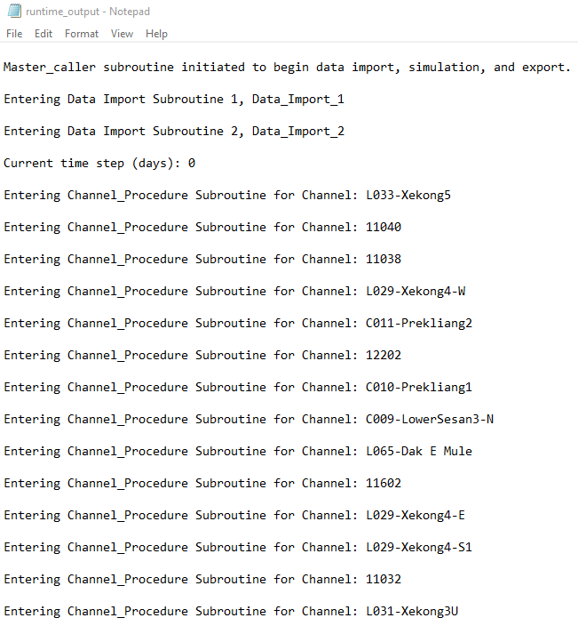

Figure 7‑1. An example of runtime output.

# Output File(s) Description

## 8.1. Overview of Model Output Workbook

Output file(s) are automatically created during the simulation and saved (using the user-specified file location and name in the “PySedSim.xlsm” file). As discussed in Chapter 5 (the “PySedSim.xlsm” file preferences), users have the option of creating up to two output files, or none at all. Currently, the two output files users can create are (1) a time series output for a variety of variables for all locations in the system to which the variables are applicable, and (2) a statistical summary of the time series output for a variety of variable values at all locations where they apply.

In the time series output file, each worksheet within the workbook corresponds to a different variable. Each column of time series data corresponds to a different location, which is listed at the top of each time series column. The number of variables (and system elements) included in the two output files depends on whether the system being simulated is Regulated or Unregulated. Fewer variables and locations are applicable in an unregulated simulation, as no reservoirs are present. In the statistical output file, in general, each worksheet contains output that corresponds to a unique combination of model variables and set of statistics taken over a particular time period. One worksheet will contain the mean, standard deviation, median, maximum and minimum of the values of a variable for each month at all system locations, whereas another worksheet will contain the same statistical manipulations but on an annual time scale. The automatically loaded worksheet labels, column and row labels, and worksheet/variable descriptions (in the first row of every worksheet) should clarify the organization of data in both files.

Worksheets in both files are color coded such that if the variable primarily relates to water the tab color is blue, whereas if the variable primarily relates to sediment the tab color is brown.

The model does not automatically generate figures (charts, graphs, tables, etc.) to graphically summarize the data in Excel. However, the user can easily access Excel’s plotting capabilities to prepare any desired plots.

Each of the output files will now be discussed separately. The time series output file section provides a separate discussion of every worksheet included in the file, whereas the statistical output file section provides a more general discussion of the worksheets included in the file.

## 8.2. Time Series Output File

The following is a description of the information conveyed by each variable for which there is a worksheet in the time series output file. Worksheet names appear below in bolded text, although the actual worksheet names do not include the variable units listed below. The first row of each output file worksheet contains a brief description of the information contained in the worksheet, and those descriptions are given below to provide very brief summaries of the information included in the time series output file. However, much more detailed descriptions of the model output contained in each worksheet are provided immediately afterward.

* “Water Storage” Worksheet Description: Represents the total volume of water (m^3) stored in a reservoir or reach at the end of each time period.
* “Water Surface Elevation” Worksheet Description: Represents the elevation (mamsl) associated with the water storage in each reservoir.
* “Active Storage Volume” Worksheet Description: Represents the volume of water (m^3) held within the active storage zone at the end of each time period.
* “Dead Storage Volume” Worksheet Description: Represents the volume of water (m^3) held within the dead storage zone at the end of each time period.
* “Storage Volume Target Deviation” Worksheet Description: Represents the difference (m^3), or error, between the storage target for the end of each time period and the simulated reservoir storage at the end of each time period.
* “Stor. Vol. Target Deviation (%)” Worksheet Description: Represents the % difference (m^3), or error, between the reservoir storage target for the end of each time period and the simulated reservoir storage at the end of each time period.
* “Elevation Target Deviation” Worksheet Description: Represents the difference (mamsl), or error, between the reservoir elevation (mamsl) target for the end of each time period and the simulated reservoir elevation at the end of each time period.
* “Elevation Target Deviation (%)” Worksheet Description: Represents the % difference, or error, between the elevation (mamsl) target for the end of each time period and the simulated reservoir elevation at the end of each time period.
* “Active Storage Volume Capacity” Worksheet Description: Represents maximum capacity (m^3) of a system element to store water within its active storage zone during each time period. This value will not remain constant over time in a reservoir if sediment volume accumulates in the reservoir.
* “Act. Stor. Capacity Reduction” Worksheet Description: Represents the percentage (%) reduction in size of the initial capacity of the active storage zone in each reservoir during each time period.
* “Dead Storage Volume Capacity” Worksheet Description: Represents the maximum capacity (m^3) of a reservoir to store water in the dead storage zone during each time period. The value of this variable for a particular reservoir is only different from the initial value if sediment accumulates in the dead storage zone of the reservoir.
* “Dead Stor. Capacity Reduction” Worksheet Description: Represents the percentage (%) reduction in size of the initial capacity of the dead storage zone in each reservoir during each time period.
* “Flow_inflow” Worksheet Description: Represents water discharge (m^3/s) into a reach or reservoir during each time period.
* “Flow_outflow” Worksheet Description: Represents the water discharge (m^3/s) from each element (reaches and reservoirs), not including evaporation.
* “Storage_evaporation” Worksheet Description: Represents water evaporation rate (m^3/s) at each reservoir site during each time period.
* “Downstream Flow” Worksheet Description: Represents water discharge (m^3/s) released from a reservoir during each time period that enters the reach immediately downstream of the reservoir.
* “Turbine Flow” Worksheet Description: Represents water discharge (m^3/s) released from a reservoir during each time period through the hydropower outlet (turbines).
* “Spilled Flow” Worksheet Description: Represents water discharge (m^3/s) released from a reservoir during each time period that does not generate any power.
* “Overflow Worksheet” Description: Represents water discharge (m^3/s) released from a reservoir during each time period through the spillway outlet.
* “Diversion Flow” Worksheet Description: Represents water discharge (m^3/s) released from a reservoir during each time period through the diversion outlet.
* “Controlled Flow” Worksheet Description: Represents water discharge (m^3/s) released from a reservoir during each time period through the controlled outlet.
* “Low level flow” Worksheet Description: Represents water discharge (m^3/s) released from a reservoir during each time period through the low-level outlet.
* “Power Production (MW)” Worksheet Description: Represents the power (MW) generated at a hydropower dam during each time period.
* “Energy Production (MWH)” Worksheet Description: Represents the energy (MWH) generated at a hydropower dam during each time period.
* “Suspended Sediment Mass Inflow” Worksheet Description: Represents the mass of suspended sediment (kg) that enters a system element during one time period.
* “Suspended Sediment Mass Outflow” Worksheet Description: Represents the mass of suspended sediment (kg) that exits a system element during one time period.
* “Trap Efficiency” Worksheet Description: Represents the trap efficiency (as a fraction) for each reservoir in the system during each time period.
* “Residence Time” Worksheet Description: Represents the residence time (years) of water in each reservoir at the end of each time period.
* “Settled Sediment Mass” Worksheet Description: Represents the sediment mass (kg) held in bottom storage in the element of interest at the end of each time period. This value can increase or decrease depending on whether scour or deposition is the dominant process.
* “Suspended Sediment Mass” Worksheet Description: Represents the mass (kg) of sediment in suspension in a reach or reservoir during a time period.
* “Total Sediment Mass” Worksheet Description: This variable represents the sum (kg) of the bottom sediment mass and suspended sediment mass, which are defined in their respective worksheets.
* “Total Sediment Surplus Deficit” Worksheet Description: Represents the total sediment (kg) that exists in a reach or reservoir at the end of each time period that is in excess (or deficit) of the amount of sediment that existed in the element at the start of simulation.
* “Flow_Junction” Worksheet Description: Represents the water discharge (m^3/s) at each user-defined junction.
* “Flow_bypass” Worksheet Description: Represents the water discharge (m^3/s) in the reservoir bypass channel.
* “Bypass Suspended Sediment Mass” Worksheet Description: Represents the suspended sediment mass (kg) discharged into the reservoir bypass channel

The following is a more detailed discussion of the model output contained within each of the time series output file worksheets. The worksheet names are listed in bold type.

1. **Water Storage (m3).** This variable represents the volume of water (m3) stored at the end of every time period in a reservoir or reach.
2. **Water Surface Elevation (mamsl).** This variable represents the elevation (mamsl) associated with the water storage (m3) in each reservoir in each time period. This is determined via interpolation over the user-provided Elevation-Volume table. The reported elevation does account for impact of accumulation of sediment volume on the water surface elevation.
3. **Active Storage Volume (m3).** This variable represents the volume (m3) of water held within the active storage zone at the end of each time period. This value can vary over time. However, active storage is limited to the active storage capacity, which is given by the volume of water held between the low and full supply level elevations (the elevations between which the reservoir is expected to be operated for hydropower generation). The active storage capacity can also change over time, as will be discussed below.
4. **Dead Storage Volume (m3).** This variable represents the volume (m3) of water held within the dead storage zone in each reservoir at the end of each time period. This value can vary over time as the water storage in the reservoir varies (assuming the water level drops below the lower limit of the active storage zone). However, dead storage is limited to the dead storage capacity, which is given by the volume of water held below the low supply level (below the bottom of the active storage).
5. **Storage Volume - Target Deviation (m3).** This variable represents the difference (m3), or deviation, between the user-established reservoir storage volume target (m3) for the end of each time period and the simulated reservoir storage at the end of each time period. This variable is only applicable to a particular reservoir if the user is simulating hydrology internally in the model and selects the option to operate the reservoir based on storage volume targets (rather than storage elevation targets).
6. **Storage Volume - Target Deviation (%).** This variable represents the error between the user-established reservoir storage target (m3) for the end of each time period and the simulated reservoir storage at the end of each time period, represented as a % of the storage target. This variable is only applicable to a particular reservoir if the user is simulating hydrology internally in the model and selects the option to operate the reservoir based on storage targets (rather than storage elevation targets).
7. **Elevation Target Deviation (m3).** This variable represents the difference (m3), between the user-established reservoir elevation target (mamsl) for the end of each time period and the simulated reservoir storage elevation at the end of each time period. This variable is only applicable to a particular reservoir if the user is simulating hydrology internally in the model and selects the option to operate the reservoir based on storage elevation targets (rather than storage volume targets).
8. **Elevation Target Deviation (%).** This variable represents the difference between the user-established reservoir storage elevation target (mamsl) for the end of each time period and the simulated reservoir storage elevation at the end of each time period, represented as a % of the storage elevation target. This variable is only applicable to a particular reservoir if the user is simulating hydrology internally in the model and selects the option to operate the reservoir based on storage elevation targets (rather than storage volume targets).
9. **Active Storage Volume Capacity (m3).** This variable represents maximum capacity (m3) of a reservoir to store water within its active storage zone. This value is defined at the simulation start date by the user in the "Reservoir Specifications" worksheet. This value will not remain constant if sediment volume accumulates in the reservoir.
10. **Active Storage Capacity Reduction (%).** This variable represents the percentage reduction in size of the initial capacity of the active storage volume zone in each reservoir. The active capacity will only be reduced in size from the initial value if sedimentation in the active storage volume zone occurs.
11. **Dead Storage Volume Capacity (m3).** This variable represents maximum capacity (m3) of a reservoir to store water within its dead storage volume zone. This value is defined for the simulation start date by the user in the "Reservoir Specifications" worksheet. This value will not remain constant if sediment volume accumulates in the reservoir.
12. **Dead Storage Capacity Reduction (%).** This variable represents the percentage reduction in size of the initial capacity of the dead storage zone in each reservoir. The dead capacity will only be reduced in size from the initial value if sedimentation in dead storage zone occurs.
13. **Flow_inflow (m3/s).** This variable represents the water flow rate (m3/s) into a reach or reservoir during each time period. The value reported for each time period is assumed to remain constant for the duration of that time period.
14. **Flow_outflow (m3/s).** This variable represents the water flow rate (m3/s) out of a reach or reservoir during each time period. The value reported for each time period is assumed to remain constant for the duration of that time period. Note that for reservoirs, this value represents the sum of the discharge from all of the reservoir's outlets during the time period.
15. **Flow_junction (m3/s).** This variable represents the water flow rate at each user-defined junction during each time period. The value reported for each time period is assumed to remain constant for the duration of that time period.
16. **Suspended sed. mass junction (kg).** This variable represents the suspended sediment mass (kg) entering each user-defined junction during each time period. The value reported for each time period is assumed to remain constant for the duration of that time period.
17. **Storage_evaporation (m3/s).** This variable represents the water loss from evaporation expressed as a flow rate (m3/s) for each reservoir during each time period. The value reported for each time period is assumed to remain constant for the duration of that time period.
18. **Downstream flow (m3/s).** This variable represents the water flow rate (m3/s) that enters the reach (channel) or reservoir immediately downstream of the reservoir of interest each time period. At diversion reservoirs, this value does not include the diverted flow rate. The value reported for each time period is assumed to remain constant for the duration of that time period. This variable is only reported for hydrologic simulations that are conducted using the *PySedSim* model.
19. **Turbine flow (m3/s).** This variable represents the water flow rate (m3/s) that is discharged through the turbines of the hydropower plant at the reservoir in each time period. Turbine flow is constrained by the discharge capacity of the outlet works that feed the turbines, and by the maximum power (MW) capacity of the turbines. The value reported for each time period is assumed to remain constant for the duration of that time period. This variable is only reported for hydrologic simulations that are conducted using the *PySedSim* model.
20. **Flow_bypass (m3/s).** This variable represents the water flow rate (m3/s) that is discharged into every reservoir bypass, if a reservoir bypass exists. The remainder of flow is assumed to enter the reservoir.
21. **Spilled Flow (m3/s).** This variable represents any water flow rate (m3/s) that is discharged from the reservoir during each time period without contributing to hydropower production. Any outlet that does not generate hydropower contributes flow to the spill rate. The value reported for each time period is assumed to remain constant for the duration of that time period. This variable is only reported for hydrologic simulations that are conducted using the *PySedSim* model. Spill flows include overflows.
22. **Overflow (m3/s).** This variable represents any water flow rate (m3/s) that is discharged from the overflow (spillway) outlet of a reservoir each time period, which generally separates the top of the active storage zone from the flood storage zone. The value reported for each time period is assumed to remain constant for the duration of that time period. This variable is only reported for hydrologic simulations that are conducted using the *PySedSim* model.
23. **Diversion flow (m3/s).** This variable represents any water flow rate (m3/s) that is discharged from the diversion outlet during each time period. The value reported for each time period is assumed to remain constant for the duration of that time period. This variable is only reported for hydrologic simulations that are conducted using the *PySedSim* model.
24. **Controlled flow (m3/s).** This variable represents any water flow rate (m3/s) that is discharged from the controlled outlet of a reservoir during each time period. The value reported for each time period is assumed to remain constant for the duration of that time period. This variable is only reported for hydrologic simulations that are conducted using the *PySedSim* model.
25. **Low level flow (m3/s).** This variable represents any water flow rate (m3/s) that is discharged from the low-level outlet of a reservoir during each time period. The value reported for each time period is assumed to remain constant for the duration of that time period. This variable is only reported for hydrologic simulations that are conducted using the *PySedSim* model.
26. **Power Production (MW).** This variable represents the hydropower production at each reservoir during each time period. The value cannot exceed the user-supplied hydropower plant capacity (in the "Reservoir Specifications" worksheet in the input data file).
27. **Energy Production (MWH).** This variable represents the energy production at each hydropower reservoir during each time period.
28. **Suspended Sediment Mass Inflow (kg).** This variable represents the mass of suspended sediment (kg) that enters a reach or reservoir during each time period.
29. **Suspended Sediment Mass Outflow (kg).** This variable represents the mass of suspended sediment (kg) that exits a reach or reservoir during each time period.
30. **Bypass Suspended Sediment Mass (kg).** This variable represents the suspended sediment mass (kg) contained in the flow that is discharged into each reservoir's sediment bypass, if a sediment bypass exists for the reservoir.
31. **Trapping Efficiency (fraction).** This calculated value is the fraction of suspended sediment that remains in the reservoir in a simulated time period. Available sediment includes sediment that remains in suspension from a previous time period and sediment that enters the reservoir from an upstream element during the time period.
32. **Residence Time (years).** This variable represents the residence time (years) of water in a reservoir. This value currently is currently calculated based on the average storage (m3) over the last 365 days, and the total reservoir outflow volume during the last 365 days (m3).

1. **Settled Sediment Mass (kg).** This variable represents the sediment mass (kg) that is held in bottom storage in the element of interest. This includes sediment that has settled in the dead and active storage zones. In reservoirs, the bottom sediment mass includes only mass that has been trapped according to the Brune (1953) curve trap efficiency. The user may specify that some bottom sediment mass exists in reservoirs at the beginning of simulation. In reaches, a calibrated rating function such as appears in Eq. (2.3) is responsible for determining the discharge of sediment from a reach. Any sediment that exists in suspension (either as a remainder from the previous simulation period or as inflow from an upstream reach or reservoir) in excess of the carrying capacity mass and that is not discharged from the reach must settle in the reach. This settled mass contributes to the bottom sediment mass. In reaches, this bottom sediment mass can be re-suspended in future time periods when not enough sediment exists in suspension in a reach to satisfy the sediment mass discharge specified by the calibrated carrying capacity function. Each reach begins with a pre-specified, finite amount of initial sediment mass, and is therefore by definition exhaustible. In reservoirs, a variety of sediment management practices are capable of removing the settled sediment.
2. **Suspended Sediment Mass (kg).** This variable represents the mass (kg) of sediment in suspension in a reach or reservoir. In reservoirs, suspended sediment mass is any mass that is not trapped due to sedimentation or discharged from the reservoir outlets. The same is true of reaches, in that suspended sediment is sediment that did not settle or get discharged from the reach.
3. **Total Sediment Mass (kg).** This variable represents the sum (kg) of the bottom sediment mass and suspended sediment mass, which were defined previously.
4. **Total Sed. Surplus Deficit (kg).** This variable represents the total sediment mass (kg) that exists in a reach or reservoir that is in excess (or deficit) of the amount of sediment that existed in the element at the beginning of simulation. As reservoirs do not begin with initial sediment mass availability in the bottom sediment mass pool, the value of this variable is always a surplus value in reservoirs, and is equal to the total sediment mass stored in the reservoir. Conversely, reaches are initialized with a certain amount of sediment mass. For this reason, the TS_surplus_deficit value is useful reach-related information to review, because it indicates what total quantity of mass (including suspended and settled mass) resides in a reach that is different from the value assumed to exist at the simulation start date.

## 8.3. Statistics Output File

The statistics output file contains many more worksheets than the time series output file. They are listed below together with a short description. Many of the worksheets are only slightly different from one another. For this reason, every worksheet contained in this output file will not be separately described. Instead, this section will provide a description of the six different types of statistical manipulation of the time series data that are provided, and a summary of which variables are included within of these six categories. Before the six categories are presented, it will first be helpful to provide a more detailed description of the first two worksheets that appear in this output file (assuming a regulated system simulation):

1. **Power Reliability.** For every reservoir, this worksheet provides the reliability for various levels of hydropower production, where power reliability for a particular level of power production is defined as the fraction of the simulation days during which power production at the reservoir exceeded the power production level of interest. Reliability results for each reservoir are shown for 50 different levels of power production, where each interval is equally sized at 1/50 of the facility's power production capacity (MW).
2. **Energy Reliability.** For every reservoir, this worksheet provides the reliability for various levels of hydropower facility energy production, where energy reliability for a particular level of power production is defined as the fraction of the simulation days during which energy production at the reservoir exceeded the energy production level of interest. Reliability results for each reservoir are shown for 50 different levels of energy production, where each interval is equally sized at 1/50 of the facility's energy production capacity (MWH).

The following six categories of statistical calculations are applicable to many of the worksheets. For some of the variables, only four of the six categories are applicable, whereas all of the categories apply for a few of the variables. After the categories are presented, a list of the variables to which each category applies is provided.

1. **Annual Statistics.** For every reach and reservoir, this worksheet presents the mean, standard deviation, maximum, minimum, and median of all the daily variable values contained within each year. For example, for a 50-year simulation, for every reservoir the water inflow rate (m3/s) worksheet would include 50 mean annual flow rates, 50 standard deviations, etc.
2. **Annual Sum Statistics.** For every reach and reservoir, this worksheet presents the annual sum of all the daily variable values contained within each year. For example, for a 50-year simulation, for every reservoir the water inflow volume (m3) worksheet would include 50 annual inflow volume values (one for each simulation year). In this case, the point of the worksheet is to report the annual sum, which means statistics are not relevant. Note that Sum-based manipulations of the time series are not appropriate for all variables. For example, taking the sum of daily inflow rates over the course of one simulation year would not be meaningful information.
3. **Monthly Statistics.** For every reach and reservoir, this worksheet presents the mean, standard deviation, maximum, minimum, and median of all the daily variable values contained within each month. For example, for a 50-year simulation, for every reservoir the water inflow rate (m3/s) worksheet would include 12*50=600 mean monthly flow rates, 50*12 monthly standard deviations of flow rate, etc.
4. **Monthly Sum Statistics.** For every reach and reservoir, this worksheet presents the monthly sum of all the daily variable values contained within each month. For example, for a 50-year simulation, for every reservoir the water inflow volume (m3) worksheet would include 12*50 monthly inflow volume values (one for each simulation month). In this case, the point of the worksheet is to report the monthly sum, which means statistics are not relevant. Note that Sum-based manipulations of the time series are not appropriate for all variables. For example, taking the sum of daily inflow rates over the course of one month in a particular simulation year would not be meaningful information.
5. **Mean Monthly Statistics.** For every reach and reservoir, this worksheet presents the mean of the mean, standard deviation, maximum, minimum, and median of all the daily variable values contained within each month. For example, for a 50-year simulation, for every reservoir the water inflow rate (m3/s) worksheet would include 12 means (each of the 12 taken over the 50 mean monthly flow rates for each month), 12 means of the standard deviations of flow rates, etc.
6. **Mean Monthly Sum Statistics.** For every reach and reservoir, this worksheet presents the mean, standard deviation, maximum, minimum and median of the monthly sum of all the daily variable values contained within each month. For example, for a 50-year simulation, for every reservoir the water inflow volume (m3) would include 12 (one for each month) mean monthly inflow volume values (taken over the 50 sums), 12 (one for each month) standard deviations of the monthly inflow volume values (taken over the 50 sums), etc. Note that Sum-based manipulations of the time series are not appropriate for all variables. For example, taking the sum of daily inflow rates over the course of one month in a particular simulation year would not be meaningful information.

For categories A, C and E above, variables for which corresponding worksheets are provided are the following:

1. Water Storage
2. Suspended Sediment Mass
3. Settled Sediment Mass
4. Total Sediment Mass
5. Total Sediment Surplus Deficit
6. Outflow Rate
7. Inflow Rate
8. Outflow Volume
9. Inflow Volume
10. Sediment Mass Outflow
11. Sediment Mass Inflow
12. Water Surface Elevation
13. Trap Efficiency
14. Residence Time
15. Power
16. Energy
17. Spilled Flow

For categories B, D and F above, variables for which corresponding worksheets are provided are the following:

1. Outflow Volume
2. Inflow Volume
3. Sediment Mass Outflow
4. Sediment Mass Inflow
5. Energy

# References

Atkinson, E. 1996. The Feasibility of Flushing Sediment from Reservoirs, TDR Project R5839, Rep. OD 137. HR Wallingford.

Brune, G.M. (1953). Trap Efficiency of Reservoirs. Transactions of the American Geophysical Union 34, 407-418.

Churchill, M.A. (1948). Discussion of “Analysis of Use of Reservoir Sedimentation Data,” by L.C. Gottschalk, pp. 139-140. *Proc. Federal Inter-Agency Sedimentation Conf.*, Denver, CO, USA.

Fan. J., 1986. "Turbid Density Currents in Reservoirs," Water International, 11 (3): 107-116.

Fan, J., 1991. "Density Currents in Reservoirs," Workshop on Management of Reservoir Sedimentation, New Delhi.

Habib-ur-Rehman, M. A. Chaudhry and N. Akhtar, 2009. Assessment of Sediment Flushing Efficiency of Reservoirs. Pakistan Journal of Science 61(3):181-187.

Kawashima, S., Johndrow, T.B., Annandale, G.W., and Shah, F., 2003. Reservoir conservation volume I: the *RESCON* approach, economic and engineering evaluation of alternative strategies for managing sedimentation in storage reservoirs. A contribution to promote conservation of water storage assets worldwide, The International Bank for Reconstruction and Development /The World Bank, Washington, DC, USA. 52 pp.

Kondolf, G.M. (1997). Hungry water: Effects of dams and gravel mining on river channels. *Environmental Management* 21(4):533-551.

Kondolf, G.M., Alford, C., and Rubin, Z. (2011). Cumulative Effects of Tributary Dams on the Sediment Loads and Channel Form in the Lower Mekong River: Progress Report through 30 September 2011. Department of Landscape Architecture and Environmental Planning, University of California, Berkeley.

Kummu, M. and Varis, O. (2007). Sediment-related impacts due to upstream reservoir trapping, the Lower Mekong River. *Geomorphology* 85:275-293.

Kummu, M., Lu, X.X., Wang, J.J., Varis, O. (2010). Basin-wide sediment trapping efficiency of emerging reservoirs along the Mekong. *Geomorphology* 119:181–197

Meybeck, M., Laroche, L., Durr, H.H., Syvitski J.P.M. (2003). Global variability of daily total suspended solids and their fluxes in rivers. *Global and Planetary Change* 39(1-2): 65-93.

Migniot, C. (1981). Erosion and Sedimentation in sea and river, La Pratique des sols et des fondations, editions Le Moniteur 1981.

Milliman, J.D., Meade, R.H. (1983). World-wide delivery of river sediment to the oceans. *Journal of Geology*, 91: 1-21.

Morehead, M.D., Syvitski, J.P., Hutton, E.W.H., Peckham, S.D. (2003). Modeling the temporal variability in the flux of sediment from ungaged river basins. *Global and Planetary Change*, 39(1-2): 95-110.

Morris, G.L. and Fan, J. (1998). Reservoir Sedimentation Handbook, McGraw Hill, New York, USA.

Palmieri A., Shah F., Annandale G.W., Dinar A. 2003. Reservoir conservation volume I: the *RESCON* approach economic and engineering evaluation of alternative strategies for managing sedimentation in storage reservoirs. A contribution to promote conservation of water storage assets worldwide, The International Bank for Reconstruction and Development /The World Bank, Washington, DC, USA. 101 pp.

Strand, R. I., and Pemberton, E. L., 1987. "Reservoir Sedimentation," In Design of Small Dams. U.S. Bureau of Reclamation, Denver.

Vörösmarty, C.J., Meybeck, M., Fekete, B., Sharma, K., Green, P., Syvitski, J.P.M., 2003. Anthropogenic sediment retention: major global impact from registered river impoundments. *Global and Planetary Change* 39 (1–2), 169–190.

Walling, D.E., Webb, B.W. (1983). Patterns of Sediment Yield. In: Gregory, K.J. (Ed.), Background to Pelaeohydrology. Wiley, New York, NY, pp. 69-100.

Walling, D.E. (2009). The Sediment Load of the Mekong River. In Ian Campbell (Ed.), Mekong: Biophysical Environment of an International River Basin (113-142). New York, NY: Academic Press.

Washburn, E.W. (1928). International Critical Tables of Numerical Data, Physics, Chemistry and Technology, National Research Council of USA. McGraw-Hill, New York.

White, W.R. (2000). “Flushing of Sediments from Reservoirs.” Thematic Review IV.5. World Commission on Dams.

White, W. R. (2001). Evacuation of Sediments from Reservoirs. London: Thomas Telford.

Wild, T.B. and Loucks, D.P. (2014). Managing Flow, Sediment and Hydropower Regimes in the Sre Pok, Se San and Se Kong Rivers of the Mekong Basin. *Water Resour. Res.*, 50, 5141-57.

Wild, T.B., Loucks, D.P., Annandale, G.W., and Kaini, P. (2015a). Maintaining Sediment Flows through Hydropower Dams in the Mekong River Basin. *J. Water Resour. Plann. Manage*, 142(1), 05015004.

Wild, T.B. and Loucks, D.P. (2015b). Mitigating Dam Conflicts in the Mekong River Basin. Chapter 2 in *Conflict Resolution in Water Resources and Environmental Management*, edited by K.W. Hipel et al., Springer (Heidelberg), pp. 25-48.

Wild, T.B. and Loucks, D.P. (2015c). An Approach to Simulating Sediment Management in the Mekong River Basin. Chapter 12 in *Sediment Matters*, edited by P. Heininger and J. Cullman, Springer (Heidelberg), pp. 187-99.

Wild, T.B., Reed, P.M., Loucks, D.P., Mallen-Cooper, M., Jensen, E.D. (2018). Balancing Hydropower and Ecological Impacts in the Mekong: Tradeoffs for Sambor Mega Dam. J. Water Resour. Plann. Manage. DOI: 10.1061/(ASCE)WR.1943-5452.0001036.

Wild, T.B., Loucks, D.P. and Annandale, G.W. (in review). SedSim: A River Basin Simulation Screening Model for Reservoir Management of Sediment, Water, and Hydropower. Journal of Open Research Software.

Xue, Z., Liu, J.P., DeMaster, D., Nguyen, L.V., and Ta, T.K.O. (2010). Late Holocene Evolution of the Mekong Subaqueous Delta, Southern Vietnam. Marine Geology, 269: 45-60.

# Appendix B: Equations for Flow, Sediment and Hydropower Simulation

*PySedSim* simulates the mass balance of water and sediment in each reach (or river channel) and reservoir, as well as the hydropower production associated with the water released during each time period.

For reaches and reservoirs, the inflows of water and sediment mass are determined in the same way, by summing all of the inflows into the reach or reservoir of interest. In symbolic form, the water and sediment mass balances are given by the following:

*Water:*

IQ(j,t) = Incremental inflow (m3/s) to reach j in period t

Qin(j,t) = total inflow (m3/s) from upstream reaches and/or reservoirs, diversions, and incremental inflow into reservoir j in period t.

=  outflow over all incoming reaches k to reach j +  outflow over all incoming reservoirs z to reach j +  over all incoming diversions d to reach j +  incremental inflows into reach j

= + ++ IQ(j,t)

*Sediment:*

IS(j,t) = Incremental mass (kg) of sediment to reach j in period t

SMin(j,t) = total inflow (kg) from upstream reaches and/or reservoirs, diversions, and incremental inflow into reservoir j in period t.

=  outflow over all incoming reaches k to reach j +  outflow over all incoming reservoirs z to reach j +  over all incoming diversions d to reach j +  incremental inflows into reach j

= + ++ IS(j,t)

Next, assumptions specific to reaches and reservoirs are discussed, respectively.

Reach components

*Water*

Internal hydrologic simulation requires river reach flow routing. Note that sediment simulation and flow simulation in reaches are completely separated in *SedSim*, in that the extent of deposition/scour/concentration does not impact flow. Each reach is assumed to be similar to a lake in which the outflow rate is a function of the storage (elevation) in the reach. In the model the release of water from each reach in each time period is assumed to be defined as a non-linear function of the total initial storage volume plus inflow minus losses in each period minus the volume that would remain in ponds in the reach if all remaining water were suddenly withdrawn. Letting S(t) be the initial storage volume (m3); I(t) the inflow volume; L(t) the losses from seepage and evaporation; and PS the ponding storage, or the reach storage volume below which no outflow occurs; the outflow Qout(t) (m3/s) in period t will be

Qout(t) =δ[S(t) – min(PS, S(t)) + I(t) – L(t)]γ for all periods t (1)

Parameters PS, δ and γ will differ for each reach. Both δ and γ will usually be less than 1 but never outside the range from 0 to 1. If the value of the expression in brackets is less than 1, then γ is assumed to be 1.

The final reach storage volume is:

S(t+1) = S(t) + I(t) – L(t) – Qout(t)Δt for all periods t (2)

Alternatively, the user can choose to specify that reach outflow equals reach inflow (steady state).

*Sediment*

SM(j,t) = mass of sediment in reach j at beginning of period t

SMout(k,t) = sediment mass (kg) outflow from reach k in period t

= Min{a(j) * Qout(j,t)b(j) * Qout(j,t) * Δt, Sediment available in reach as bed or suspended sediment}

where a(j) and b(j) are user-defined sediment carrying capacity constants for reach j.

SM(j,t) + SMin(j,t) – SMout(j,t) = SM(j,t+1)

Reservoir components

Flows:

The outflow rate (m3/s) from reservoir j in time period t, Qout(j,t), is given by the following relationship:

Qout(j,t) = Min{Max{RST(j,t),REnv(j,t)},KR(j,t),Max{0,(S(j,t) + Vin(j,t) – Evap(j,t) * Δt)/ Δt }}}

where RST(j,t) is the water release rate (m3/s) required to meet the storage target (m3) at reservoir j at the end of time period t (or beginning of time period t+1); REnv(j,t) is the user-established minimum downstream environmental flow (m3/s) for reservoir j during time period t; KR(j,t) is the capacity (m3/s) of the outlets at reservoir j to release flow during time period t; and Vin(j,t) is the water inflow volume (m3) to reservoir j during time period t; S(j,t) is the water storage volume (m3) at reservoir j at the beginning of time period t; and Evap(j,t) is the evaporation rate (m3/s) from reservoir j during time period t.

The storage target, STarget(j,t), represents the storage target (m3) in reservoir j to be met at the end of period t (i.e., the storage target for the beginning of period t+1). This can be the user’s pre-established storage target for the current date, the storage target corresponding to the user’s pre-established water surface elevation target, or a storage target that is established internally in the model to achieve sediment management-related goals (e.g. to initiate reservoir drawdown for flushing).

Note that RST(j,t) is defined as follows:

RST(j,t) = S(j,t) + (Qin(j,t) – Evap(j,t)) - - STarget(j,t)

where is the volume of sediment that settles, or is trapped, in reservoir *j* during time period *t*. Note that the inflowing water volume (m3) in a time period is reduced by an amount equal to the volume of sediment that settles, as *PySedSim* assumes the estimation of water volume flowing into the reservoir included suspended sediment in the estimation. Any sediment volume that remains in suspension is technically part of the water volume until it settles.

Evaporation (m3/s), or Evap(j,t), is given by the following relationship:

Evap(j,t) = (Em(j)/Dm)As(j,t)/86400

where Em(j) is the average monthly (for the corresponding month time period *t* is in) evaporation depth (mm) at reservoir j; Dm(j) is the number of days in the month time period *t* is in; and As(j,t) is the water surface area of reservoir *j* during time period *t*.

The water storage balance is given by the following:

S(j,t) + (Qin(j,t) - Qout(j,t) - Evap(j,t)) * Δt - = S(j,t+1)

Every reservoir j begins with an initial total storage capacity, K(j), but this capacity declines as a result of sediment accumulation. That is, the reservoir water storage capacity at the end of each timer period, K(j,t+1), is given by the following:

K(j,t+1) = K(j,t) - SSM(j,t+1)/ρ

Where SSM(j,t+1) is the mass of sediment that has settled in the reservoir through the end of time period t, and ρ is the user-defined density of deposited sediment (kg/m3). *SSM* can increase as sediment settles in the reservoir, but can decrease if sediment is removed from the reservoir via sediment management techniques.

*Sediment*

Under normal operating conditions, the sediment released from a reservoir is given by the following

SMout(k,t) = sediment mass outflow from reservoir k in period t

= Qout(j,t)*C(j,t) + Srem(j,t) + Sdc(j,t)

Where Qout(j,t) is the outflow rate from hydropower, spillway and mid-level outlets at reservoir j during time period t; C(j,t) is the concentration of sediment stored in suspension in the reservoir j during time period t, assumed to be uniform throughout the reservoir’s storage space; Srem(j,t) is the sediment mass (kg) removed from reservoir j during time period t via flushing or general sediment removal; and Sdc(j,t) is the sediment mass discharged through low-level outlets at reservoir j during time periods t when density current venting is taking place.

The mass of sediment that has settled in the reservoir through the end of time period t, SSM(j,t+1) is described by the following relationship:

SSM(j,t+1) = SSM(j,t) + TE(j,t) * SMin(j,t) - Srem(j,t)

where TE(j,t) = trapping efficiency of reservoir j in period t based on initial conditions, and SMin(j,t) is the sediment mass (kg) inflow to reservoir j during time period t.

Note that the approach to computing TE(j,t) changes depending on whether the reservoir is being operated normally or if reservoir operations-based sediment management techniques are being performed (e.g., flushing, sluicing, bypassing and density current venting). See previous sections of the user manual for the approach we take for each sediment management technique.

*Hydropower*

HP(j,t) = Hydropower production (MW) at reservoir j in period t

= (9.81/1000) * e(j) * h(j,t) * Qout(j,t)

where h(t,j) is the head above the turbines at reservoir *j* in timer period *t*, and e(j) is the efficiency (fraction) of the turbines at reservoir j, assumed not to vary over time.

The hydropower calculations assume there are no losses in water quantity or in hydraulic head as the water is transmitted from the reservoir to the powerhouse.